Parry Sound, Ontario, Canada
Birthplace of hockey legend Bobby Orr and gateway to the world's largest freshwater archipelago, Parry Sound sits on the rugged pink-granite shore of Georgian Bay — a rare, crowd-free Great Lakes call.
⚓ Pier (Town Dock) or tender for larger ships · 🕒 Typical call: 7-9 hrs · 💵 Canadian Dollar (CAD) · 🗣️ English · 🌿 UNESCO Biosphere Reserve
✍️ MY DAY IN PORT (FILL IN)
Ship / Date
In port | arrive ______ · all aboard ______
Booked excursion
Notes / meeting point
GETTING ASHORE
- Docking: Town Dock (Bay St); smaller ships tie up directly, larger vessels anchor and tender in
- Walk to Centre: 10-15 min uphill to downtown James St; Stockey Centre 1 min from dock
- Best For: Island boat tours, hockey history, Canadian wilderness scenery
- Don't Miss: Island Queen cruise through the 30,000 Islands, Tower Hill observation tower
GETTING AROUND
- 🚕 Taxi: CAD $10–$15 to downtown — Local taxi services are available in Parry Sound for on-demand transport. The downtown core is only about 1–2 km from th
TOP THINGS TO DO
- Island Queen 30,000 Islands Cruise — Board the Island Queen catamaran for a 2- or 3-hour narrated cruise through the world's largest freshwater archipelago.
- Georgian Bay Airways Floatplane Tour — Lift off from the Town Dock seaplane base for an aerial view of the 30,000 Islands that no boat can match.
- Bobby Orr Hall of Fame — Parry Sound's most famous son is celebrated in this interactive sports heritage museum inside the Stockey Centre, steps from the…
- Tower Hill Lookout & Museum on Tower Hill — Climb 130 steps up a 98-foot (30 m) observation tower for 360-degree views of the harbour, the CPR Trestle, and Georgian Bay.
- Rotary Waterfront Trail & Waubuno Beach — A 3.3 km crushed-granite trail follows the Georgian Bay shoreline, passing through parkland to Waubuno Beach — a sandy…
BEST WALKS
- Waterfront to Downtown Loop: 3-4 km · 45-60 min · Mostly flat with one uphill stretch — From the Town Dock, follow the waterfront park past the Stockey Centre, then head up Bay Street to…
- Waterfront Trail to Tower Hill: 4-5 km round trip · 60-80 min · One steep climb — Head north along the flat Rotary Waterfront Trail, then cut inland up to Tower Hill for the…
WEATHER · DAYLIGHT · MONEY
Month | High °F | Low °F | Rainy days
May | 61 | 44 | 10
Jul | 74 | 62 | 11
Sep | 68 | 56 | 11
Daylight: May 5:49AM–8:43PM · Jul 5:47AM–9:04PM · Sep 6:59AM–7:30PM
cruiseports.org/parry-sound-on · Confirm terminal & all-aboard time with your ship

Parry Sound, Ontario, Canada — Port Map
Red = walkable sights · Amber = excursions farther out · P = cruise terminal
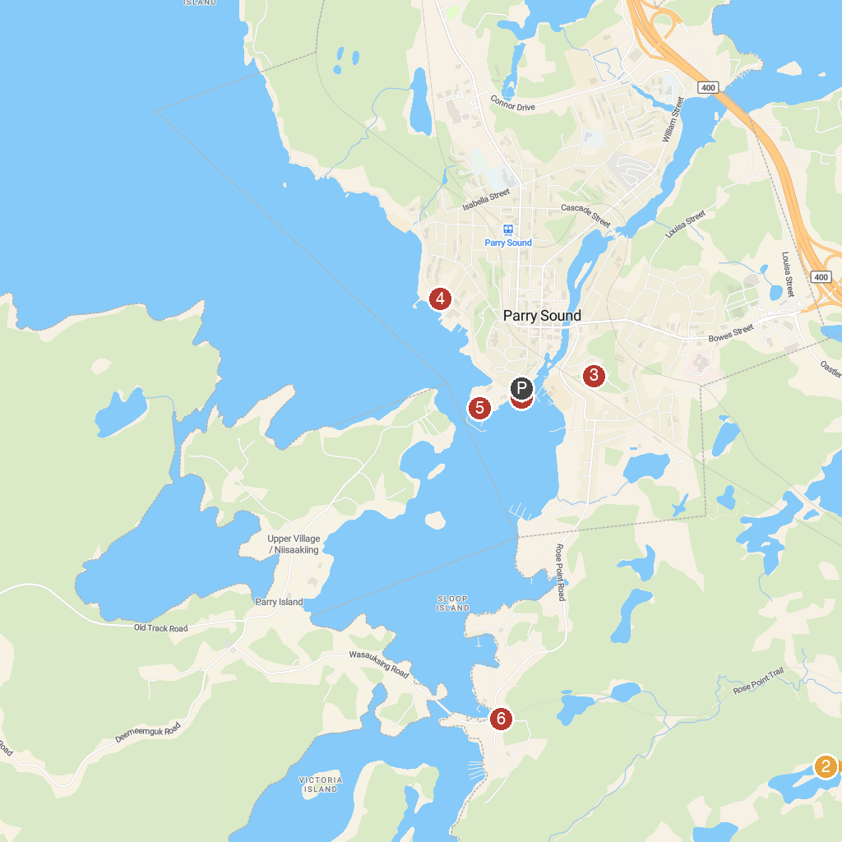
MAP KEY
1. Town Dock | 4. Waubuno Park
2. Oastler Lake Provincial Park | 5. Big Sound Marina
3. West Parry Sound District Museum | 6. Rose Point Trail
P. Cruise port / terminal
Map © MapTiler © OpenStreetMap contributors · cruiseports.org

