Pärnu, Pärnu County, Estonia
They call Pärnu Estonia's Summer Capital for good reason — every June Tallinn ceremonially hands the title over. Sun-warmed Baltic water, powdery white sand, Art Nouveau spas, and a compact Old Town that's all yours once the day-trippers head home.
⚓ Pier (direct dock) · 🕒 Typical call: 6–8 hrs · 💶 Euro (€) — card accepted everywhere · 🗣️ Estonian / English widely spoken · 🏖️ Best beach port in the Baltics
✍️ MY DAY IN PORT (FILL IN)
Ship / Date
In port | arrive ______ · all aboard ______
Booked excursion
Notes / meeting point
GETTING ASHORE
- Docking: Direct pier at Port of Pärnu (Pärnu River mouth)
- Walk to Old Town: ~10–15 min (1 km flat)
- Best For: Beach days, spa treatments, relaxed Baltic town wandering
- Don't Miss: Pärnu Beach + Rannahoone, Tallinn Gate, mud bath at Hedon Spa
GETTING AROUND
- 🚕 Taxi: €4–€7 — Traditional taxis are available near the port. Short rides within the city center cost approximately €4–€7 with a base f
- 📱 Rideshare: ✅ Bolt
TOP THINGS TO DO
- Mud Bath & Spa at Hedon — Pärnu's spa tradition dates to 1838 when the first mud baths opened here.
- Old Town & Tallinn Gate Walk — Stroll Rüütli Street past 17th–19th century merchant houses, then duck through the Tallinn Gate — the only surviving baroque city…
- Pärnu Museum — 11,000 Years of History — Modern and interactive, this museum traces the area from Stone Age settlements through the Hanseatic trading era, Estonian…
- Pärnu Beach & Coastal Meadow Trail — Walk the 4 km sandy promenade past the iconic 1930s functionalist Rannahoone beach pavilion, then follow the 600 m boardwalk over…
- Soomaa National Park — Bogs & Canoes — About 50 km east, Soomaa is one of Europe's largest intact raised bog systems.
BEST WALKS
- Pier → Old Town → Tallinn Gate Loop: 2 km · ~30 min · flat — Walk the river path to the Old Town, up pedestrian Rüütli Street, through the Tallinn Gate into…
- Old Town to Pärnu Beach Promenade: 2 km · ~25 min · flat — Head south from the Old Town through tree-lined avenues to the beach, walk the promenade past the…
WEATHER · DAYLIGHT · MONEY
Month | High °F | Low °F | Rainy days
May | 60 | 44 | 9
Jul | 71 | 58 | 15
Sep | 61 | 51 | 11
Daylight: May 4:55AM–9:42PM · Jul 4:40AM–10:14PM · Sep 6:52AM–7:40PM
cruiseports.org/parnu · Confirm terminal & all-aboard time with your ship

Pärnu, Pärnu County, Estonia — Port Map
Red = walkable sights · Amber = excursions farther out · P = cruise terminal
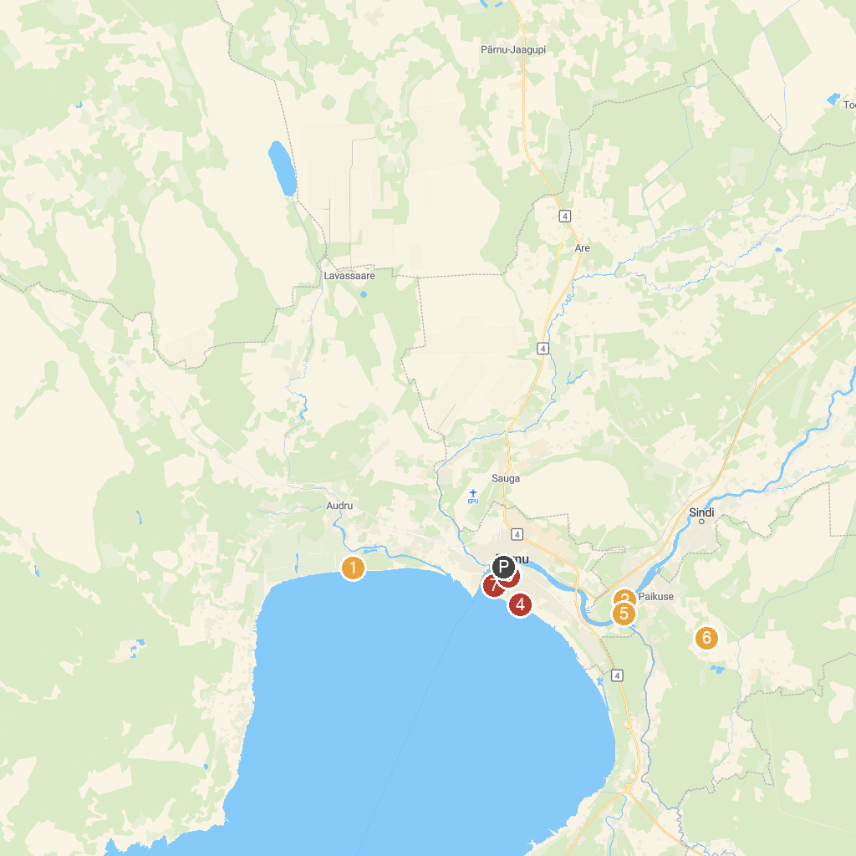
MAP KEY
1. Valgeranna Seikluspark | 5. Sindi-Lodja Stone Age village
2. Markna Ltd. | 6. Seljametsa Museum
3. Town Hall | 7. Rannapark
4. Rannaniidu matkarada | 8. St. Elizabeth's Church
P. Cruise port / terminal
Map © MapTiler © OpenStreetMap contributors · cruiseports.org

