Paris, Île-de-France, France
Paris needs no introduction. River cruise ships tie up right on the Seine, steps from the Eiffel Tower — the whole city is yours for the day.
⚓ Docked (river berth) · 🕒 Typical call: 1-2 days · 💶 Euro (€) · 🗣️ French
✍️ MY DAY IN PORT (FILL IN)
Ship / Date
In port | arrive ______ · all aboard ______
Booked excursion
Notes / meeting point
GETTING ASHORE
- Docking: Quai André Citroën or Quai de Grenelle, 15th arr.
- Walk to center: ~25 min to Eiffel Tower; Trocadéro 30 min
- Best For: History, art, food, iconic landmarks
- Don't Miss: A twilight Seine stroll past Notre-Dame
GETTING AROUND
- 🚕 Taxi: €6–€20 within central Paris — Metered taxis are plentiful; fares across central Paris range €6–€20 depending on dock location. A €4 surcharge applies
- 📱 Rideshare: ✅ Uber, Bolt
- 🚌 Hop-on hop-off: ✅ Big Bus Tours / Tootbus
TOP THINGS TO DO
- Eiffel Tower & Trocadéro — Ride the lift to the second floor (or summit) for panoramic views, then cross Pont d'Iéna for the classic Trocadéro photo.
- Louvre Museum — The world's largest art museum houses the Mona Lisa, Venus de Milo, and thousands more.
- Palace of Versailles Day Trip — Louis XIV's opulent palace and its formal gardens sit 30 minutes by RER C from central Paris.
- Musée d'Orsay & Impressionists — Housed in a Beaux-Arts railway station, the Orsay holds the world's finest collection of Impressionist and Post-Impressionist…
- Marais & Le Bon Marché Food Walk — Wander the medieval Marais quarter — Place des Vosges, the Jewish Quarter's falafel shops on Rue des Rosiers, and the Grande…
BEST WALKS
- Left Bank Riverside Walk: 5 km · ~1.25 hr · Flat — Follow the Seine east from the dock past the Eiffel Tower, Pont Alexandre III, and the Musée…
- Île de la Cité & Notre-Dame: 3 km · ~1 hr · Easy — Cross to the islands at the heart of Paris — Île de la Cité for Notre-Dame Cathedral (reopened…
WEATHER · DAYLIGHT · MONEY
Month | High °F | Low °F | Rainy days
May | 66 | 49 | 12
Jul | 78 | 60 | 9
Sep | 71 | 55 | 8
Daylight: May 6:09AM–9:25PM · Jul 6:03AM–9:48PM · Sep 7:27AM–8:02PM
cruiseports.org/paris-city · Confirm terminal & all-aboard time with your ship

Paris, Île-de-France, France — Port Map
Red = walkable sights · Amber = excursions farther out · P = cruise terminal
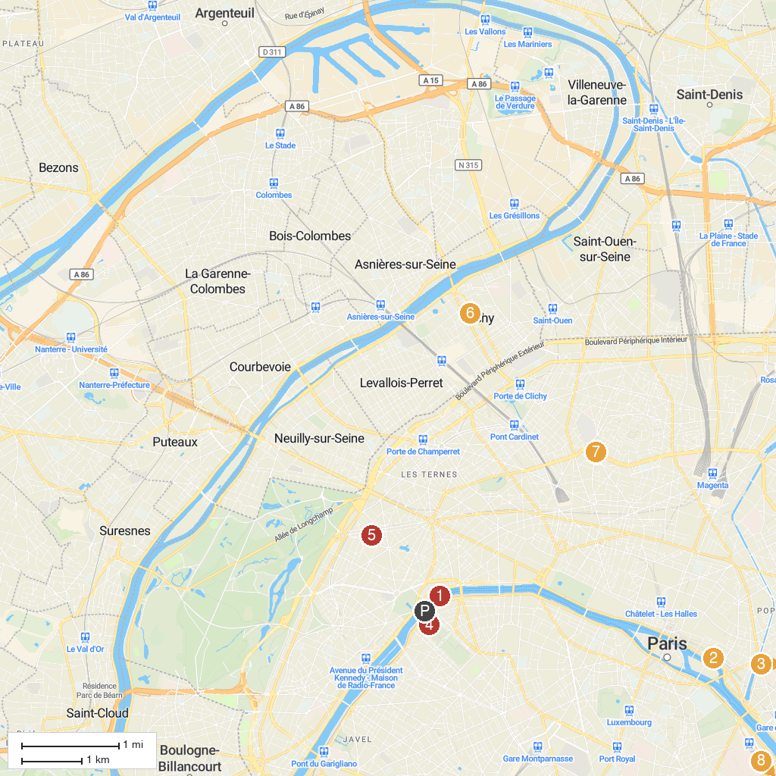
MAP KEY
1. Passerelle Debilly | 5. Ennery Museum
2. Hôtel de Sens | 6. Pavillon Vendôme
3. Opéra Bastille | 7. Moulin Rouge
4. Eiffel Tower | 8. Bibliothèque François-Mitterrand
P. Cruise port / terminal
Map © MapTiler © OpenStreetMap contributors · cruiseports.org

