Parintins, Amazonas, Brazil
A river-island town mid-Amazon that erupts every June into one of Brazil's biggest folklore spectacles — the Boi-Bumbá Festival, where the red Garantido and blue Caprichoso factions battle it out in the Bumbódromo arena in a riot of dance, music, and Amazonian myth.
⚓ Tender (no cruise pier) · 🕒 Typical call: 5–7 hrs · 💵 Brazilian Real (BRL) · 🗣️ Portuguese
✍️ MY DAY IN PORT (FILL IN)
Ship / Date
In port | arrive ______ · all aboard ______
Booked excursion
Notes / meeting point
GETTING ASHORE
- Docking: Tender to town riverfront
- Walk to center: ~5 min from tender landing
- Best For: Folklore · Amazon culture
- Don't Miss: Bumbódromo arena & Boi-Bumbá show
GETTING AROUND
- 📱 Rideshare: ✅ Uber
TOP THINGS TO DO
- Bumbódromo Arena & Boi-Bumbá Show — The Bumbódromo is the purpose-built arena where the Garantido (red) and Caprichoso (blue) factions compete each June.
- Garantido & Caprichoso Cultural Centers — Each rival faction has its own headquarters and museum in town.
- Amazon Riverfront & Local Market — The Parintins waterfront and central market give a genuine slice of Amazon river-town life — local produce, açaí, fresh fish…
- Skiff Excursion into Amazon Backwaters — Small-boat excursions into the igarapés (narrow channels) and flooded forest around Parintins offer glimpses of Amazon wildlife…
BEST WALKS
- Riverfront to Bumbódromo: ~1.5 km · 30 min each way · easy — Walk from the Porto de Parintins landing along the waterfront and into town to the Bumbódromo arena…
WEATHER · DAYLIGHT · MONEY
Month | High °F | Low °F | Rainy days
May | 85 | 75 | 28
Jul | 86 | 76 | 20
Sep | 90 | 77 | 11
Daylight: May 5:43AM–5:43PM · Jul 5:53AM–5:52PM · Sep 5:39AM–5:44PM
cruiseports.org/parintins · Confirm terminal & all-aboard time with your ship

Parintins, Amazonas, Brazil — Port Map
Red = walkable sights · Amber = excursions farther out · P = cruise terminal
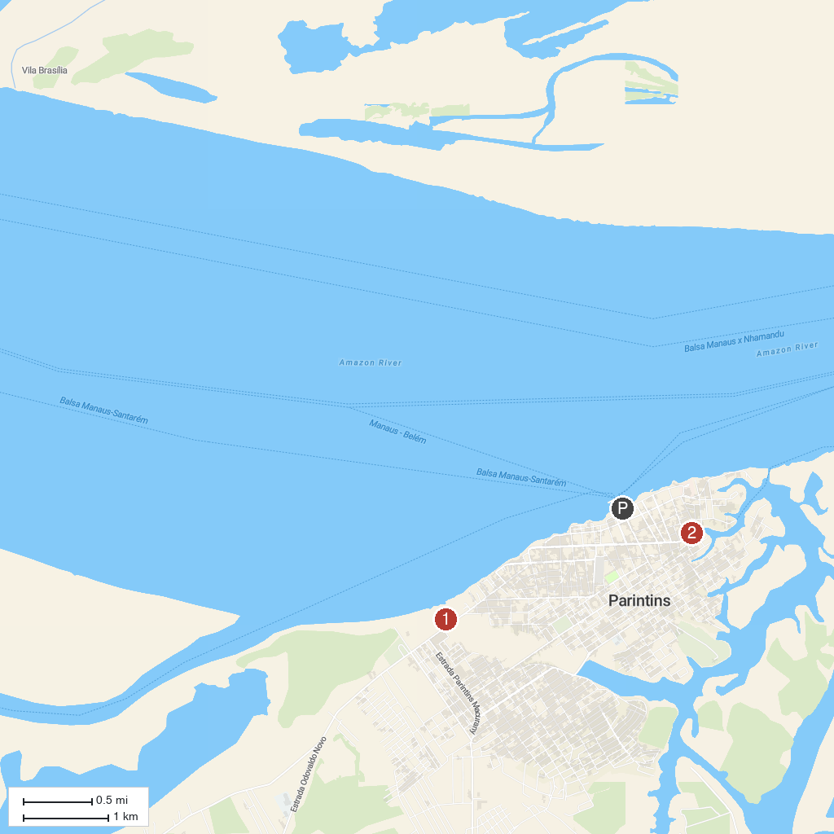
MAP KEY
1. Cidade Garantido | 2. Lagoa da Francesa
P. Cruise port / terminal
Map © MapTiler © OpenStreetMap contributors · cruiseports.org

