Parga, Epirus, Greece
Colorful Venetian houses tumble down a hillside to a bay of luminous turquoise water — Parga is one of mainland Greece's most photogenic ports, green and lush where Cycladic islands are bare and white.
⚓ Tender port (no pier) · 🕒 Typical call: 6–8 hrs · 💶 Currency: Euro (€) · 🗣️ Language: Greek (English widely spoken)
✍️ MY DAY IN PORT (FILL IN)
Ship / Date
In port | arrive ______ · all aboard ______
Booked excursion
Notes / meeting point
GETTING ASHORE
- Docking: Tender — ships anchor in the bay; boats drop passengers at the town harbor (Limanaki)
- Walk to center: 0 min — tender pier lands you directly on the harbor promenade
- Best For: Beach days, castle views, Venetian old town, Epirus cuisine
- Don't Miss: The Panagia Islet and a water taxi to Valtos Beach
GETTING AROUND
- 🚕 Taxi: €3.50 start + €0.70/km (~€7 for 5 km) — Taxis are available in the town center and can be booked via the Taxaki app. Fixed-rate transfers to Preveza Airport run
- 📱 Rideshare: ❌ not available
TOP THINGS TO DO
- Venetian Castle of Parga — A free 10–15 min uphill walk rewards with sweeping panoramas over the bay, Valtos Beach, and the Panagia Islet.
- Acheron River Gorge — The mythological River Acheron — the ancient Greeks' river of the Underworld, where Charon ferried souls and the Necromanteion…
- Ali Pasha Castle (Anthousa) — Built by the Ottoman ruler Ali Pasha on a commanding hilltop 5 km outside town to besiege Parga, this fortress is in better…
- Valtos Beach Day — A wide arc of golden-pebble sand with crystal-clear Ionian water, beach bars, and water sports rentals.
- Parga Old Town & Olive Oil Tasting — Wander the Tourkopazaro — narrow cobblestone lanes climbing toward the castle, draped in bougainvillea and lined with artisan…
BEST WALKS
- Harbor to Venetian Castle: 1.5 km round trip | 30–45 min | Moderate (steep steps) — From the Limanaki tender pier, walk along the waterfront promenade, then follow the cobblestone…
- Krioneri & Piso Krioneri Beaches: 0.5 km one way | 5–10 min | Easy (flat) — Step off the tender and walk 3 minutes to Krioneri Beach, the town beach facing the Panagia Islet.
WEATHER · DAYLIGHT · MONEY
Month | High °F | Low °F | Rainy days
May | 72 | 60 | 9
Jul | 87 | 73 | 2
Sep | 80 | 68 | 8
Daylight: May 6:25AM–8:44PM · Jul 6:24AM–9:03PM · Sep 7:19AM–7:46PM
cruiseports.org/parga · Confirm terminal & all-aboard time with your ship

Parga, Epirus, Greece — Port Map
Red = walkable sights · Amber = excursions farther out · P = cruise terminal
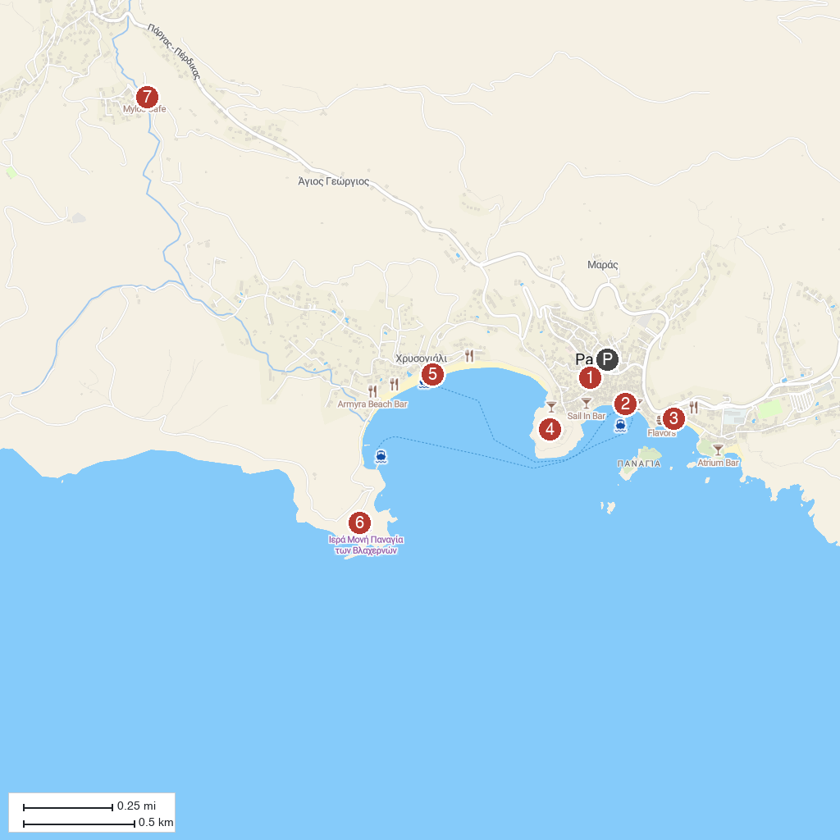
MAP KEY
1. Necromanteion of Acheron | 5. Venetian Castle of Parga
2. Paragaea Old Olive Oil Factory | 6. Valtos Beach
3. Anchor | 7. Vlacherna Monastery
4. Krioneri Beach | 8. Watermill Mylos
P. Cruise port / terminal
Map © MapTiler © OpenStreetMap contributors · cruiseports.org

