Paraty, Rio de Janeiro, Brazil
A 17th-century gold-rush port frozen in time, Paraty delivers cobblestoned lanes, schooner-dotted bays, and a UNESCO dual heritage — all starting steps from where your tender drops you.
⚓ Tender port · 🕒 Typical call: 6–9 hrs · 💵 Brazilian Real (BRL) · 🗣️ Portuguese · 🏛️ UNESCO World Heritage
✍️ MY DAY IN PORT (FILL IN)
Ship / Date
In port | arrive ______ · all aboard ______
Booked excursion
Notes / meeting point
GETTING ASHORE
- Docking: Tender — ships anchor in bay; ~30-min tender to Cais de Paraty
- Walk to center: 0 min — historic center starts at the pier
- Best For: Colonial architecture, island beaches, cachaça tasting, history
- Don't Miss: Schooner tour to Ilha Comprida; Jorge Amado cocktail; Igreja de Santa Rita
GETTING AROUND
- 🚕 Taxi: R–R — Taxis wait near the pier and drop passengers at the edge of the car-free historic zone. Fares are not metered — agree on
- 📱 Rideshare: ✅ Uber
TOP THINGS TO DO
- Schooner Island & Beach Tour — Wooden schooners depart from the pier daily for 4–5-hour tours of Paraty's islands and secluded beaches.
- Colonial Historic Center Walk — Wander the pedestrian lanes of Brazil's best-preserved 18th-century colonial town.
- Cachaça Distillery Tour — Paraty produces some of Brazil's finest artisanal cachaça.
- Gold Trail (Caminho do Ouro) — Hike a preserved section of the original 18th-century stone road used to carry gold from Minas Gerais to Portugal.
- Jeep Tour to Waterfalls — Jeep excursions head into Serra da Bocaina National Park to natural rock slides and waterfalls including Cachoeira do Tobogã.
BEST WALKS
- Historic Center & Churches Loop: 1.5 km · 45–60 min · Easy (uneven cobblestones) — From the Cais de Paraty pier, head into the pedestrian zone.
- Pier to Forte Defensor Perpétuo: 2 km round trip · 45 min · Easy uphill — Walk north from the historic center uphill 15 minutes to the Forte Defensor Perpétuo (built 1822).
WEATHER · DAYLIGHT · MONEY
Month | High °F | Low °F | Rainy days
May | 77 | 66 | 14
Jul | 75 | 63 | 8
Sep | 78 | 66 | 14
Daylight: May 6:25AM–5:24PM · Jul 6:40AM–5:29PM · Sep 5:56AM–5:52PM
cruiseports.org/paraty · Confirm terminal & all-aboard time with your ship

Paraty, Rio de Janeiro, Brazil — Port Map
Red = walkable sights · Amber = excursions farther out · P = cruise terminal
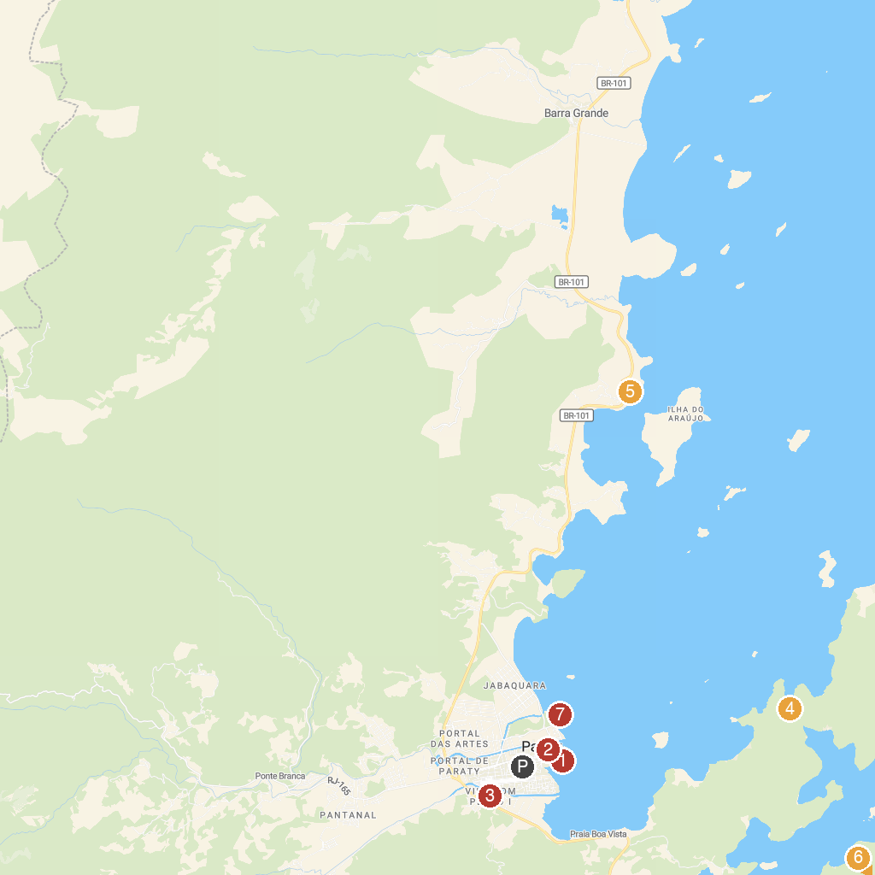
MAP KEY
1. Porto Paraty - Passeios de Escuna / Barco | 5. Praia Grande
2. Paraty | 6. Mamanguá Bay
3. Reserva Ecológica Estadual da Juatinga (sede adiministrativa e operacional) | 7. Museu Forte Defensor Perpétuo
4. Jurumirim Beach
P. Cruise port / terminal
Map © MapTiler © OpenStreetMap contributors · cruiseports.org

