Paranaguá, Paraná, Brazil
Founded in 1648 and still anchored around its riverfront colonial streets, Paranaguá punches above its size — the Serra Verde Express rail descent through the Atlantic Forest and the car-free beaches of Ilha do Mel are among the best day trips in all of South America.
⚓ Pier (commercial cargo port) · 🕒 Typical call: 8-10 hrs · 💵 Brazilian Real (BRL) · 🗣️ Portuguese
✍️ MY DAY IN PORT (FILL IN)
Ship / Date
In port | arrive ______ · all aboard ______
Booked excursion
Notes / meeting point
GETTING ASHORE
- Docking: Pier — mandatory shuttle to city; no walking through the port
- Walk to center: ~5 min from shuttle drop to Praça Mário Roque
- Best For: Scenic train rides, island beaches, colonial history
- Don't Miss: Serra Verde Express to Morretes or a fast ferry to Ilha do Mel
GETTING AROUND
- 🚕 Taxi: R$20–40 (~$4–8 USD) — Official taxis wait at the pier and are a quick, inexpensive option. Fares to the city center are typically R$20–40 depe
- 📱 Rideshare: ✅ Uber, 99
TOP THINGS TO DO
- Serra Verde Express — Curitiba Train Descent — Ride one of the world's great scenic railways: a roughly 3.5-hour descent through the Serra do Mar mountain range, crossing…
- Ilha do Mel (Honey Island) Beach Day — A roughly 1.5-hour boat ride direct from Paranaguá (or a quick 30-min crossing from Pontal do Sul) drops you on this car-free…
- Paranaguá Historic Center Walking Tour — Explore the colonial heart of Paraná's oldest city on foot — the MAE Archaeology & Ethnology Museum (stunning restored Jesuit…
- Morretes Colonial Town & Barreado Lunch — The charming colonial town at the foot of Serra do Mar is the spiritual home of Barreado — the slow-cooked clay-pot beef stew…
- Superagüi National Park Boat Tour — A UNESCO World Heritage site protecting one of the largest remaining Atlantic Forest tracts.
BEST WALKS
- Rua da Praia Waterfront & Historic Core: 1.5 km · 30–40 min · Easy — Start at Praça Mário Roque on the Itiberê riverfront, then walk west along Rua da Praia past the…
WEATHER · DAYLIGHT · MONEY
Month | High °F | Low °F | Rainy days
May | 73 | 64 | 15
Jul | 70 | 59 | 10
Sep | 73 | 63 | 15
Daylight: May 6:44AM–5:36PM · Jul 6:59AM–5:40PM · Sep 6:11AM–6:07PM
cruiseports.org/paranagua · Confirm terminal & all-aboard time with your ship

Paranaguá, Paraná, Brazil — Port Map
Red = walkable sights · Amber = excursions farther out · P = cruise terminal
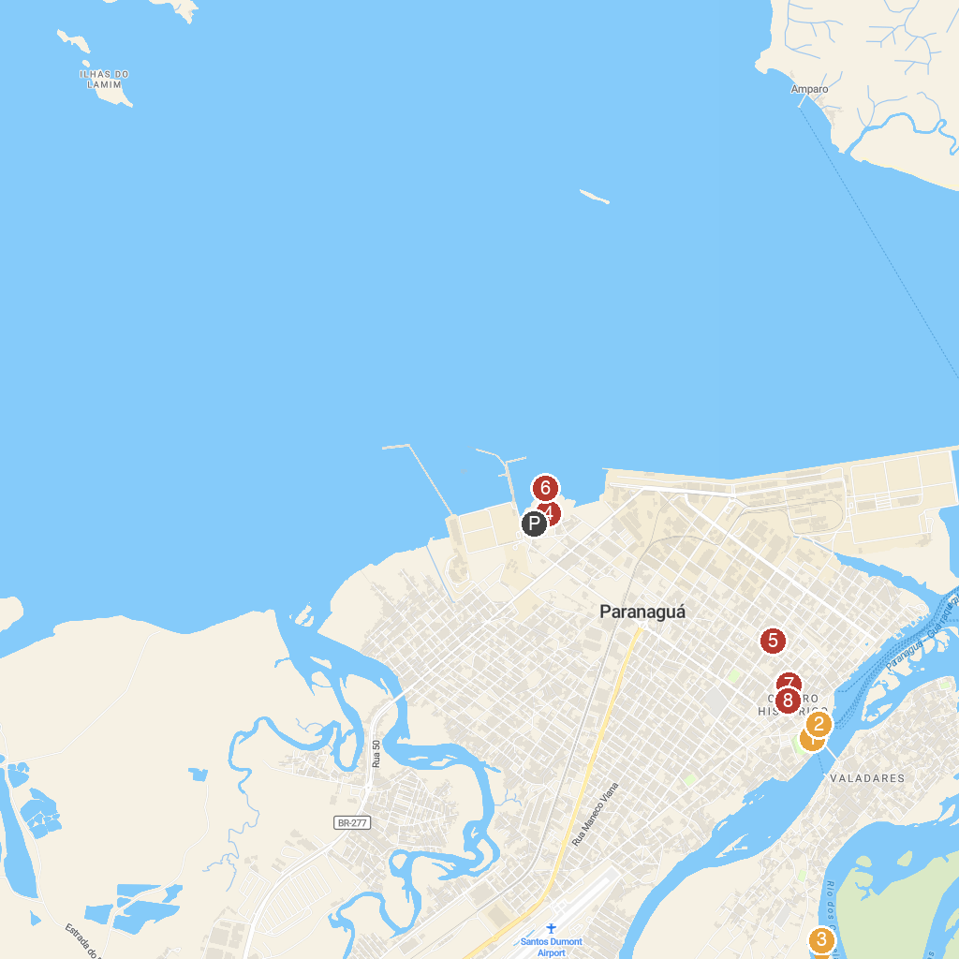
MAP KEY
1. Municipal Market Paranaguá | 5. Praça João Gualberto
2. Aquário de Paranaguá | 6. Trapiche do Rocio
3. Estação Ecológica do Guaraguaçu | 7. Fair Moon - Square of the Lions
4. Faith Square | 8. Centro Histórico de Paranaguá
P. Cruise port / terminal
Map © MapTiler © OpenStreetMap contributors · cruiseports.org

