Papenburg, Lower Saxony, Germany
Where the world's greatest cruise ships are born — Papenburg's web of canals, historic sailing ships, and the legendary Meyer Werft shipyard make this flat Dutch-flavored German town a surprisingly fascinating stop.
⚓ Pier (river dock — no tendering) · 🕒 Typical call: 6-8 hrs · 💶 Currency: Euro (€) · 🗣️ Language: German · 🚢 River & small ocean ships only
✍️ MY DAY IN PORT (FILL IN)
Ship / Date
In port | arrive ______ · all aboard ______
Booked excursion
Notes / meeting point
GETTING ASHORE
- Docking: Pier along Hauptkanal; river cruise ships dock in town center, 0–5 min walk to sights
- Walk to center: 0–5 min from river cruise dock; ~3 km (taxi) from industrial harbor
- Best For: Meyer Werft shipyard tours, canal walks, maritime history
- Don't Miss: Meyer Werft Visitor Centre — book ahead, tours sell out fast
GETTING AROUND
- 🚕 Taxi: €6–€15 — Taxis are the most practical on-demand option. Base fare is around €6 with roughly €2.70/km; a short trip within town or
TOP THINGS TO DO
- Meyer Werft Shipyard Tour — Step inside one of the world's largest covered dry docks and watch cruise ships being assembled from the viewing galleries.
- Canal District & Historic Ship Walk — Stroll the Hauptkanal to see six full-scale 19th-century wooden sailing ship replicas anchored in the water, including the brig…
- Von-Velen-Anlage Open-Air Museum — Explore reconstructed turf huts and peat-cutter cottages showing how Papenburg's first fen settlers lived.
- Gut Altenkamp Baroque Manor — A beautifully preserved 1728 manor house surrounded by a moat and Dutch-style gardens in nearby Aschendorf.
- Canal Cycling Tour — Papenburg is flat as a pancake and laced with cycling paths along its canals.
BEST WALKS
- Hauptkanal Historic Ships Walk: 1.5 km · 30 min · flat · free — A leisurely stroll along the Main Canal from the dock past the historic ship replicas, the Town…
- Windmill & Zeitspeicher Loop: 2 km · 45 min · flat · €5 museum entry — Walk from the dock to Meyer's Mühle (the 1888 Dutch windmill), then swing past the Zeitspeicher…
WEATHER · DAYLIGHT · MONEY
Month | High °F | Low °F | Rainy days
May | 63 | 48 | 12
Jul | 72 | 58 | 15
Sep | 67 | 53 | 10
Daylight: May 5:31AM–9:22PM · Jul 5:23AM–9:48PM · Sep 7:04AM–7:45PM
cruiseports.org/papenburg · Confirm terminal & all-aboard time with your ship

Papenburg, Lower Saxony, Germany — Port Map
Red = walkable sights · Amber = excursions farther out · P = cruise terminal
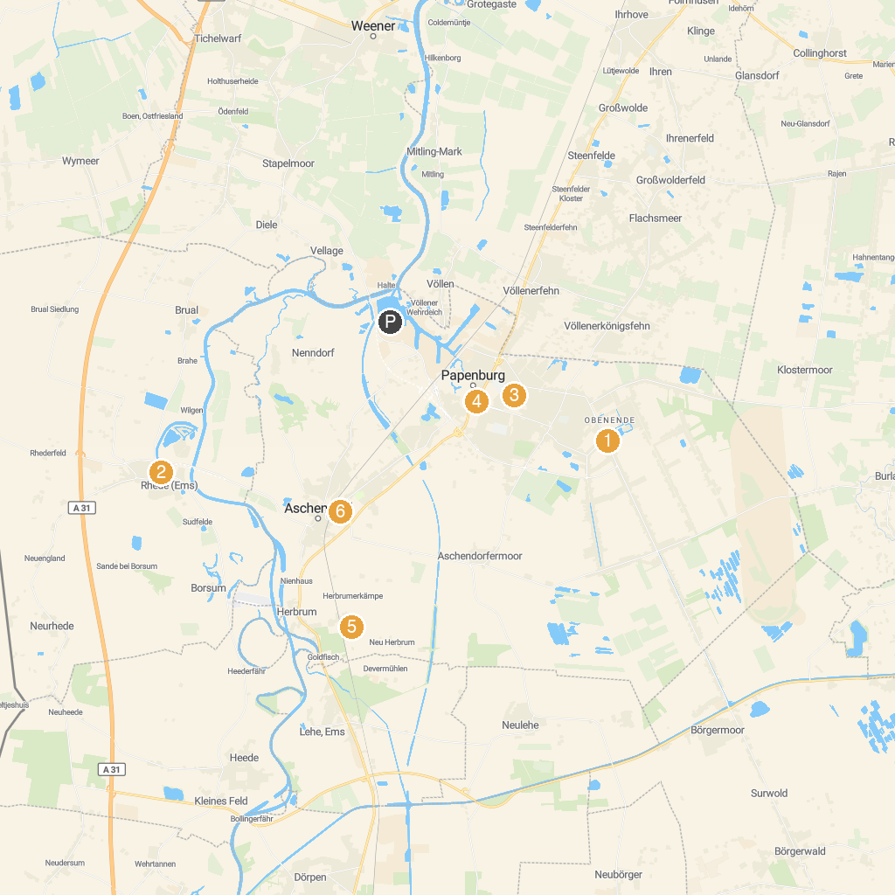
MAP KEY
1. Von-Velen-Anlage | 5. Schades Garten
2. Landwirtschaftsmuseum Rhede | 6. Fehn- und Schiffahrtsmuseum Westrhauderfehn
3. Bockwindmühle | 7. Märchenwald
4. Museumsschiff "Friederike von Papenburg" | 8. Gut Altenkamp
P. Cruise port / terminal
Map © MapTiler © OpenStreetMap contributors · cruiseports.org

