Panama City, Panama
Stand at the crossroads of the world's most famous waterway — watch Panamax ships squeeze through the Miraflores Locks, stroll cobblestoned Casco Viejo, or cruise the causeway by bike with the skyline at your back.
⚓ Docked (Flamenco Island pier) · 🕒 Typical call: 8-10 hrs · 💵 US Dollar · 🗣️ Spanish
✍️ MY DAY IN PORT (FILL IN)
Ship / Date
In port | arrive ______ · all aboard ______
Booked excursion
Notes / meeting point
GETTING ASHORE
- Docking: Fuerte Amador Cruise Terminal, Flamenco Island — two berths, no tendering
- Walk to center: Not walkable; 25-40 min taxi/Uber to downtown Panama City or Casco Viejo
- Best For: Panama Canal sightseeing, history, cycling, Frank Gehry architecture
- Don't Miss: Watching a ship transit the Miraflores Locks live — book tickets in advance
GETTING AROUND
- 🚕 Taxi: $15–$20 — Official taxis wait at Fuerte Amador cruise terminal. Agree on fare before departure — meters are not always used. The 9
- 📱 Rideshare: ✅ Uber, Bolt
- 🚌 Hop-on hop-off: ✅ City Sightseeing Panama
TOP THINGS TO DO
- Miraflores Locks Visitor Center — Panama's #1 cruise excursion.
- Casco Viejo Walking Tour — Panama City's UNESCO-listed colonial quarter is a compact grid of 17th-century plazas, crumbling churches, and restored boutique…
- Biomuseo — Frank Gehry's Biodiversity Museum — The only building Frank Gehry designed in Latin America sits right on the Amador Causeway — a riot of colored panels celebrating…
- Amador Causeway Bike Ride — Rent a bike steps from the terminal and pedal the flat, 3-km Amador Causeway linking three islands.
- Gatun Lake Eco-Cruise & Monkey Island — Boat through the jungle-lined Chagres River to Monkey Island on Gatun Lake, spotting howler and capuchin monkeys, toucans, and…
BEST WALKS
- Amador Causeway Stroll: 2.5 km one-way · Flat · 30-45 min — Walk from the cruise terminal along the Causeway's shaded path to Flamenco Island's tip.
- Casco Viejo Self-Guided Walk: 1.5 km loop · Easy · 1-2 hrs (30 min taxi from port) — Taxi to Casco Viejo then explore on foot: start at Plaza de la Independencia, visit the…
WEATHER · DAYLIGHT · MONEY
Month | High °F | Low °F | Rainy days
May | 85 | 77 | 30
Jul | 85 | 76 | 29
Sep | 84 | 76 | 30
Daylight: May 5:58AM–6:30PM · Jul 6:06AM–6:41PM · Sep 6:08AM–6:17PM
cruiseports.org/panama-city · Confirm terminal & all-aboard time with your ship

Panama City, Panama — Port Map
Red = walkable sights · Amber = excursions farther out · P = cruise terminal
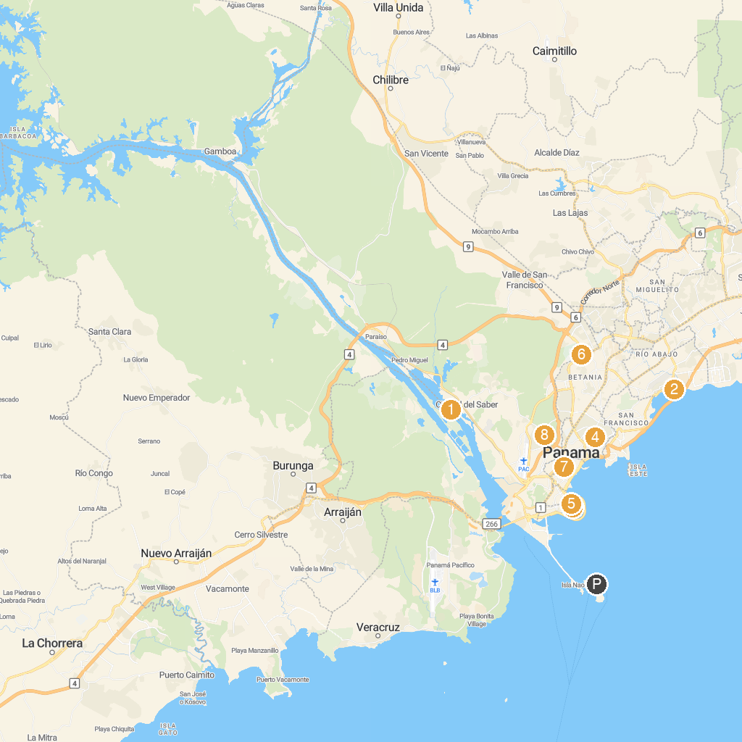
MAP KEY
1. Miraflores Locks | 5. Parish of San Felipe de Neri
2. Old Panama | 6. Hindu Temple
3. Convento de Santo Domingo | 7. Don Bosco Minor Basilica
4. Parroquia Santuario Nacional del Corazón de María | 8. Metropolitan Natural Park Visitor Center
P. Cruise port / terminal
Map © MapTiler © OpenStreetMap contributors · cruiseports.org

