Palmarola Island, Pontine Islands, Italy
A near-deserted volcanic island in the Tyrrhenian Sea — tender into glassy coves, swim through sea grottos, and find a rare corner of the Mediterranean that genuinely feels undiscovered.
⚓ Tender port (no pier infrastructure) · 🕒 Typical call: 4–7 hrs · 💶 Euro (EUR) · 🗣️ Italian
✍️ MY DAY IN PORT (FILL IN)
Ship / Date
In port | arrive ______ · all aboard ______
Booked excursion
Notes / meeting point
GETTING ASHORE
- Docking: Tender to Cala del Porto or anchor bay
- Walk to center: No town — a handful of seasonal fishermen's huts
- Best For: Swimming · Sea caves · Snorkelling
- Don't Miss: La Cattedrale basalt sea cliffs
GETTING AROUND
- 📱 Rideshare: ❌ not available
TOP THINGS TO DO
- La Cattedrale & Sea Cave Circuit — The island's most famous feature is La Cattedrale (The Cathedral) — soaring basalt cliffs sculpted into fissures and arches that…
- Swimming & Snorkelling at Cala del Porto — The cove where tenders land has exceptionally clear water — visibility of 15–20 metres is common.
- Circumnavigation by Kayak or RIB — A full circuit of Palmarola by kayak or rigid inflatable reveals the rugged western cliffs — the island's most dramatic scenery…
- Cliff Walk & Island Viewpoints — A rough footpath from Cala del Porto climbs the eastern ridge — passing near the San Silverio shrine — to elevated viewpoints…
- Lunch at a Seasonal Beach Restaurant — A handful of seasonal trattorie operate on the island in summer, serving grilled fish caught the same morning, pasta with clams…
BEST WALKS
- Cala del Porto to the Eastern Ridge: ~1.5 km return · 45–60 min · moderate (rocky terrain) — From the tender landing at Cala del Porto, a marked but rough path climbs the eastern hillside…
WEATHER · DAYLIGHT · MONEY
Month | High °F | Low °F | Rainy days
May | 73 | 55 | 11
Jul | 89 | 69 | 4
Sep | 80 | 63 | 9
Daylight: May 5:50AM–8:23PM · Jul 5:48AM–8:43PM · Sep 6:50AM–7:19PM
cruiseports.org/palmarola-island · Confirm terminal & all-aboard time with your ship

Palmarola Island, Pontine Islands, Italy — Port Map
Red = walkable sights · Amber = excursions farther out · P = cruise terminal
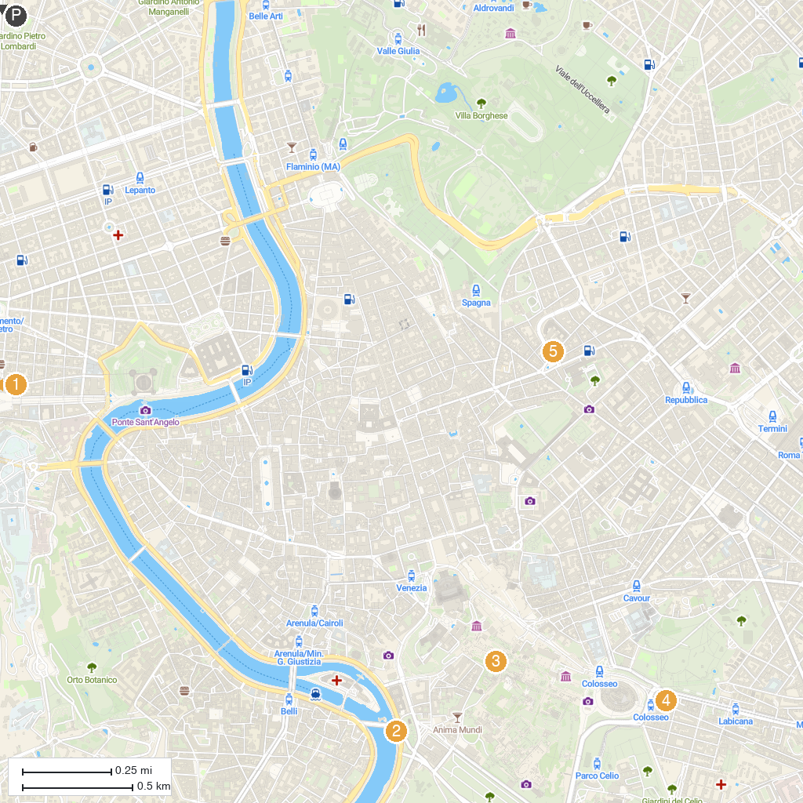
MAP KEY
1. The Last Judgment | 5. Fountain of the Bees
2. Cloaca Maxima | 6. Aurelian Walls
3. Temple of Castor and Pollux | 7. Porta Maggiore
4. Ludus Magnus
P. Cruise port / terminal
Map © MapTiler © OpenStreetMap contributors · cruiseports.org

