Palermo, Sicily, Italy
Sicily's street-food-scented capital layers Arab-Norman cathedrals, crumbling baroque piazzas, and raucous outdoor markets into one of the Mediterranean's most vivid port days.
⚓ Docked (cruise terminal) · 🕒 Typical call: 8-10 hrs · 💶 Currency: Euro (€) · 🗣️ Language: Italian
✍️ MY DAY IN PORT (FILL IN)
Ship / Date
In port | arrive ______ · all aboard ______
Booked excursion
Notes / meeting point
GETTING ASHORE
- Docking: Cruise Terminal, Porto di Palermo — 1 km from city center
- Walk to center: 15-20 min walk or 5-min taxi to Quattro Canti
- Best For: History lovers, street food, architecture, markets
- Don't Miss: Cappella Palatina, Ballarò Market, Teatro Massimo
GETTING AROUND
- 🚕 Taxi: €8–€15 — Taxis are readily available at the port. The short distance to the center keeps fares low; use the meter and confirm bef
- 📱 Rideshare: ✅ Uber, FreeNow, ITTaxi
- 🚌 Hop-on hop-off: ✅ City Sightseeing Palermo
TOP THINGS TO DO
- Cappella Palatina & Palazzo dei Normanni — The gold-mosaic chapel inside the Norman Palace is one of the finest examples of Arab-Norman art in the world.
- Ballarò & Vucciria Markets — Palermo's ancient street markets are theatrical experiences: vendors shout prices, smoke rises from grills, and arancini and…
- Teatro Massimo Opera House — The third-largest opera house in Europe, best known to film buffs as the setting for The Godfather Part III's finale.
- Monreale Cathedral Day Trip — About 7 km uphill from Palermo, Monreale's 12th-century cathedral has one of the finest collections of Byzantine mosaics in Europe.
- Palermo Street Food Walk — Palermo is one of Italy's best street-food cities.
BEST WALKS
- Terminal to Norman Palace via Quattro Canti: 3.5 km · ~1.5 hrs · Easy — Walk from the cruise terminal along Via Francesco Crispi to the historic center, then explore Via…
- Market Quarter Loop: 2 km · ~1 hr · Easy — From Quattro Canti head south into the Albergheria district for the Ballarò Market, then loop back…
WEATHER · DAYLIGHT · MONEY
Month | High °F | Low °F | Rainy days
May | 72 | 59 | 8
Jul | 87 | 73 | 2
Sep | 81 | 70 | 9
Daylight: May 5:56AM–8:10PM · Jul 5:56AM–8:28PM · Sep 6:48AM–7:14PM
cruiseports.org/palermo · Confirm terminal & all-aboard time with your ship

Palermo, Sicily, Italy — Port Map
Red = walkable sights · Amber = excursions farther out · P = cruise terminal
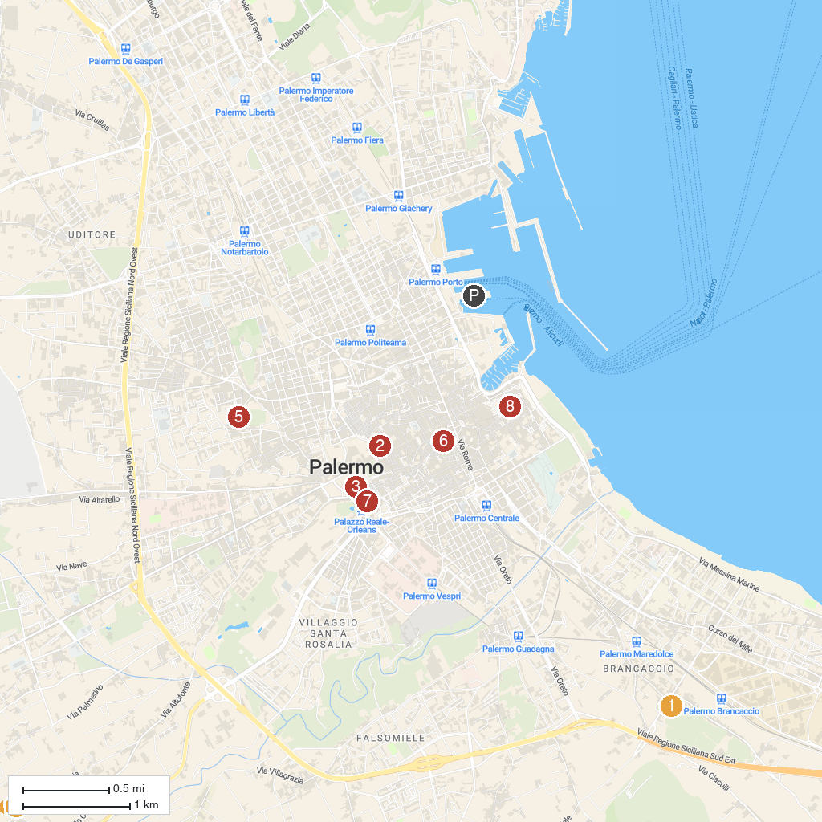
MAP KEY
1. Castello di Maredolce | 5. Zisa Palace
2. Palermo Cathedral | 6. Church of Saint Mary 'dell'Ammiraglio'
3. Palazzo dei Normanni | 7. Church of Saint John of the Hermits
4. Cattedrale di Monreale | 8. Palazzo Chiaramonte Steri
P. Cruise port / terminal
Map © MapTiler © OpenStreetMap contributors · cruiseports.org

