Palavas-les-Flots, Occitanie, France
A retro-charming French seaside resort where fishing boats bob on the canal, flamingos wade in coastal lagoons, and 7km of Blue Flag beaches stretch along the Mediterranean.
⚓ River/barge port (small vessels only) · 🕒 Typical call: 6-8 hrs · 💶 Currency: Euro (€) · 🗣️ Language: French · 🏖️ Beach destination
✍️ MY DAY IN PORT (FILL IN)
Ship / Date
In port | arrive ______ · all aboard ______
Booked excursion
Notes / meeting point
GETTING ASHORE
- Docking: Canal berth (barge/river cruise only; no large cruise ships)
- Walk to center: 0 min — step off directly onto the quayside
- Best For: Beaches, flamingo spotting, cycling to Montpellier
- Don't Miss: Phare de la Méditerranée observation deck & the Transcanal chairlift
GETTING AROUND
- 🚕 Taxi: €8 minimum (within town); €35–€45 to Montpellier — Local taxis serve the town with a minimum fare of €8 (2025 French national rate). Rides to Montpellier city center run €
- 📱 Rideshare: ✅ Uber
TOP THINGS TO DO
- Phare de la Méditerranée — Ride up the 43m observation tower (a converted 1940s water tower, roof at 45m) for 360° views of the sea, the saltwater lagoons…
- Flamingo Spotting at the Étangs — Walk or cycle the gravel paths bordering the coastal lagoons (Étang du Grec, Étang de l'Arnel, Méjean reserve) to spot hundreds…
- Cathédrale de Maguelone — An isolated 12th-century Romanesque cathedral on a former island (now a sandbar peninsula) 4km west, surrounded by lagoons and…
- Albert Dubout Museum — Inside the 18th-century Redoute de Ballestras in Parc du Levant, this museum celebrates the French cartoonist who lovingly…
- Blue Flag Beaches — Seven kilometers of fine sandy beaches line both banks of the canal.
BEST WALKS
- Canal & Town Walk: 1.5km · 30-45 min · flat — Cross between Rive Gauche and Rive Droite using the swing bridges, watching them rotate to let…
- Lagoon & Flamingo Loop (Cycling): 8-12km · 1.5-2.5 hrs · flat cycling — Rent a bike and take the lagoon-side path northwest toward the Méjean regional nature reserve…
WEATHER · DAYLIGHT · MONEY
Month | High °F | Low °F | Rainy days
May | 72 | 56 | 8
Jul | 86 | 69 | 3
Sep | 77 | 62 | 6
Daylight: May 6:19AM–9:02PM · Jul 6:17AM–9:22PM · Sep 7:24AM–7:54PM
cruiseports.org/palavas-les-flots · Confirm terminal & all-aboard time with your ship

Palavas-les-Flots, Occitanie, France — Port Map
Red = walkable sights · Amber = excursions farther out · P = cruise terminal
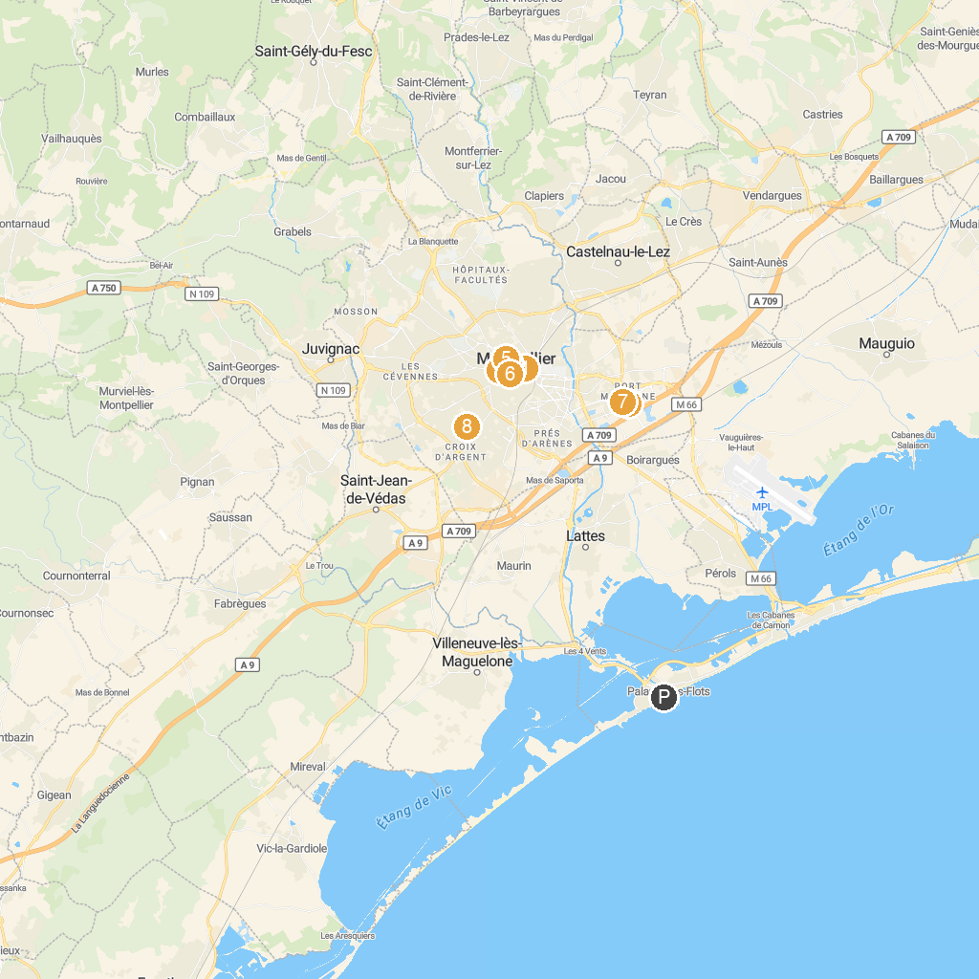
MAP KEY
1. Musée Fabre | 5. Jardin des plantes de Montpellier
2. Planet Ocean Montpellier | 6. Carré Sainte Anne
3. Promenade du Peyrou | 7. Patinoire Vegapolis
4. Cathédrale Saint-Pierre de Montpellier | 8. Parc Montcalm
P. Cruise port / terminal
Map © MapTiler © OpenStreetMap contributors · cruiseports.org

