Palatka, Florida, USA
A moss-draped river town on the northward-flowing St. Johns, Palatka rewards slow walkers with 30+ murals, WPA-era ravine gardens, and Florida's oldest diner.
⚓ Docked (river pier) · 🕒 Typical call: 6-8 hrs · 💵 US Dollar · 🗣️ English · 🌿 Small-ship / river cruise
✍️ MY DAY IN PORT (FILL IN)
Ship / Date
In port | arrive ______ · all aboard ______
Booked excursion
Notes / meeting point
GETTING ASHORE
- Docking: Pier — direct tie-up at Palatka Riverfront Park bulkhead; no tender needed
- Walk to center: 0 min — downtown shops and murals begin across the street from the gangway
- Best For: History buffs, walkers, Southern food, photography, nature (Ravine Gardens)
- Don't Miss: Angel's Dining Car (est. 1932) and Ravine Gardens State Park suspension bridges
GETTING AROUND
- 🚕 Taxi: .50/mile (flat rate) — Rydei is a local Palatka taxi service with no surge pricing and 24/7 availability. Useful for reaching Ravine Gardens St
- 📱 Rideshare: ✅ Uber, Lyft
TOP THINGS TO DO
- Ravine Gardens State Park — WPA-built in the 1930s, this 59-acre park features two deep ravines, thousands of azaleas (spectacular Jan–Mar), and suspension…
- City of Murals Walking Tour — Palatka has 30+ large-format murals depicting Florida history, river life, and local wildlife.
- South Historic District Stroll — Victorian-era Queen Anne and Colonial Revival homes line the shaded streets of Palatka's South Historic District.
- Angel's Dining Car — Florida's oldest diner (est.
- St. Johns Riverfront Wildlife Watch — The St.
BEST WALKS
- Mural & Downtown Loop: 1.5 miles · ~60 min · flat · free — From the Riverfront Park gangway, cross Reid Street and follow St.
- To Ravine Gardens State Park: 1.5 miles each way · ~30 min walk or rideshare · easy paved loop inside — Head south on Twigg Street, then east on Moseley Avenue to reach the park entrance.
WEATHER · DAYLIGHT · MONEY
Month | High °F | Low °F | Rainy days
May | 85 | 67 | 10
Jul | 90 | 75 | 23
Sep | 86 | 73 | 19
Daylight: May 6:33AM–8:12PM · Jul 6:36AM–8:28PM · Sep 7:11AM–7:31PM
cruiseports.org/palatka-fl · Confirm terminal & all-aboard time with your ship

Palatka, Florida, USA — Port Map
Red = walkable sights · Amber = excursions farther out · P = cruise terminal
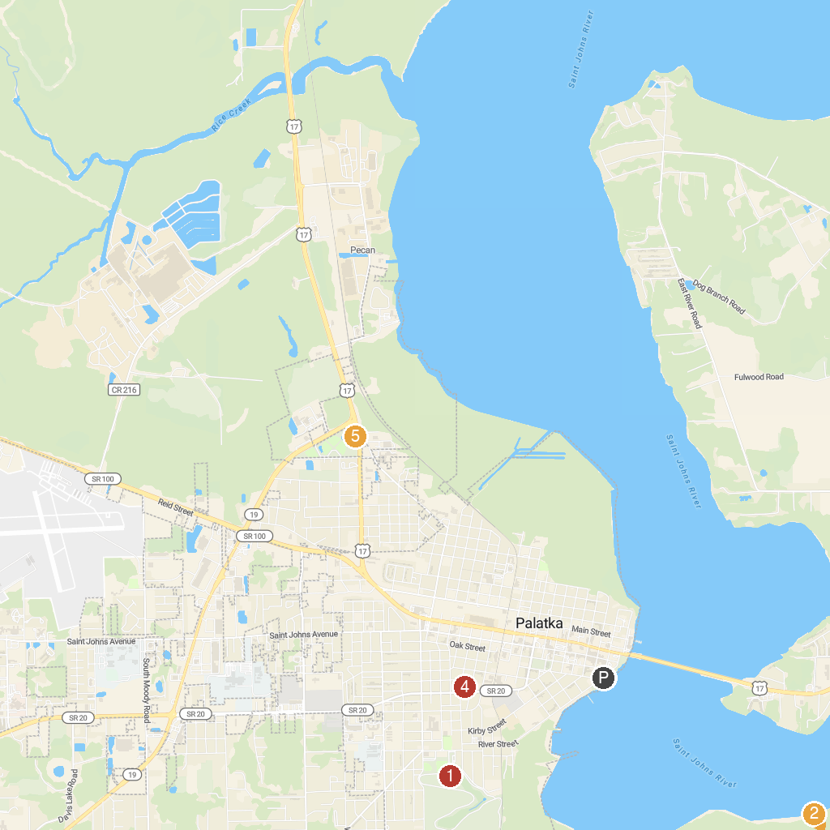
MAP KEY
1. Ravine Gardens State Park | 4. Hank Bryan Park
2. Dunns Creek Wildlife Management Area | 5. Project P.L.A.Y. Park
3. Boathouse Riverfront Park
P. Cruise port / terminal
Map © MapTiler © OpenStreetMap contributors · cruiseports.org

