Pago Pago, Tutuila, American Samoa
One of the most dramatic harbor arrivals in the South Pacific — emerald cliffs plunging into deep blue water, a living Polynesian culture, and the only US National Park south of the equator.
⚓ Pier (Multiuse Wharf) · 🕒 Typical call: 7-9 hrs · 💵 USD (US Territory) · 🗣️ English & Samoan · 🌧️ Tropical — bring a poncho
✍️ MY DAY IN PORT (FILL IN)
Ship / Date
In port | arrive ______ · all aboard ______
Booked excursion
Notes / meeting point
GETTING ASHORE
- Docking: Pier — Multiuse Wharf, downtown Fagatogo
- Walk to center: 2 min — you step off into the town
- Best For: Authentic culture, harbor scenery, hiking, beaches
- Don't Miss: Jean P. Haydon Museum & Fagatogo Market
GETTING AROUND
- 🚕 Taxi: $2–$35 — Licensed taxis wait at the pier gate and Fagatogo Market. Fares are regulated by the American Samoa Commerce Commission
- 📱 Rideshare: ❌ not available
TOP THINGS TO DO
- National Park of American Samoa Hike — The only US National Park south of the equator.
- Jean P. Haydon Museum & Downtown Walk — Explore 650+ artifacts of Samoan history including ancient woven mats, traditional canoes, and the American Samoa flag that flew…
- Two Dollar Beach (Avaio Beach) — Despite the name, entry is $5 USD.
- Tisa's Barefoot Bar — Beach Lunch — A legendary South Pacific beach bar at Alega Beach.
- Island Scenic Tour — Aiga Bus or Taxi — Circle Tutuila's stunning coastline past villages, through the National Park, and to Fatu-ma-Futi (Flowerpot Rock), the dramatic…
BEST WALKS
- Fagatogo Waterfront Loop: 30–45 min · Flat · Free — From the Multiuse Wharf, walk along the harbor road past the Fagatogo Market, the Historic…
- Utulei Beach Stroll: 15 min each way · Flat · Free — Walk west along the harbor road to Utulei beach and Sadie's by the Sea.
WEATHER · DAYLIGHT · MONEY
Month | High °F | Low °F | Rainy days
May | 81 | 77 | 24
Jul | 79 | 76 | 21
Sep | 79 | 76 | 19
Daylight: May 6:35AM–6:02PM · Jul 6:48AM–6:09PM · Sep 6:17AM–6:18PM
cruiseports.org/pago-pago · Confirm terminal & all-aboard time with your ship

Pago Pago, Tutuila, American Samoa — Port Map
Red = walkable sights · Amber = excursions farther out · P = cruise terminal
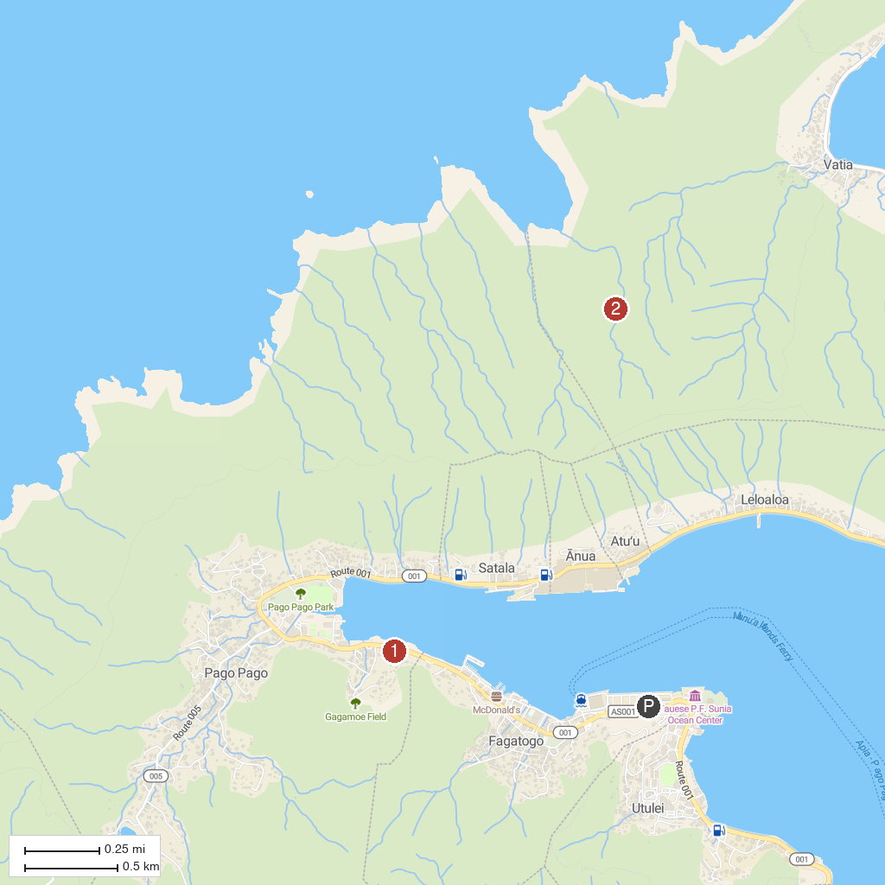
MAP KEY
1. National Park of American Samoa Visitor Center | 2. National Park of American Samoa
P. Cruise port / terminal
Map © MapTiler © OpenStreetMap contributors · cruiseports.org

