Paducah, Kentucky, USA
A UNESCO Creative City of Crafts & Folk Art, Paducah punches way above its size — world-class quilt art, life-sized history murals, and Southern cooking, all steps from the dock.
⚓ Pier (foot of Broadway) · 🕒 Typical call: 6–8 hrs · 💵 USD · 🗣️ English · 🎨 UNESCO Creative City
✍️ MY DAY IN PORT (FILL IN)
Ship / Date
In port | arrive ______ · all aboard ______
Booked excursion
Notes / meeting point
GETTING ASHORE
- Docking: Pier — riverboats tie up at the Paducah Riverfront levee; no tender required
- Walk to center: 2–5 min; floodwall murals are right at the gangway
- Best For: Arts & quilting lovers, history buffs, Southern food seekers
- Don't Miss: National Quilt Museum + the 50+ Robert Dafford floodwall murals
GETTING AROUND
- 🚕 Taxi: $8 min, $2/mile — Blue Dot Taxi ($8 min, $2/mile) serves the city; other local operators may vary. Useful if rideshare wait times are long
- 📱 Rideshare: ✅ Uber, Lyft
TOP THINGS TO DO
- National Quilt Museum — The world's premier quilt museum showcases stunning contemporary fiber art across three galleries.
- Floodwall Murals — Wall to Wall — Over 50 life-sized panoramic murals by artist Robert Dafford line the concrete floodwall right at the dock.
- LowerTown Arts District — A 25-block neighborhood of galleries, artist studios, Victorian homes, and cafes.
- River Discovery Center — Hands-on inland waterways museum in a historic 1843 brick building.
- Downtown Dining & Kirchhoff's Bakery — Kirchhoff's Bakery has been baking since 1873.
BEST WALKS
- Riverfront to Downtown Loop: 1.5 miles • ~45 min • Easy — Walk the floodwall murals along the levee, pass through the Broadway gate, stroll up to the…
- Broadway Historic Stroll: 0.75 miles • ~25 min • Easy — Head straight up Broadway from the dock through the floodwall gate into the heart of downtown…
WEATHER · DAYLIGHT · MONEY
Month | High °F | Low °F | Rainy days
May | 77 | 60 | 12
Jul | 89 | 72 | 11
Sep | 83 | 65 | 7
Daylight: May 5:46AM–7:55PM · Jul 5:46AM–8:13PM · Sep 6:37AM–7:01PM
cruiseports.org/paducah-ky · Confirm terminal & all-aboard time with your ship

Paducah, Kentucky, USA — Port Map
Red = walkable sights · Amber = excursions farther out · P = cruise terminal
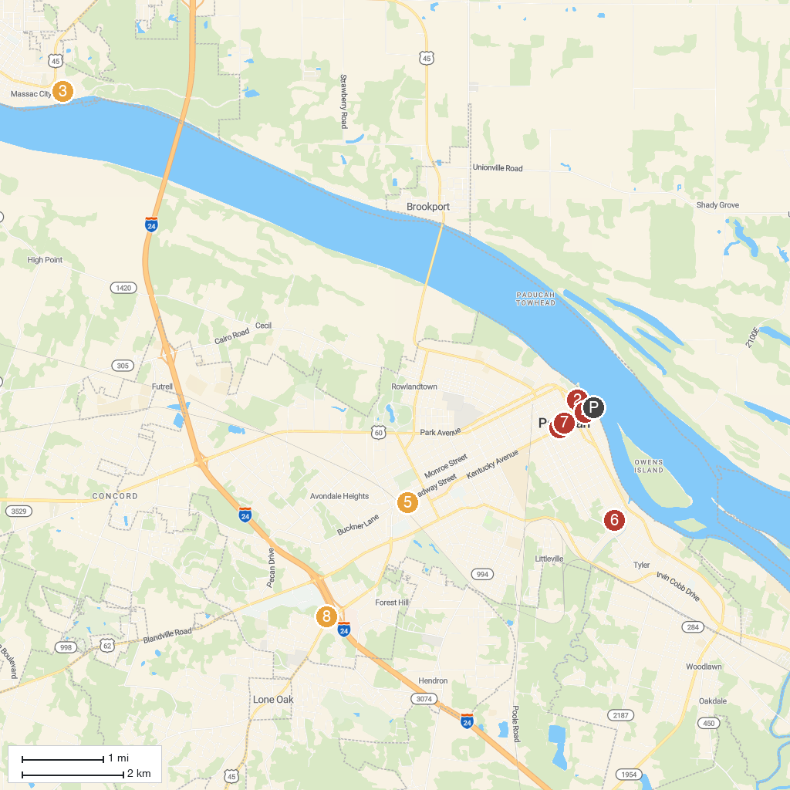
MAP KEY
1. Lloyd Tilghman House & Civil War Museum | 5. Keiler Park
2. The National Quilt Museum | 6. Kolb Park
3. Fort Massac State Park | 7. St Francis de Sales Catholic Church
4. William Clark Market House Museum | 8. Whitehaven Welcome Center
P. Cruise port / terminal
Map © MapTiler © OpenStreetMap contributors · cruiseports.org

