Padua, Veneto, Italy
One of Italy's oldest university cities, Padua packs Giotto's world-changing frescoes, a medieval market square, and one of Europe's largest piazzas into a compact, flat, and easily walkable historic center.
⚓ No deep-water pier — shore excursion or river cruise · 🕒 Typical call: 7-9 hrs · 💶 Euro (€) · 🗣️ Italian · 🚂 20 min by train from Venice Mestre
✍️ MY DAY IN PORT (FILL IN)
Ship / Date
In port | arrive ______ · all aboard ______
Booked excursion
Notes / meeting point
GETTING ASHORE
- Access: Shore excursion from Venice by train (20 min) or coach (40 min), or via Brenta Canal Burchiello boat
- Walk to center: 10-min walk or tram from Padua train station to Scrovegni Chapel; all major sights within 2.7 km
- Best For: Art history (Giotto's Scrovegni Chapel), student-city atmosphere, Prato della Valle, Venetian villas
- Don't Miss: Scrovegni Chapel (book weeks ahead), Caffè Pedrocchi, the twin market piazzas under Palazzo della Ragione
GETTING AROUND
- 🚕 Taxi: €5–12 — Taxis are metered with a base fare of €4–6.50 plus ~€1.10–1.50/km. Short rides within the center are inexpensive; call P
- 📱 Rideshare: ✅ Uber
- 🚌 Hop-on hop-off: ✅ City Sightseeing Padova
TOP THINGS TO DO
- Scrovegni Chapel — Giotto's Masterpiece — The Cappella degli Scrovegni contains Giotto's early-14th-century fresco cycle, considered the spark of the Renaissance.
- University of Padua & Anatomical Theater — Founded in 1222, Italy's second-oldest university.
- Basilica of Saint Anthony (Il Santo) — A grand multi-domed basilica blending Byzantine, Gothic, and Romanesque styles, housing the tomb of St.
- Orto Botanico — World's Oldest Academic Garden — Founded in 1545 and still in its original location, this UNESCO World Heritage garden features a striking circular walled design…
- Brenta Riviera Burchiello Cruise — The historic Il Burchiello boat links Venice and Padua along the Brenta Canal, stopping at magnificent Venetian villas including…
BEST WALKS
- Station to Prato della Valle — The Grand Loop: 2.7 km · ~35–40 min · Flat · All major sights — From Padua's train station, walk south past the Scrovegni Chapel, through the medieval market…
- Portello Dock to Historic Center: 1.5 km · ~20 min · Flat · For Brenta Canal arrivals — Arriving by Brenta Canal boat at the historic Portello dock? Walk west along the Piovego Canal and…
WEATHER · DAYLIGHT · MONEY
Month | High °F | Low °F | Rainy days
May | 72 | 55 | 15
Jul | 86 | 68 | 10
Sep | 77 | 60 | 10
Daylight: May 5:42AM–8:35PM · Jul 5:39AM–8:57PM · Sep 6:51AM–7:23PM
cruiseports.org/padua · Confirm terminal & all-aboard time with your ship

Padua, Veneto, Italy — Port Map
Red = walkable sights · Amber = excursions farther out · P = cruise terminal
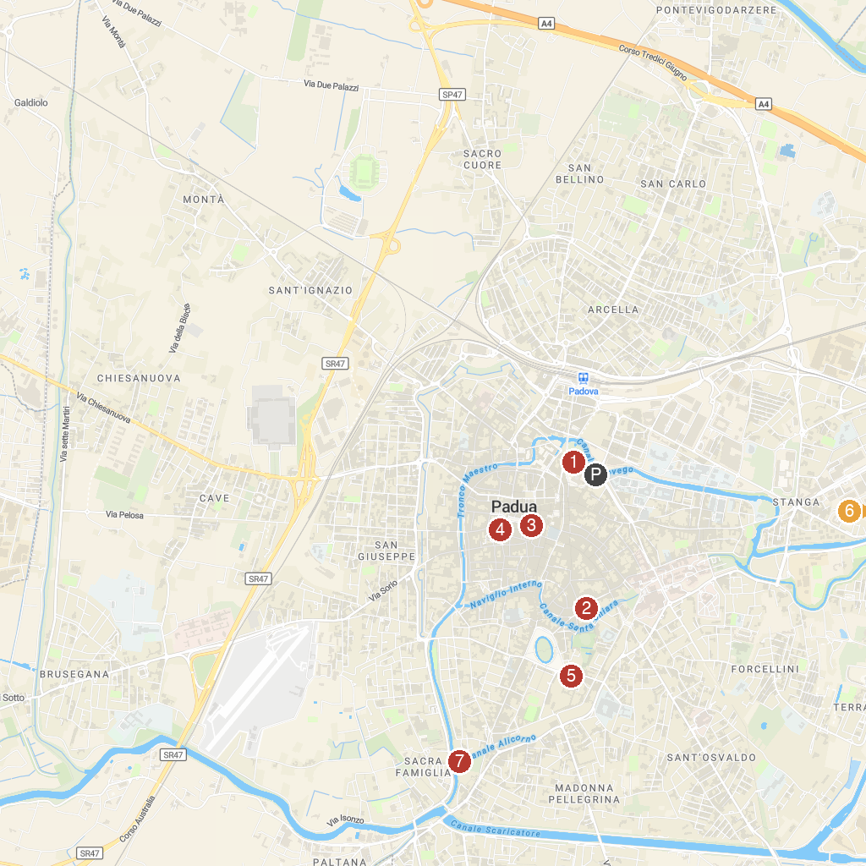
MAP KEY
1. Scrovegni Chapel | 5. Abbazia di Santa Giustina
2. The Basilica of St. Anthony | 6. Villa Pisani National Museum
3. Ragione Palace | 7. Bastione Alicorno
4. Arco Vallaresso
P. Cruise port / terminal
Map © MapTiler © OpenStreetMap contributors · cruiseports.org

