Padangbai, Bali, Indonesia
Skip the tourist crowds of South Bali — Padangbai drops you into authentic East Bali, where jukung fishing boats line white-sand coves and an 11th-century clifftop temple watches over it all.
⚓ Tender port · 🕒 Typical call: 7-9 hrs · 💵 Indonesian Rupiah (IDR) · 🗣️ Indonesian / Balinese · 🏖️ Beaches & snorkeling
✍️ MY DAY IN PORT (FILL IN)
Ship / Date
In port | arrive ______ · all aboard ______
Booked excursion
Notes / meeting point
GETTING ASHORE
- Docking: Tender — ships anchor in the bay; boats ferry you to the main jetty
- Walk to town: Steps from tender jetty; Blue Lagoon Beach 10–15 min on foot
- Best For: Snorkeling, East Bali day trips, temples, and fresh seafood
- Don't Miss: Blue Lagoon snorkeling, Pura Silayukti temple, and Tirta Gangga Water Palace
GETTING AROUND
- 🚕 Taxi: IDR 300,000–550,000 (~$18–$34) — Official port taxis wait at the pier and serve most Bali destinations. Fares are negotiated — agree on a price before yo
- 📱 Rideshare: ✅ Grab, Gojek
TOP THINGS TO DO
- Blue Lagoon Snorkeling — A 10-minute walk north over the hill reveals a sheltered white-sand cove with some of Bali's best accessible snorkeling…
- Tirta Gangga Water Palace — About 45 minutes by car, this former Karangasem royal palace is a maze of koi-filled pools, ornate stepping stones, and lush…
- Tenganan Bali Aga Village — One of Bali's last original pre-Hindu villages, Tenganan preserves ancient architecture and the rare double-ikat weaving…
- Klungkung Court of Justice — The Kertha Gosa pavilion at the historic Klungkung palace complex features stunning ceiling paintings depicting Balinese concepts…
- Bias Tugel (White Sand) Beach — A hidden cove 15–20 minutes on foot from the pier, protected by a rocky headland with softer sand and a calmer vibe than Blue…
BEST WALKS
- Town & Pura Silayukti Temple Walk: 30–45 min | Easy | Free — From the tender jetty, stroll along the main beach road past colorful jukung fishing boats, then…
- Blue Lagoon Beach Hike: 10–15 min each way | Moderate (hill) | Free — Head north from the jetty and follow the path up and over the hill to Blue Lagoon Beach.
WEATHER · DAYLIGHT · MONEY
Month | High °F | Low °F | Rainy days
May | 85 | 77 | 18
Jul | 82 | 74 | 19
Sep | 84 | 74 | 18
Daylight: May 6:22AM–6:05PM · Jul 6:34AM–6:13PM · Sep 6:11AM–6:14PM
cruiseports.org/padangbai · Confirm terminal & all-aboard time with your ship

Padangbai, Bali, Indonesia — Port Map
Red = walkable sights · Amber = excursions farther out · P = cruise terminal
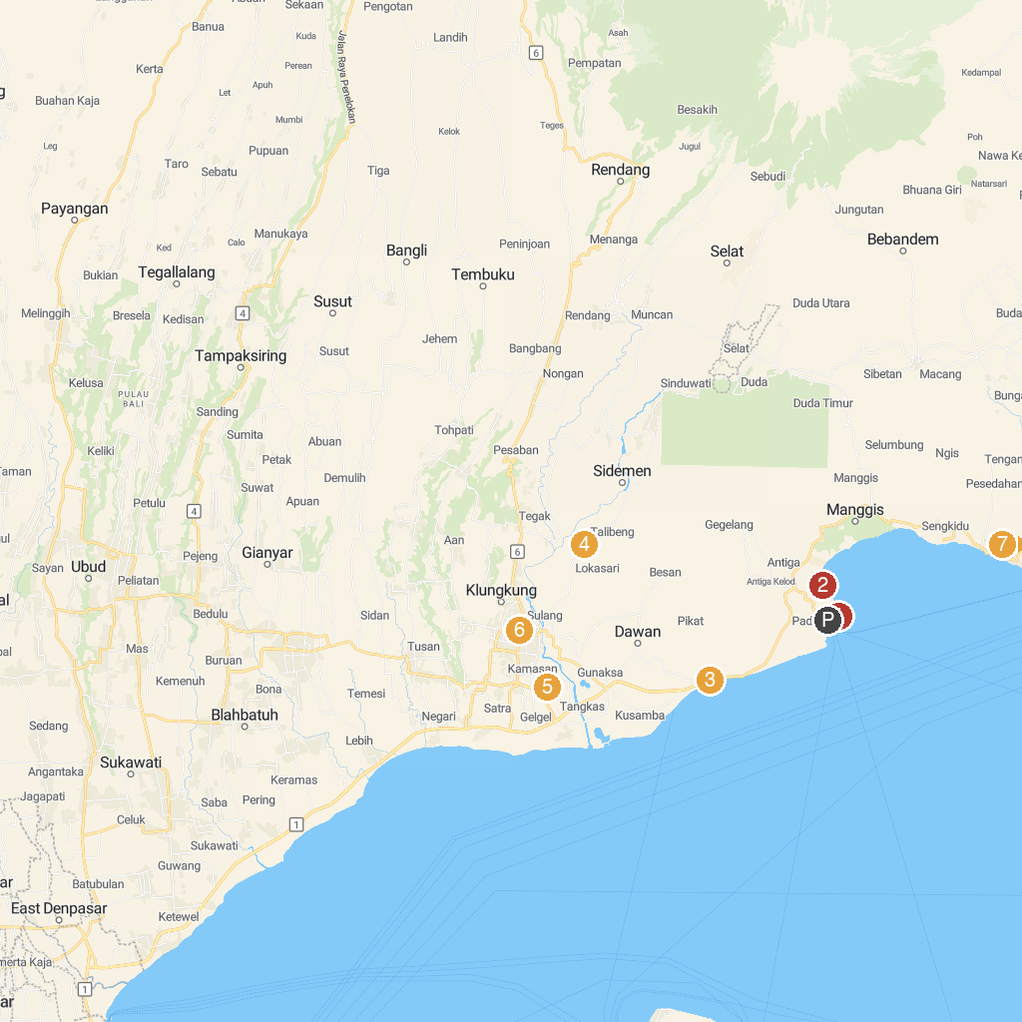
MAP KEY
1. Blue Lagoon Beach | 5. Wisata Tirta Srinadi
2. Ketut's Hideaway | 6. Puputan Klungkung monument
3. Goa Lawah Temple | 7. Bukit Asah Desa Bugbug
4. Bali Countryside Sidemen | 8. Kemoning Klungkung
P. Cruise port / terminal
Map © MapTiler © OpenStreetMap contributors · cruiseports.org

