Oxford, Maryland, USA
A 300-year-old maritime village where workboats still sail and you won't find a single chain store on the streets. Oxford moves at the pace of the tide — and that's exactly the point.
⚓ Docked (town wharf) · 🕒 Typical call: 6-8 hrs · 💵 US Dollar · 🗣️ English · 🚶 Very walkable
✍️ MY DAY IN PORT (FILL IN)
Ship / Date
In port | arrive ______ · all aboard ______
Booked excursion
Notes / meeting point
GETTING ASHORE
- Docking: Town wharf on Strand Road — most small ships dock directly; short walk to everything
- Walk to center: < 5 min from wharf to Market St and Oxford Museum
- Best For: History, cycling, Chesapeake seafood, slow-travel charm
- Don't Miss: Oxford-Bellevue Ferry (1683) and a cone at Scottish Highland Creamery
GETTING AROUND
- 📱 Rideshare: ✅ Uber
TOP THINGS TO DO
- Oxford-Bellevue Ferry Crossing — Hop aboard America's oldest continuously operating privately owned ferry, in service since 1683.
- Oxford Museum & Historic Walk — The Oxford Museum covers three centuries of maritime history with artifacts, photos, and colonial-era exhibits.
- Oxford–St. Michaels Bike Trail — One of the best cycling routes on the Mid-Atlantic coast — a flat 12-mile round trip (or one-way to St.
- Oxford Conservation Park — An 86-acre wetland park on the edge of town with walking and biking trails, viewing platforms, and excellent birding and wildlife…
- Chesapeake Seafood & Ice Cream — Oxford takes its food seriously.
BEST WALKS
- Town Center Stroll: 0.5 mi · 15 min · Easy — Walk from the Strand Road wharf along The Strand to Morris Street, past the Robert Morris Inn…
- Oxford Park & Shoreline Walk: 1 mi · 25 min · Easy — Head to Oxford Park on the Tred Avon waterfront for river views, a living shoreline, and picnic…
WEATHER · DAYLIGHT · MONEY
Month | High °F | Low °F | Rainy days
May | 72 | 59 | 12
Jul | 85 | 74 | 14
Sep | 78 | 67 | 10
Daylight: May 5:52AM–8:09PM · Jul 5:52AM–8:28PM · Sep 6:46AM–7:13PM
cruiseports.org/oxford-md · Confirm terminal & all-aboard time with your ship

Oxford, Maryland, USA — Port Map
Red = walkable sights · Amber = excursions farther out · P = cruise terminal
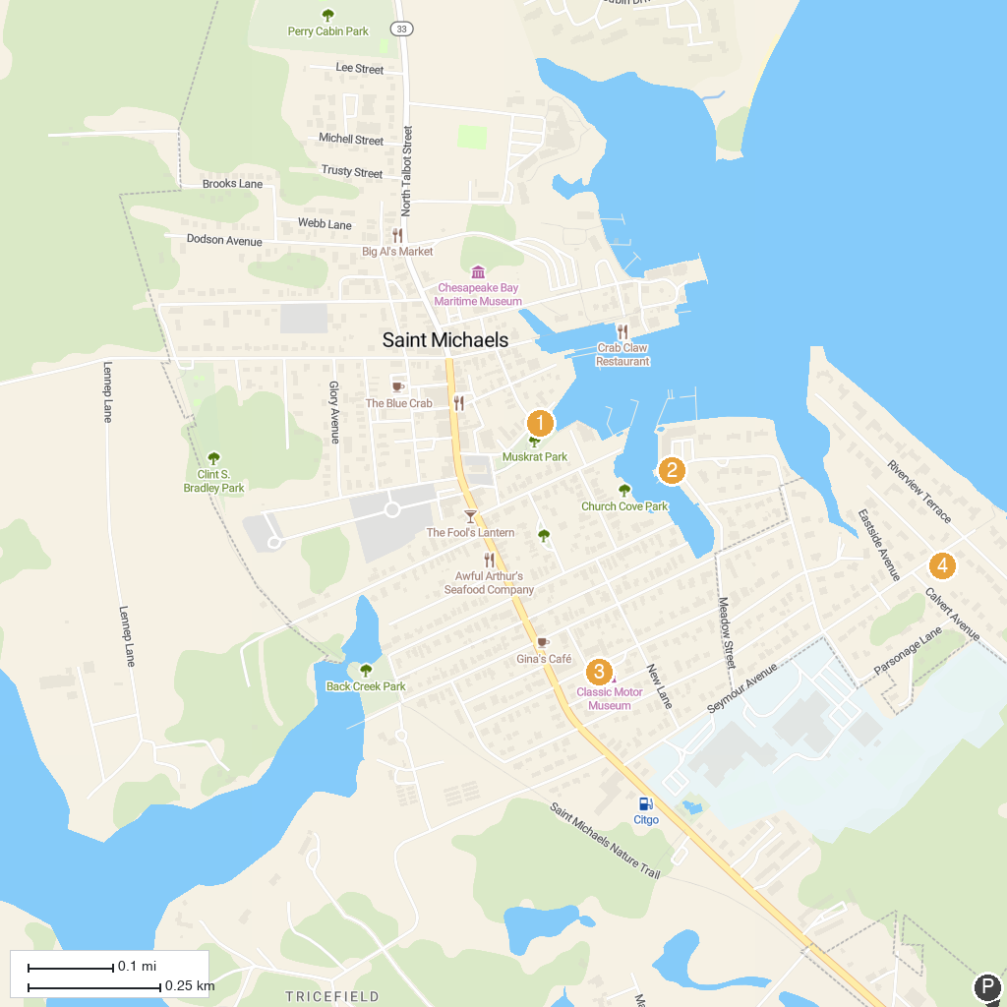
MAP KEY
1. Muskrat Park | 5. Bradley Park
2. Sail Selina II | 6. Academy Art Museum
3. Gerry Boyle Park at Great Marsh | 7. Waterfront Park on Miles River
4. Classic Motor Museum of St. Michaels
P. Cruise port / terminal
Map © MapTiler © OpenStreetMap contributors · cruiseports.org

