Oulu, Northern Ostrobothnia, Finland
Finland's cycling capital on the Gulf of Bothnia — flat, friendly, and refreshingly uncrowded. An industrial port gives way to a charming city of wooden islands, riverside parks, and exceptional Nordic food.
⚓ Pier (Oritkari Quay — shuttle required) · 🕒 Typical call: 6–8 hrs · 💶 Currency: Euro (cashless city) · 🗣️ Language: Finnish / English widely spoken · 🎭 European Capital of Culture 2026
✍️ MY DAY IN PORT (FILL IN)
Ship / Date
In port | arrive ______ · all aboard ______
Booked excursion
Notes / meeting point
GETTING ASHORE
- Docking: Pier at Oritkari Quay (~5 km from city center; walking not permitted from port)
- Walk to center: Shuttle or taxi only from port; city center itself is fully walkable
- Best For: Nordic culture, cycling, Finnish food, beaches, architecture
- Don't Miss: Market Hall reindeer soup, Pikisaari island, Toripolliisi statue
GETTING AROUND
- 🚕 Taxi: €15–€20 one way — Taxis wait at the pier; OTAXI is a major local operator. The ~5 km ride to the city center typically costs €15–20 depend
- 📱 Rideshare: ✅ Uber, Bolt
TOP THINGS TO DO
- Market Square & Market Hall — The heart of Oulu.
- Pikisaari Wooden Island — A 10-minute walk across a pedestrian bridge from Market Square brings you to Pikisaari, an island of colorful 18th-century timber…
- Hupisaaret City Park — A cluster of river islands connected by picturesque white wooden bridges in the Oulujoki delta.
- Nallikari Beach — Known as the 'Riviera of the North,' Nallikari is a broad stretch of fine white sand on the Bothnian Bay, about 3.5 km from city…
- Kierikki Stone Age Centre — About an hour northeast of Oulu in Yli-Ii, this archaeological park features a reconstructed Neolithic village where you can try…
BEST WALKS
- Market Square to Pikisaari Loop: 2 km · 30–45 min · Easy — Start at Oulu Market Square (Kauppatori), browse the Market Hall, then cross the pedestrian bridge…
- Hupisaaret Islands Park Walk: 3 km loop · 45–60 min · Easy — Head east from Market Square along the riverbank to Hupisaaret.
WEATHER · DAYLIGHT · MONEY
Month | High °F | Low °F | Rainy days
May | 53 | 38 | 11
Jul | 69 | 56 | 13
Sep | 56 | 46 | 12
Daylight: Sep 6:40AM–7:44PM
cruiseports.org/oulu · Confirm terminal & all-aboard time with your ship

Oulu, Northern Ostrobothnia, Finland — Port Map
Red = walkable sights · Amber = excursions farther out · P = cruise terminal
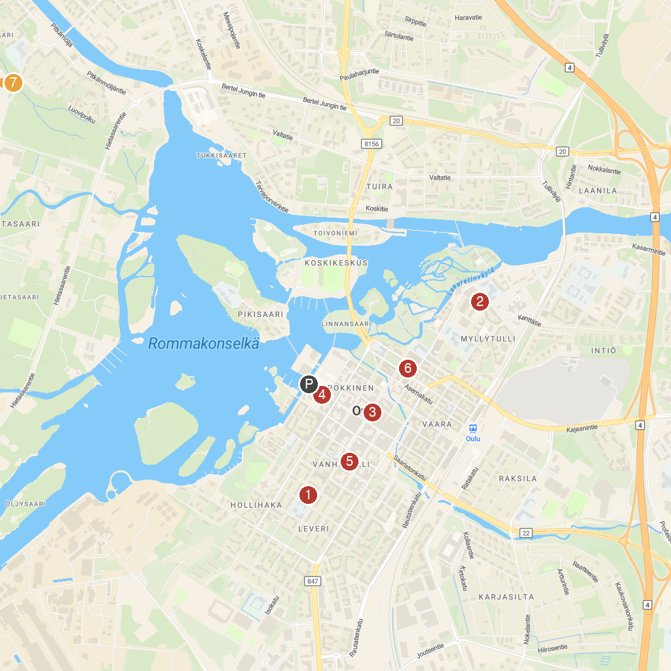
MAP KEY
1. Heinätorinpuisto park | 5. Mannerheim park
2. Tietomaa Science Centre | 6. Oulu Cathedral
3. Rotuaarin pallo | 7. Nallikari Beach
4. Oulu Market Hall
P. Cruise port / terminal
Map © MapTiler © OpenStreetMap contributors · cruiseports.org

