Ottawa, Illinois, USA
Where Lincoln and Douglas first squared off in 1858, Ottawa sits at the confluence of the Illinois and Fox Rivers — a compact Midwestern river town with surprisingly deep history and a dramatic state park just down the road.
⚓ Docked (riverside tie-up) · 🕒 Typical call: 6–8 hrs · 💵 USD · 🗣️ English · 🏞️ Gateway to Starved Rock
✍️ MY DAY IN PORT (FILL IN)
Ship / Date
In port | arrive ______ · all aboard ______
Booked excursion
Notes / meeting point
GETTING ASHORE
- Docking: Dockside tie-up at Allen Park or downtown seawall — no tender
- Walk to center: 5–15 min depending on berth; flat and easy
- Best For: American history, scenic river parks, craft beer, antique browsing
- Don't Miss: Washington Square Park Lincoln-Douglas debate monument
GETTING AROUND
- 🚕 Taxi: $8–$15 — Local cabs like City Cab (815-830-3389) and Affordable Rides (815-579-7944) serve the port area. City Cab operates 24/7;
- 📱 Rideshare: ✅ Uber, Lyft
TOP THINGS TO DO
- Washington Square & the Lincoln-Douglas Debate Site — The very spot where Abraham Lincoln and Stephen Douglas first debated in August 1858.
- Starved Rock State Park — Illinois' most-visited state park sits 15 minutes west of Ottawa.
- Ottawa Historical & Scouting Heritage Museum — Ottawa is the hometown of W.D.
- Ottawa Murals Walking Tour — Dozens of large-scale historic murals are painted across downtown buildings, depicting the canal era, indigenous history, and…
- Tangled Roots Brewing Co. & Downtown Dining — Tangled Roots is Ottawa's standout craft brewery — a sprawling farm-to-foam restaurant serving locally sourced Midwestern fare in…
BEST WALKS
- Downtown History Loop: 1.5 miles · 30–45 min · Easy — From the riverfront, walk up to Washington Square Park (Lincoln-Douglas monument), around to the…
- Riverside & Fox River Confluence: 1 mile · 20–30 min · Easy — Walk west along the Illinois River bank to the spot where the Fox River joins — a scenic overlook…
WEATHER · DAYLIGHT · MONEY
Month | High °F | Low °F | Rainy days
May | 73 | 51 | 12
Jul | 85 | 64 | 10
Sep | 76 | 54 | 9
Daylight: May 5:35AM–8:05PM · Jul 5:30AM–8:20PM · Sep 6:35AM–7:00PM
cruiseports.org/ottawa-il · Confirm terminal & all-aboard time with your ship

Ottawa, Illinois, USA — Port Map
Red = walkable sights · Amber = excursions farther out · P = cruise terminal
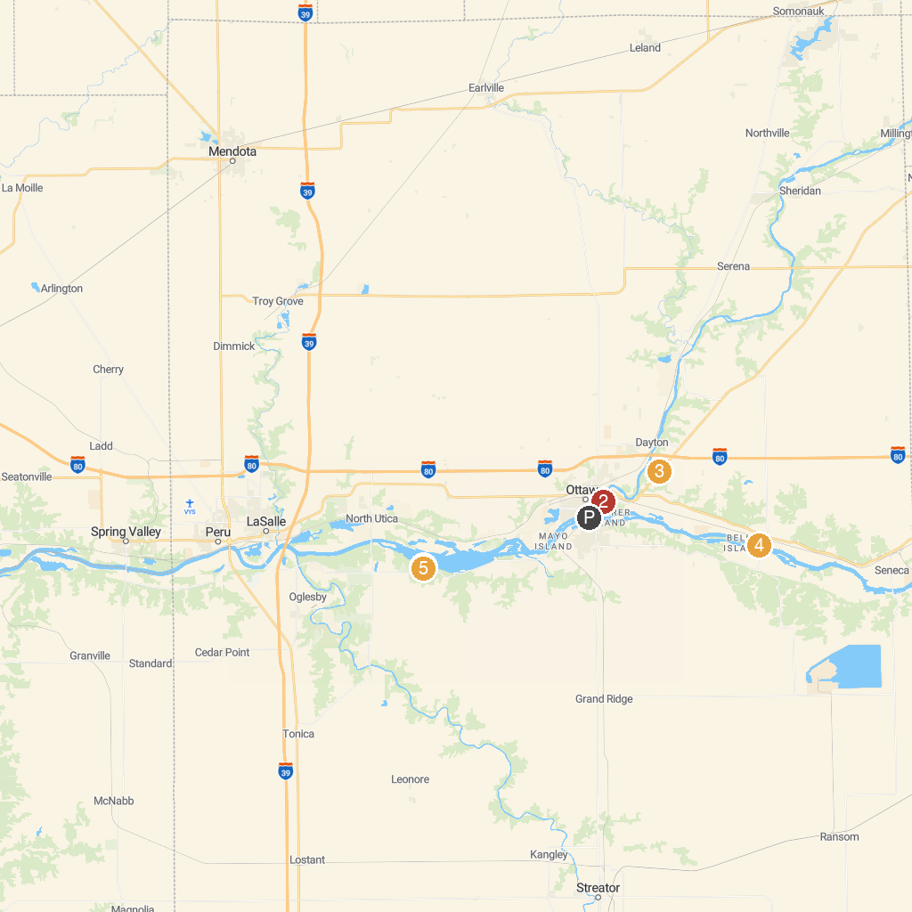
MAP KEY
1. Starved Rock State Park | 5. Middle East Conflicts Wall Memorial
2. Eagle Cliff Overlook | 6. LaSalle Canyon
3. Fox River Park | 7. Lover's Leap Overlook
4. Dayton Bluffs Preserve | 8. La Salle County Historical Society
P. Cruise port / terminal
Map © MapTiler © OpenStreetMap contributors · cruiseports.org

