Oslo, Norway
Norway's capital at the head of the Oslofjord — ships dock right in the city center, steps from a medieval fortress, a marble opera house you can walk on, and world-class polar museums.
⚓ Docked (city center) · 🕒 Often overnight call · 💵 Norwegian Krone (NOK) · 🗣️ Norwegian · English universal
✍️ MY DAY IN PORT (FILL IN)
Ship / Date
In port | arrive ______ · all aboard ______
Booked excursion
Notes / meeting point
GETTING ASHORE
- Docking: Filipstad / Vippetangen
- Walk to center: 5–30 min by pier
- Best For: Museums · Design · Fjord
- Don't Miss: Vigeland Park · Opera roof
GETTING AROUND
- 🚕 Taxi: 150–200 NOK (~–19) — Taxis are available at all terminals. Oslo cabs are metered and reliable but pricey — Filipstad to city center is a shor
- 📱 Rideshare: ✅ Uber, Bolt
- 🚌 Hop-on hop-off: ✅
TOP THINGS TO DO
- Vigeland Sculpture Park — The world's largest sculpture park by a single artist — 200+ bronze and granite figures by Gustav Vigeland, crowned by the…
- Oslo Opera House & Roof Walk — Climb the sloping Italian marble roof of the iconic Opera House and look out over the Oslofjord — one of Europe's great free…
- Bygdøy Museums (Fram, Kon-Tiki, Folk Museum) — Amundsen's polar vessel Fram, Heyerdahl's Kon-Tiki raft, and a 160-building open-air folk museum with a genuine medieval stave…
- Akershus Fortress — Medieval castle and royal chapel right at the cruise pier — 700 years of Norwegian history, a WWII Resistance Museum, and…
- Oslofjord Sightseeing Cruise — A relaxed 2-3 hour boat trip among the islands and summer cabins of the inner Oslofjord — a different angle on the city and its…
BEST WALKS
- Akershus to the Opera House: ~3 km · 1.5 hrs · flat — From medieval Akershus Fortress above the pier, walk along the harbour past City Hall and the…
- Karl Johans gate — the Royal Mile: ~2 km · 1 hr · easy — Oslo's grand main avenue from Central Station up to the Royal Palace, past the cathedral…
- Tjuvholmen & Astrup Fearnley: ~1.5 km · 45 min · easy — The stylish waterfront tip of Aker Brygge — contemporary art museum, a small harbour beach, and…
WEATHER · DAYLIGHT · MONEY
Month | High °F | Low °F | Rainy days
May | 60 | 44 | 12
Jul | 71 | 56 | 13
Sep | 61 | 50 | 11
Daylight: May 4:40AM–9:48PM · Jul 4:22AM–10:22PM · Sep 6:45AM–7:37PM
cruiseports.org/oslo · Confirm terminal & all-aboard time with your ship

Oslo, Norway — Port Map
Red = walkable sights · Amber = excursions farther out · P = cruise terminal
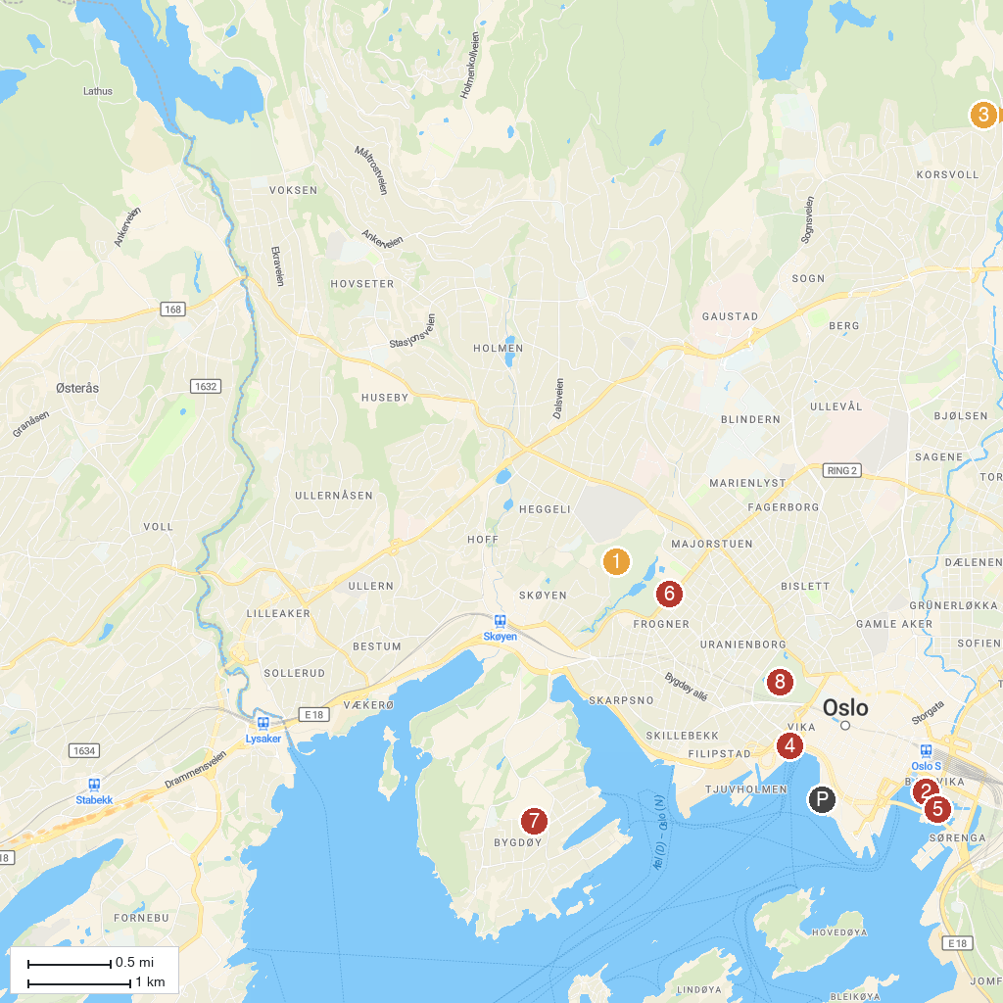
MAP KEY
1. Monolith | 5. Munch
2. Oslo Opera House | 6. Frogner Park
3. Norwegian Museum of Science and Technology | 7. Viking Ship Museum
4. National Museum | 8. The Royal Palace
P. Cruise port / terminal
Map © MapTiler © OpenStreetMap contributors · cruiseports.org

