Osijek, Slavonia, Croatia
Croatia's eastern gem on the Drava — where Baroque fortress streets meet paprika-spiced Slavonian kitchens and one of Europe's great wetland bird sanctuaries.
⚓ Pier (river dock) · 🕒 Typical call: 8-10 hrs · 💶 Euro (€) · 🗣️ Croatian (English widely spoken)
✍️ MY DAY IN PORT (FILL IN)
Ship / Date
In port | arrive ______ · all aboard ______
Booked excursion
Notes / meeting point
GETTING ASHORE
- Docking: Dedicated passenger pier on the Drava River promenade — no tender
- Walk to centre: 5–10 min to Gornji Grad; 15–20 min to Tvrđa fortress
- Best For: Baroque history, Slavonian food & wine, wetland wildlife (Kopački Rit)
- Don't Miss: Tvrđa (Baroque citadel), Kopački Rit Nature Park boat tour, Fiš Paprikaš stew
GETTING AROUND
- 🚕 Taxi: €4–€8 — Taxis are readily available at the port. A ride into the city center or to major attractions typically costs €4–€8 depen
- 📱 Rideshare: ✅ Uber, Bolt
TOP THINGS TO DO
- Tvrđa Baroque Citadel — The best-preserved ensemble of Habsburg Baroque architecture in Croatia.
- Kopački Rit Nature Park — One of Europe's largest river wetlands, just 15 minutes from the pier.
- Europska Avenija Architecture Walk — Osijek holds one of Southeast Europe's finest collections of Secessionist (Art Nouveau) palaces, built 1890–1910.
- Slavonian Food & Wine Tasting — Slavonia is Croatia's gastronomic heartland — sample EU-protected Kulen sausage, slow-cooked Čobanac stew, and world-class…
- Kompa Ferry & Copacabana River Beach — Cross the Drava on the Kompa — a hand-cranked cable ferry that uses only the river current.
BEST WALKS
- Promenade to Tvrđa: 2 km · 20 min · Easy — Head east from the pier along the Drava Promenade past the illuminated Pedestrian Bridge, then into…
- Upper Town Art Nouveau Circuit: 1.5 km · 20 min · Easy — Walk west from the pier to the Co-Cathedral of St.
WEATHER · DAYLIGHT · MONEY
Month | High °F | Low °F | Rainy days
May | 71 | 53 | 12
Jul | 84 | 65 | 8
Sep | 74 | 57 | 8
Daylight: May 5:14AM–8:09PM · Jul 5:11AM–8:30PM · Sep 6:23AM–6:55PM
cruiseports.org/osijek · Confirm terminal & all-aboard time with your ship

Osijek, Slavonia, Croatia — Port Map
Red = walkable sights · Amber = excursions farther out · P = cruise terminal
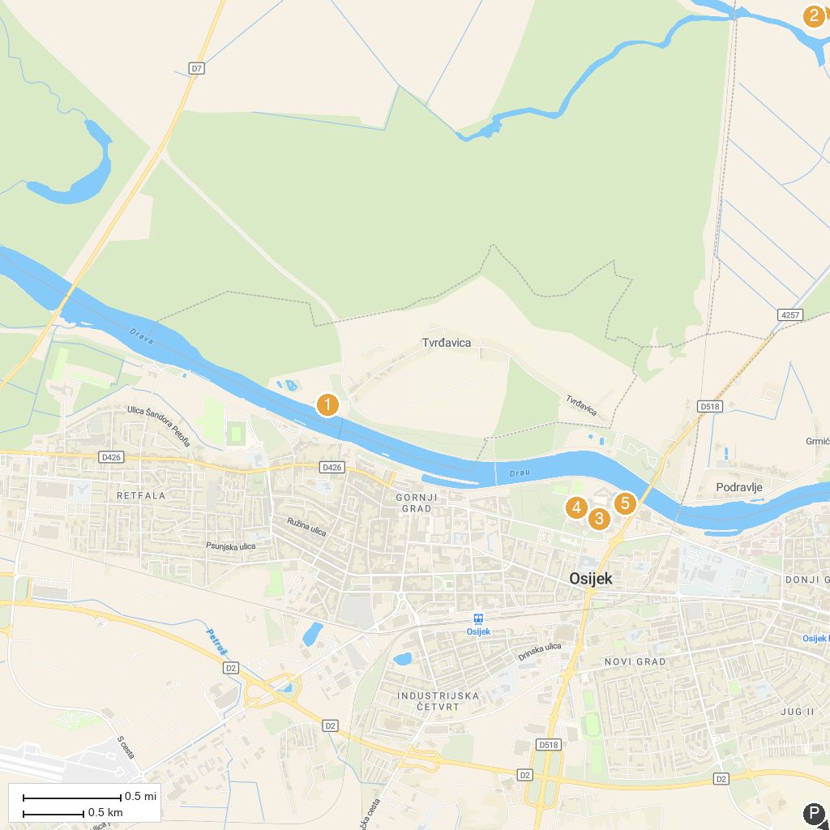
MAP KEY
1. Zoo Osijek | 4. Saint Michael’s Church
2. Kopački rit Nature Park | 5. Shell museum and Water World
3. Museum of Slavonia
P. Cruise port / terminal
Map © MapTiler © OpenStreetMap contributors · cruiseports.org

