Orsova, Mehedinti, Romania
Perched where the Cerna River meets the Danube, Orsova is the gateway to the Iron Gates — a spectacular gorge, a colossal king carved into cliff-face, and a town that rose from the waters when its predecessor was deliberately flooded.
⚓ Pier (docked) · 🕒 Typical call: 6-8 hrs · 💵 Romanian Leu (RON) · 🗣️ Romanian · 🏞️ River / Nature
✍️ MY DAY IN PORT (FILL IN)
Ship / Date
In port | arrive ______ · all aboard ______
Booked excursion
Notes / meeting point
GETTING ASHORE
- Docking: Direct quay on Cerna Gulf — no tender
- Walk to center: 5–10 min flat along the promenade
- Best For: Gorge boat tours, Decebalus rock carving, river history
- Don't Miss: Speedboat into the Cazanele Dunarii gorge
GETTING AROUND
- 🚕 Taxi: ₩20–40 RON (~–9 USD) — Local taxis operate in Orsova at standard Romanian rates (~3–4 RON/km). Fares within town are modest; agree on a price b
- 📱 Rideshare: ❌ not available
TOP THINGS TO DO
- Cazanele Dunarii Speedboat Tour — A thrilling ride into the 'Big and Small Cauldrons' — where the Danube narrows between sheer limestone cliffs to its deepest…
- Decebalus Rock Sculpture — At 55 metres, this is the tallest rock sculpture in Europe — a carving of the last Dacian king's face into the cliff above the…
- Mraconia Monastery — Often called 'the monastery under the water' — the original was submerged by the Iron Gates dam in 1970.
- Roman Catholic Church of Orsova — A striking piece of communist-era architecture (1972–76) — the only Catholic church permitted to be built in Romania under…
- St. Anne Monastery & Panorama — A wooden hilltop monastery on Mosului Hill with a breathtaking panoramic view of the Cerna Gulf, Orsova, and the Danube bending…
BEST WALKS
- Waterfront Promenade & Town Center: 30–45 min · Flat · Free — Walk the length of the Bulevardul 1 Decembrie 1918 waterfront, past cafes, the park with river…
WEATHER · DAYLIGHT · MONEY
Month | High °F | Low °F | Rainy days
May | 71 | 53 | 13
Jul | 84 | 65 | 7
Sep | 75 | 59 | 6
Daylight: May 6:02AM–8:51PM · Jul 5:59AM–9:12PM · Sep 7:09AM–7:40PM
cruiseports.org/orsova · Confirm terminal & all-aboard time with your ship

Orsova, Mehedinti, Romania — Port Map
Red = walkable sights · Amber = excursions farther out · P = cruise terminal
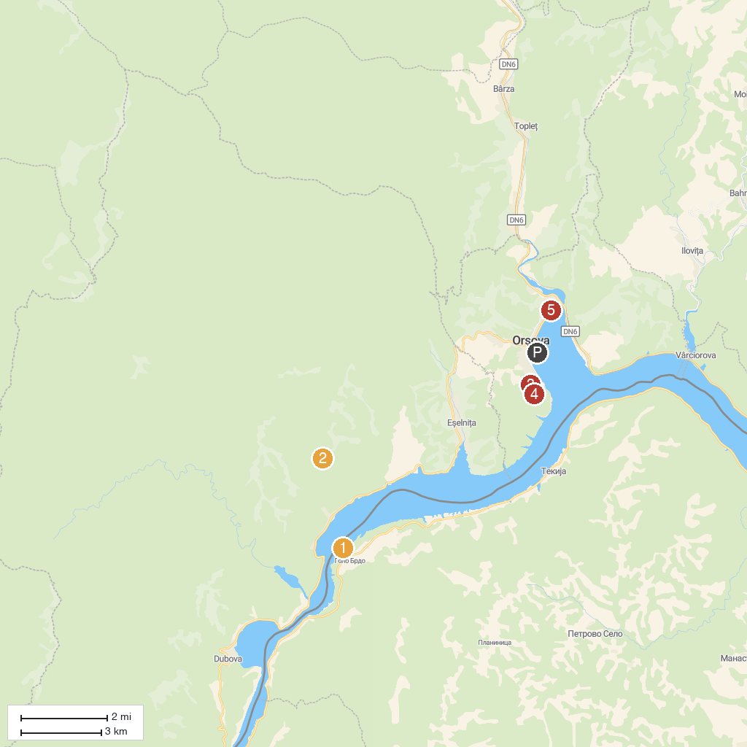
MAP KEY
1. Trajan's Plaque | 5. Iron Gates Natural Park
2. Rock Sculpture of Decebalus | 6. "Saint Ana" Monastery
3. Sfinxul Bănățean | 7. Visitor Center of Iron Gate Natural Park
4. Small Boilers | 8. Cazanele Dunarii - Plimbari cu barca | Agrement Orsova
P. Cruise port / terminal
Map © MapTiler © OpenStreetMap contributors · cruiseports.org

