Örnsköldsvik, Västernorrland, Sweden
Gateway to Sweden's High Coast UNESCO World Heritage site, Örnsköldsvik pairs a walkable harbor city with dramatic post-glacial gorges, island-hopping, and the birthplace of Fjällräven outdoor gear.
⚓ Pier (Stadskajen city quay) · 🕒 Typical call: 7-9 hrs · 💳 Cashless — cards everywhere (SEK) · 🗣️ Swedish (English widely spoken) · 🏔️ UNESCO World Heritage coast
✍️ MY DAY IN PORT (FILL IN)
Ship / Date
In port | arrive ______ · all aboard ______
Booked excursion
Notes / meeting point
GETTING ASHORE
- Docking: Pier — Stadskajen city quay, central harbor
- Walk to center: 5 min on foot from quay to main street
- Best For: High Coast hiking, archipelago tours, outdoor gear shopping
- Don't Miss: Skuleskogen National Park gorge (Slåttdalsskrevan)
GETTING AROUND
- 🚕 Taxi: ~100–200 SEK (~$10–$20) — Local taxis (Min Taxi, Sverigetaxi, Star Cab) operate in Örnsköldsvik. Short city rides are inexpensive; book by phone o
- 📱 Rideshare: ❌ not available
TOP THINGS TO DO
- Skuleskogen National Park & Slåttdalsskrevan Gorge — The crown jewel of the High Coast — hike through ancient spruce forest to the Slåttdalsskrevan, a 200-meter-long, 40-meter-deep…
- Skuleberget Mountain — Cable Car & Summit Views — Ride the cable car to the summit of Skuleberget for sweeping views over the Gulf of Bothnia and the island-dotted High Coast.
- Archipelago Island Cruise — Ulvön & Trysunda — Boat trips into Örnsköldsvik's outer archipelago visit Ulvön, historically Northern Sweden's biggest fishing community, and…
- Örnsköldsvik Museum & Art Centre — Explore the city's local history — from Viking-era settlements to the industrial rise of the High Coast — plus rotating…
- Surströmming Museum & Skeppsmalen Fishing Village — Visit the world's only museum dedicated to surströmming (fermented Baltic herring) in a traditional boathouse village on the High…
BEST WALKS
- City Center Waterfront & Paradiskullen Viewpoint: 2.5 km loop | Easy | ~1 hr — Walk the harbor promenade, browse the pedestrian shopping street (Centrumgatan), then climb…
- Varvsberget Hill Walk: 3 km loop | Easy-moderate | ~1.5 hrs — Head up Varvsberget for forest trails and elevated views over the Gulf of Bothnia.
WEATHER · DAYLIGHT · MONEY
Month | High °F | Low °F | Rainy days
May | 54 | 38 | 11
Jul | 69 | 54 | 12
Sep | 57 | 46 | 12
Daylight: May 3:39AM–9:45PM · Sep 6:09AM–7:09PM
cruiseports.org/ornskoldsvik · Confirm terminal & all-aboard time with your ship

Örnsköldsvik, Västernorrland, Sweden — Port Map
Red = walkable sights · Amber = excursions farther out · P = cruise terminal
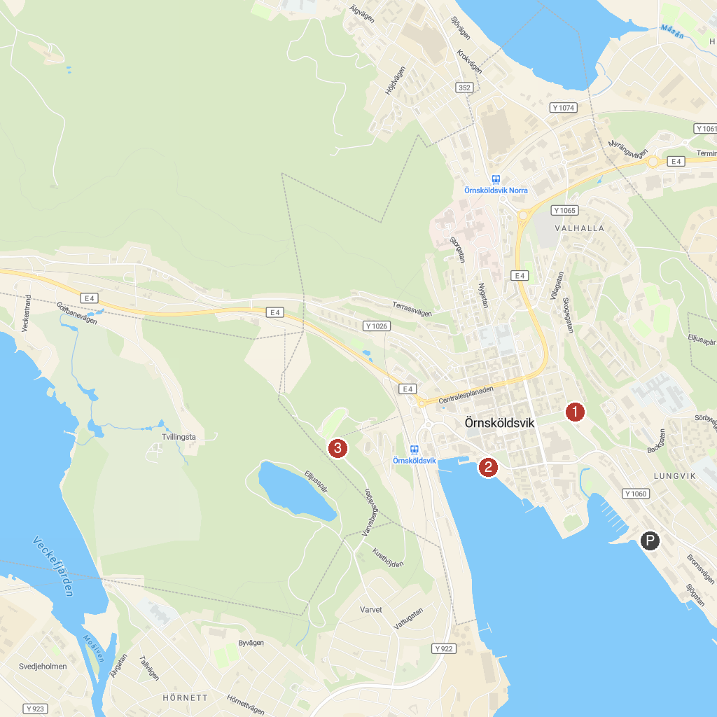
MAP KEY
1. Örnsköldsviks museum och konsthall | 3. Hamnkranarna
2. Nätra historical homestead | 4. Varvsberget
P. Cruise port / terminal
Map © MapTiler © OpenStreetMap contributors · cruiseports.org

