Oranjestad, Aruba
Aruba's capital docks you steps from downtown — pastel Dutch architecture, warm turquoise water, and perpetual sunshine just steps off the gangway. One Happy Island lives up to its nickname.
⚓ Docked (pier) · 🕒 Typical call: 8-10 hrs · 💵 USD widely accepted / Aruban florin · 🗣️ Dutch & Papiamento (English everywhere)
✍️ MY DAY IN PORT (FILL IN)
Ship / Date
In port | arrive ______ · all aboard ______
Booked excursion
Notes / meeting point
GETTING ASHORE
- Docking: Berthed at Oranjestad Cruise Terminal — 5 berths, no tender needed
- Walk to center: 2–5 min to Lloyd G. Smith Blvd; downtown is right outside the gates
- Best For: Beaches, snorkeling, duty-free shopping, island 4x4 tours
- Don't Miss: Eagle Beach, Antilla shipwreck dive, Arikok National Park
GETTING AROUND
- 🚕 Taxi: $10–34 USD — Government-regulated fixed fares; no meters. Minimum fare is $10 USD. Taxis line up at the cruise terminal — useful for
- 📱 Rideshare: ❌ not available
TOP THINGS TO DO
- Eagle Beach Day — Consistently ranked among the best beaches in the Caribbean — wide, white, calm water, and far less crowded than Palm Beach.
- Arikok National Park 4x4 Tour — Covers nearly 20% of the island — rugged limestone terrain, natural pools, ancient Caquetio cave paintings, and the Natural…
- Antilla Shipwreck Snorkel or Dive — The Antilla is one of the largest shipwrecks in the Caribbean — a 400-ft German freighter scuttled in 1940, now home to enormous…
- Atlantis Submarine Expedition — Descend 45-100 ft in a real submarine for a narrated tour of Aruba's reefs and wrecks — no dive certification needed…
- Oranjestad Tram & Town Walk — Ride the free streetcar through pastel Dutch colonial architecture, browse Havenstraat and Schelpstraat boutiques, and stop at…
BEST WALKS
- Downtown Oranjestad Stroll: 1.5 km · 30-45 min · Flat — Exit the cruise terminal onto Lloyd G.
- Surfside Beach Walk: 1.5 km one-way · 20 min walk · Easy — Head northwest along the waterfront from the port past the bus terminal toward Surfside Beach — the…
- Oranjestad Waterfront & Historic Downtown: 1.5 km · 30-45 min · Easy — Start at the cruise terminal and walk along L.G.
WEATHER · DAYLIGHT · MONEY
Month | High °F | Low °F | Rainy days
May | 85 | 79 | 5
Jul | 85 | 80 | 10
Sep | 88 | 81 | 9
Daylight: May 6:15AM–6:57PM · Jul 6:22AM–7:09PM · Sep 6:29AM–6:40PM
cruiseports.org/oranjestad-aruba · Confirm terminal & all-aboard time with your ship

Oranjestad, Aruba — Port Map
Red = walkable sights · Amber = excursions farther out · P = cruise terminal
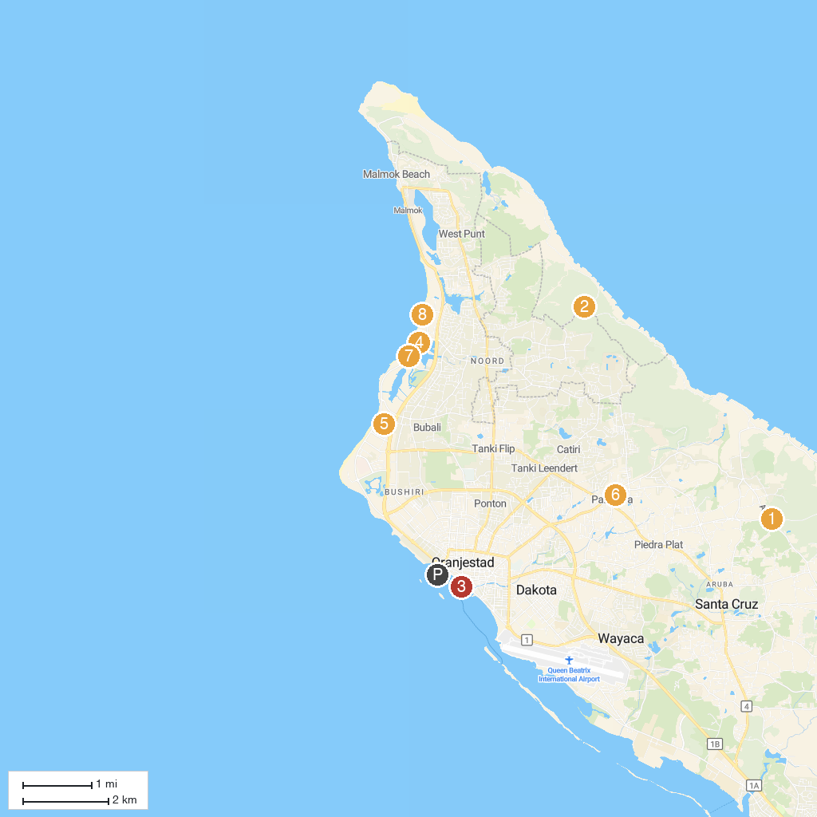
MAP KEY
1. Ayo Rock Formations | 5. Glitz Casino
2. Alto Vista Chapel | 6. Saint Philomena Catholic Parish
3. Seaport Casino | 7. Orchid Casino
4. The Casino Aruba at Hilton | 8. Octopus Aruba Sailing, Snorkeling, Sunset & Private Tours
P. Cruise port / terminal
Map © MapTiler © OpenStreetMap contributors · cruiseports.org

