Opatija, Kvarner, Croatia
Called the 'Nice of the Adriatic,' Opatija trades medieval stone for grand pastel villas, botanical parks, and a flat seafront promenade that drops you straight into a living Austro-Hungarian postcard.
⚓ Tender (most ships) · 🕒 Typical call: 6-8 hrs · 💶 Euro (€) · 🗣️ Croatian / English widely spoken
✍️ MY DAY IN PORT (FILL IN)
Ship / Date
In port | arrive ______ · all aboard ______
Booked excursion
Notes / meeting point
GETTING ASHORE
- Docking: Tender — ships anchor offshore; small ships may dock at Opatija pier
- Walk to center: 0 min — tender pier lands on the Lungomare promenade
- Best For: Scenic strolls, Habsburg architecture, fresh Kvarner scampi
- Don't Miss: Maiden with the Seagull statue & Angiolina Botanical Park
GETTING AROUND
- 🚕 Taxi: €4–8 (short rides within town) — Local taxis start at €4.00 with a rate of €1.60/km during the day. For destinations outside central Opatija, starting fe
- 📱 Rideshare: ✅ Uber, Bolt
TOP THINGS TO DO
- Lungomare Promenade Walk — Stroll the 12 km Franz Joseph I seafront promenade — or just the classic stretch from the tender pier to the fishing village of…
- Angiolina Park & Villa Angiolina — The botanical park that launched Opatija's tourism era in 1844.
- Volosko Fishing Village — A 30-minute flat walk north along the Lungomare brings you to Volosko, a tiny, photogenic harbor village with Croatia's finest…
- Mošćenice Hilltop Village — A fortified medieval village perched above the sea, about 30 minutes by taxi.
- Učka Nature Park & Vojak Summit — Mount Učka rises dramatically directly behind Opatija.
BEST WALKS
- Tender Pier to Volosko via Lungomare: 3 km one-way · ~45 min · Flat · Iconic — Head north from the Mul harbor pier along the paved Lungomare promenade.
- Town Center & Maiden with the Seagull Loop: 1.5 km · ~25 min · Flat · Landmarks — Head south from the pier along the Lungomare to the iconic Maiden with the Seagull statue on its…
WEATHER · DAYLIGHT · MONEY
Month | High °F | Low °F | Rainy days
May | 69 | 56 | 14
Jul | 83 | 68 | 10
Sep | 74 | 61 | 11
Daylight: May 5:32AM–8:26PM · Jul 5:29AM–8:47PM · Sep 6:41AM–7:13PM
cruiseports.org/opatija · Confirm terminal & all-aboard time with your ship

Opatija, Kvarner, Croatia — Port Map
Red = walkable sights · Amber = excursions farther out · P = cruise terminal
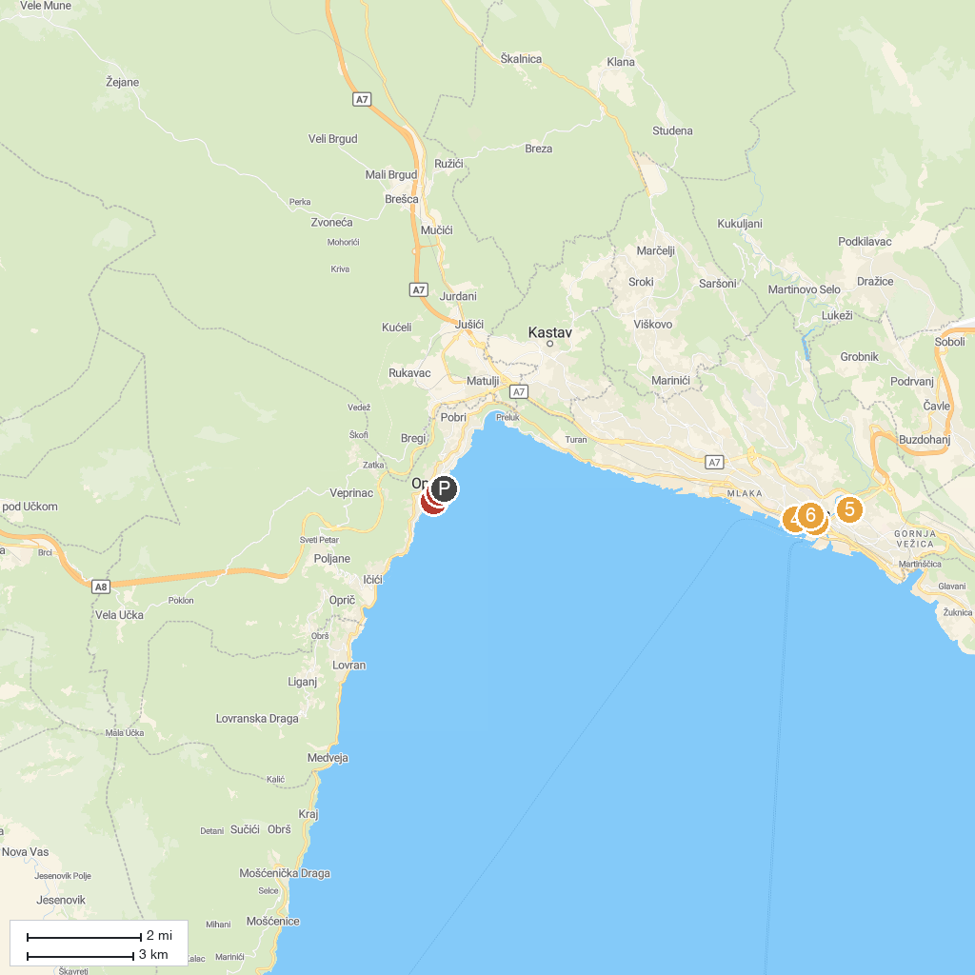
MAP KEY
1. Maiden with the Seagull | 4. Church of Our Lady of Lourdes
2. Croatian Museum of Tourism | 5. Shrine of Mary of God of Trsat
3. Saint Vitus’ Cathedral | 6. Maritime and History Museum of the Croatian Coast
P. Cruise port / terminal
Map © MapTiler © OpenStreetMap contributors · cruiseports.org

