Omiš, Split-Dalmatia, Croatia
Where the emerald Cetina River carves through towering karst cliffs to meet the Adriatic, Omiš packs centuries of pirate lore, cliffside fortresses, and rare sandy beaches into one compact, walkable port of call.
⚓ Tender (small ships may dock at quay) · 🕒 Typical call: 6–8 hrs · 💶 Currency: Euro (€) · 🗣️ Language: Croatian (English widely spoken) · 🏖️ Sandy beach 5 min walk
✍️ MY DAY IN PORT (FILL IN)
Ship / Date
In port | arrive ______ · all aboard ______
Booked excursion
Notes / meeting point
GETTING ASHORE
- Docking: Tender for larger ships; small coastal cruisers dock at town quay
- Walk to center: Steps off the tender — you land in the Old Town
- Best For: Adventure, history, canyon boat rides, beach
- Don't Miss: Mirabella Fortress views and a slice of soparnik at the market
GETTING AROUND
- 🚕 Taxi: €3–€5 (local), €30–€40 to Split — Local taxis are available near the port with a base fare of ~€3.32 and ~€1.86/km. A transfer to Split (~25 km) typically
- 📱 Rideshare: ✅ Uber
TOP THINGS TO DO
- Cetina Canyon Zipline — Eight steel cables stretch across the canyon 150 m above the river — one of the best ziplines in Europe.
- Cetina River Canyon Boat Ride — Open wooden boats depart from the bridge and cruise upriver through the dramatic karst canyon to Radmanove Mlinice (Radman's…
- Mirabella Fortress Climb — A 13th-century Romanesque pirate lookout perched on the cliff directly above the Old Town.
- Starigrad Fortress Hike — The high fortress at 311 m above sea level requires a serious 45–60 min uphill hike on a rocky mountain path.
- Velika Plaža — Sandy Beach Day — Unusually for Croatia, Omiš has a genuine sandy beach — sediment brought down by the Cetina.
BEST WALKS
- Old Town & Mirabella Fortress Loop: 2–3 hrs · Moderate (steep climb to fortress) · ~2 km — Start on the Riva waterfront, explore the stone-paved alleys of the Old Town, then follow signs up…
- Riva to Velika Plaža (Sandy Beach): 10–15 min walk each way · Easy · ~700 m — Head south from the tender pier along the coastal promenade past the mouth of the Cetina River to…
WEATHER · DAYLIGHT · MONEY
Month | High °F | Low °F | Rainy days
May | 72 | 58 | 12
Jul | 87 | 71 | 4
Sep | 78 | 64 | 9
Daylight: May 5:28AM–8:10PM · Jul 5:26AM–8:31PM · Sep 6:33AM–7:03PM
cruiseports.org/omis · Confirm terminal & all-aboard time with your ship

Omiš, Split-Dalmatia, Croatia — Port Map
Red = walkable sights · Amber = excursions farther out · P = cruise terminal
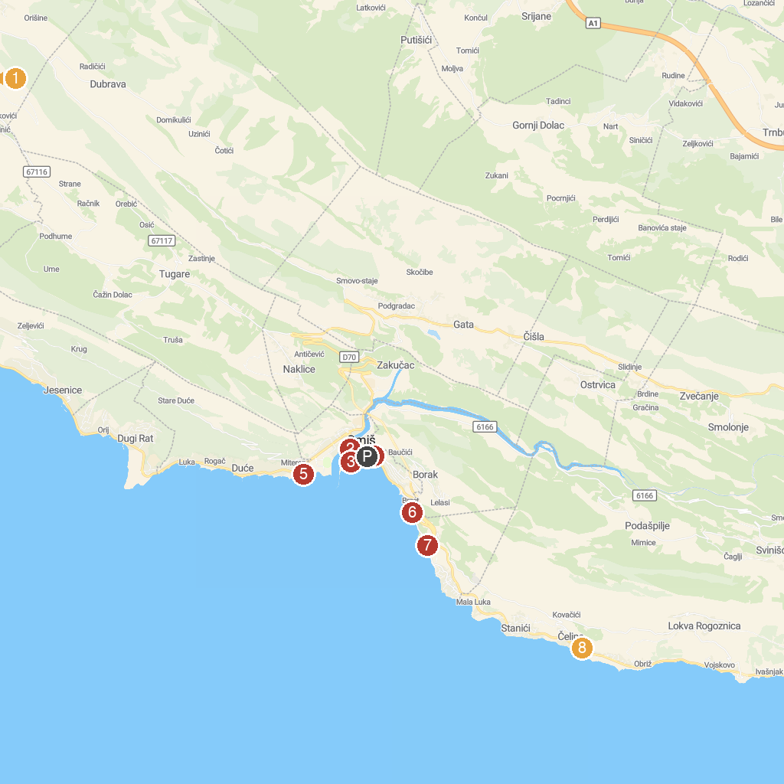
MAP KEY
1. Starry village Mosor | 5. Plaža Galeb
2. Croatia Rafting | 6. Plaža Brzet
3. Velika plaža | 7. Plaža Ravnice
4. Old cemetery Omiš | 8. Apartments villa Mira / Omis
P. Cruise port / terminal
Map © MapTiler © OpenStreetMap contributors · cruiseports.org

