Omaezaki, Shizuoka, Japan
At the windswept tip of the Shizuoka coast, Omaezaki blends a lighthouse built by British hands, sea-turtle nesting beaches, and some of Japan's finest green tea fields — all with the chance of a snow-capped Fuji on the horizon.
⚓ Pier (West Wharf) · 🕒 Typical call: 7-9 hrs · 💴 JPY (cash preferred) · 🗣️ Japanese
✍️ MY DAY IN PORT (FILL IN)
Ship / Date
In port | arrive ______ · all aboard ______
Booked excursion
Notes / meeting point
GETTING ASHORE
- Docking: Pier — West Wharf 1 or 2; shuttle required (no walk-out)
- Walk to Center: Not permitted on foot; free shuttle to Nabura Market (~5 min)
- Best For: Lighthouse climb, fresh seafood, green tea countryside
- Don't Miss: Katsuo no tataki at Sea-side Marina Nabura
GETTING AROUND
- 🚕 Taxi: ¥2,000–¥3,000 one-way — Taxis queue outside the terminal on port days and reach the city center in about 20 minutes. Carry cash — card readers a
- 📱 Rideshare: ❌ not available
TOP THINGS TO DO
- Omaezaki Lighthouse Climb — Built in 1874 by British engineer Richard Henry Brunton, this working lighthouse is one of the few in Japan open for climbing.
- Seafood at Sea-side Marina Nabura — The local fish market hub is a short shuttle hop from the pier.
- Kakegawa Castle Day Trip — About 45 minutes inland, Kakegawa Castle is one of Japan's authentically reconstructed wooden castles (rebuilt 1994 using…
- Makinohara Green Tea Plantations — Shizuoka produces roughly 40% of Japan's green tea, and the Makinohara plateau is its epicenter — rolling fields of vivid green…
- Loggerhead Sea Turtle Nesting Beaches — Omaezaki's beaches are a designated National Natural Monument for endangered loggerhead sea turtle nesting (May–August).
BEST WALKS
- Cape Promenade to the Lighthouse: 1.5 km · Easy–Moderate · 30-40 min one way — From the Nabura Market shuttle stop, follow the coastal path southwest along the cape toward the…
- Nabura Market & Coastal Stroll: ~1 km · Easy · 20-30 min — A relaxed loop around the Nabura Market seafood area and the adjacent Marine Park.
WEATHER · DAYLIGHT · MONEY
Month | High °F | Low °F | Rainy days
May | 71 | 61 | 11
Jul | 81 | 75 | 17
Sep | 80 | 73 | 18
Daylight: May 4:44AM–6:42PM · Jul 4:45AM–7:00PM · Sep 5:30AM–5:54PM
cruiseports.org/omaezaki · Confirm terminal & all-aboard time with your ship

Omaezaki, Shizuoka, Japan — Port Map
Red = walkable sights · Amber = excursions farther out · P = cruise terminal
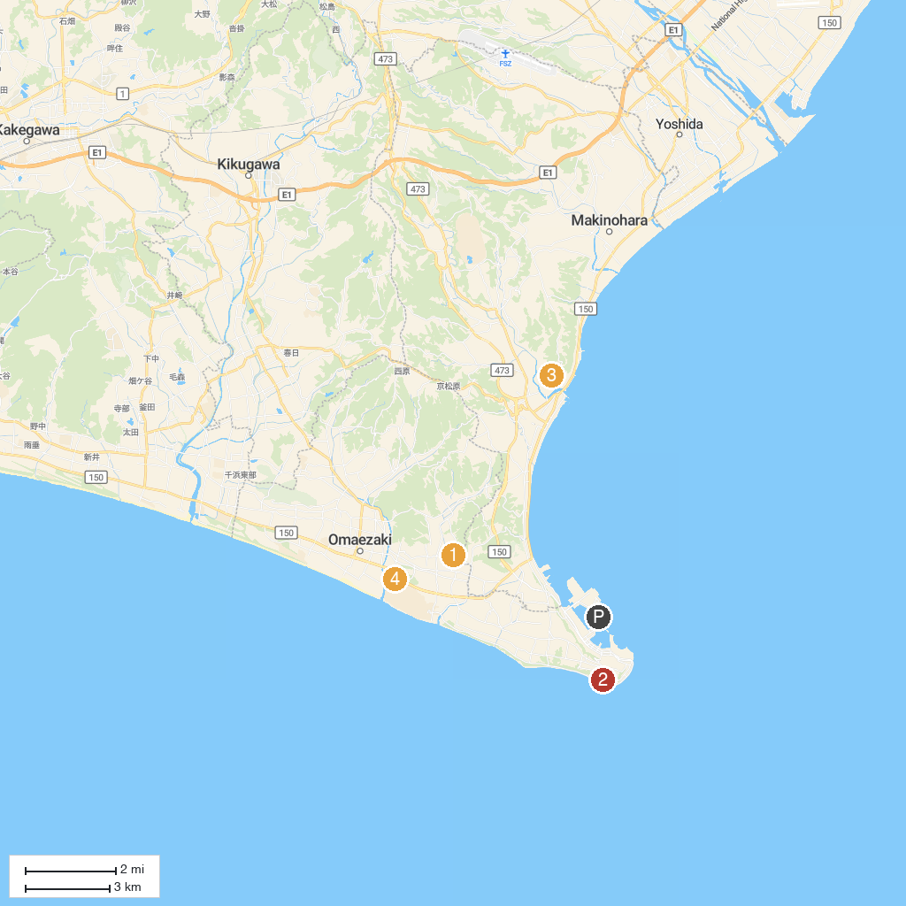
MAP KEY
1. Osagawa Fureai Park | 5. Eifukuji
2. 大鐘家 | 6. 相良梅園
3. Nezumi-zuka | 7. 東光寺の長藤
4. Heidenji | 8. Hamaoka Nuclear Power Museum
P. Cruise port / terminal
Map © MapTiler © OpenStreetMap contributors · cruiseports.org

