Oldenburg, Lower Saxony, Germany
A well-preserved university city of grand ducal palaces and bicycle-filled lanes, Oldenburg rewards river cruisers with a walkable old town that most tourists skip entirely.
⚓ River port — docked at Stadthafen quay · 🕒 Typical call: 6–9 hrs · 💶 Currency: Euro (€) · 🗣️ Language: German (English widely understood) · 🚲 Bike city — watch the cycle lanes
✍️ MY DAY IN PORT (FILL IN)
Ship / Date
In port | arrive ______ · all aboard ______
Booked excursion
Notes / meeting point
GETTING ASHORE
- Docking: River cruise ships dock directly at Stadthafen on the Hunte — no tender
- Walk to centre: ~10–15 min (800 m) from Stadthafen to the Schloss and Altstadt
- Best For: History, culture, pedestrian old town, palace gardens
- Don't Miss: Schloss Oldenburg palace, St. Lamberti Church's surprise interior, the Schlossgarten rhododendrons
GETTING AROUND
- 🚕 Taxi: ~€5–10 — Local taxis are readily available; operators include Hunte-Taxi (0441-251 25), City Taxi Oldenburg, and Zentral Taxi. St
- 📱 Rideshare: ✅ Uber, Bolt
TOP THINGS TO DO
- Schloss Oldenburg & State Museum — The yellow-and-white Renaissance-Baroque palace that was home to the Grand Dukes of Oldenburg now houses the State Museum for Art…
- St. Lamberti Church Surprise — From outside it looks like a standard brick Neo-Gothic church.
- Schlossgarten Stroll — The ~16-hectare English landscape garden behind the Schloss is one of Lower Saxony's finest green spaces.
- Landesmuseum Natur und Mensch — Nationally important museum covering the archaeology and natural history of northwestern Germany, with permanent galleries on the…
- Kale Capital Culinary Walk — Oldenburg is Germany's self-proclaimed kale capital.
BEST WALKS
- Stadthafen to Palace Loop: 2.5 km · 45–60 min · Flat — From the dock, walk along the Hunte waterfront to the Altstadt, past the Lappan tower and St.
- Pedestrian Zone & Wallstraße: 1.5 km · 30 min (plus café stops) · Flat — Stroll the main pedestrian zone — one of Germany's oldest — browsing boutique shops and cafés, then…
WEATHER · DAYLIGHT · MONEY
Month | High °F | Low °F | Rainy days
May | 63 | 47 | 12
Jul | 72 | 58 | 15
Sep | 67 | 53 | 11
Daylight: May 5:28AM–9:19PM · Jul 5:19AM–9:45PM · Sep 7:01AM–7:42PM
cruiseports.org/oldenburg · Confirm terminal & all-aboard time with your ship

Oldenburg, Lower Saxony, Germany — Port Map
Red = walkable sights · Amber = excursions farther out · P = cruise terminal
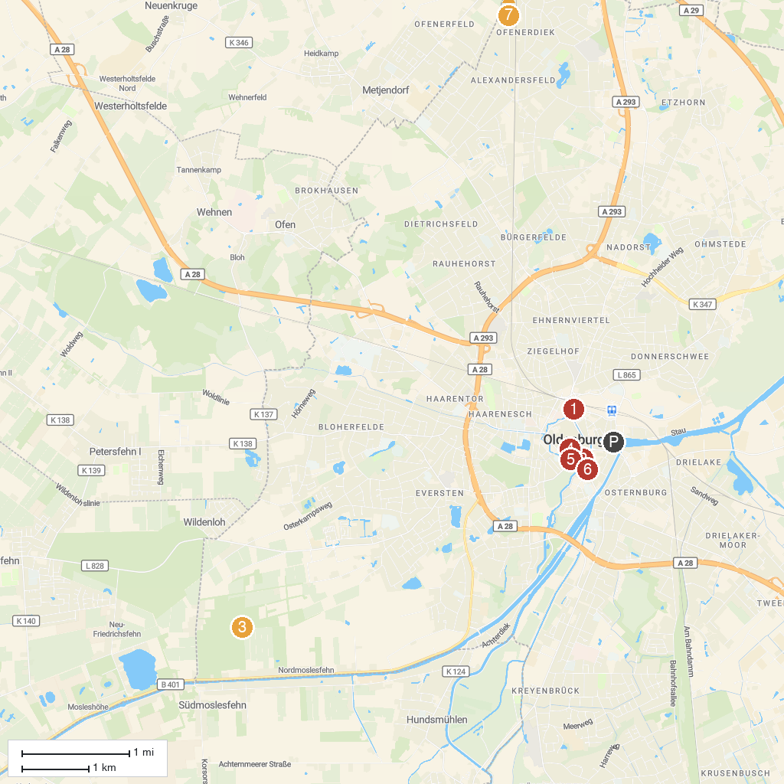
MAP KEY
1. Horst-Janssen-Museum | 5. Pulverturm
2. Schloss Oldenburg | 6. Prinzenpalais, Oldenburg
3. Everstenmoor | 7. St. Ulrich
4. Degodehaus | 8. Windmühle Bad Zwischenahn
P. Cruise port / terminal
Map © MapTiler © OpenStreetMap contributors · cruiseports.org

