Old Saybrook, Connecticut, USA
Where the Connecticut River meets Long Island Sound, Old Saybrook delivers a quintessential New England shore day — historic Main Street, lighthouse cruises, and more Katharine Hepburn lore than you can handle.
⚓ Docked at Saybrook Point Marina · 🕒 Typical call: 6–8 hrs · 💵 USD · 🗣️ English · 🚢 Small ships only (American Cruise Lines)
✍️ MY DAY IN PORT (FILL IN)
Ship / Date
In port | arrive ______ · all aboard ______
Booked excursion
Notes / meeting point
GETTING ASHORE
- Docking: Small ships dock at Saybrook Point Marina; large ocean liners do not call here
- Walk to Main St: ~1.5 miles from marina — shuttle or bike recommended
- Best For: History, New England charm, lighthouses, coastal strolls
- Don't Miss: Katharine Hepburn Cultural Arts Center and Fort Saybrook Monument Park
GETTING AROUND
- 🚕 Taxi: $8–$15 — Local taxis (AAA Taxi Service, Essex Taxi) serve Old Saybrook. The ride from Saybrook Point Marina to Main Street is sho
- 📱 Rideshare: ✅ Uber, Lyft
TOP THINGS TO DO
- Old Saybrook Main Street Walking Tour — Stroll one of Connecticut's oldest downtowns, settled in 1635.
- Lighthouse Cruise from Saybrook Point — Board a Seabird Cruises boat for a narrated tour past Lynde Point Lighthouse and the offshore Saybrook Breakwater Light — both…
- Katharine Hepburn Cultural Arts Center — Old Saybrook's most famous resident spent summers in the private Fenwick borough here.
- Fort Saybrook Monument Park & Salt Marsh Boardwalk — Walk the boardwalk over tidal salt marshes at the site of the original 1635 English settlement.
- Harvey's Beach & Long Island Sound — Old Saybrook's town beach on Long Island Sound — a calm, sandy stretch ideal for a summer swim or a stroll.
BEST WALKS
- Marina to Main Street Stroll: 1.5 miles one way | Easy | ~30 min — Walk from Saybrook Point Marina along College Street to the historic downtown.
- Causeway & Fenwick Peninsula Walk: 0.5 miles | Easy | ~15 min — The scenic causeway connects the marina area to the exclusive Fenwick borough, with panoramic views…
WEATHER · DAYLIGHT · MONEY
Month | High °F | Low °F | Rainy days
May | 64 | 51 | 12
Jul | 80 | 68 | 11
Sep | 73 | 61 | 9
Daylight: May 5:30AM–8:01PM · Jul 5:29AM–8:20PM · Sep 6:30AM–6:57PM
cruiseports.org/old-saybrook-ct · Confirm terminal & all-aboard time with your ship

Old Saybrook, Connecticut, USA — Port Map
Red = walkable sights · Amber = excursions farther out · P = cruise terminal
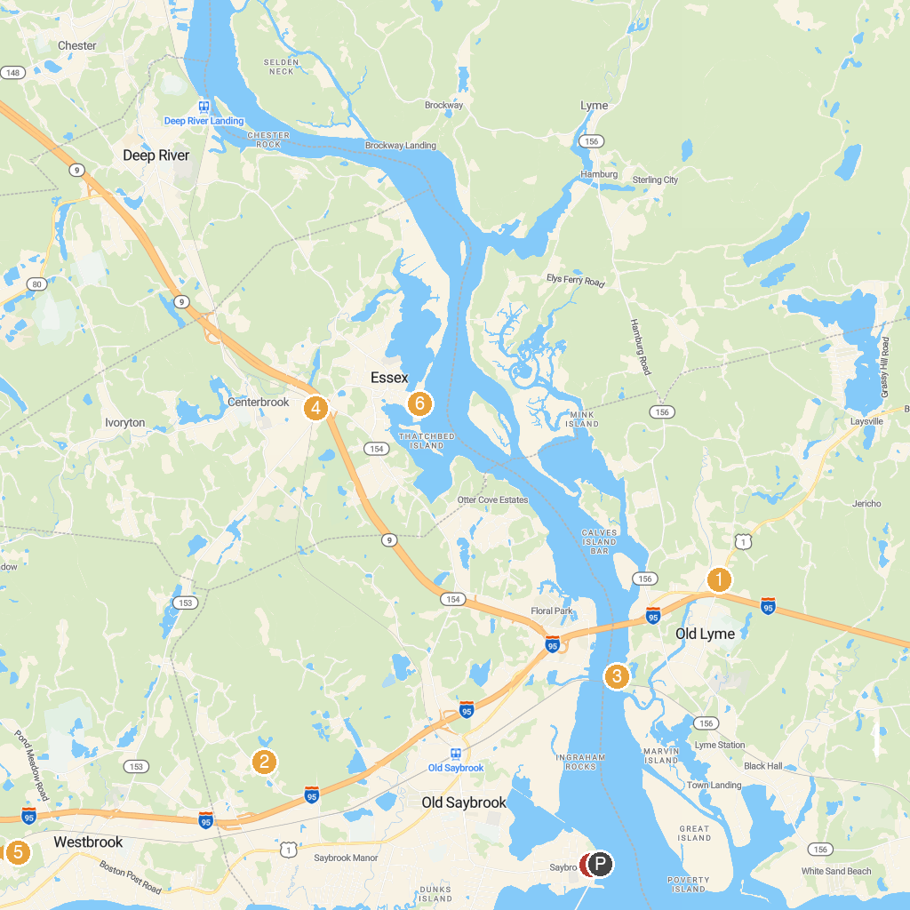
MAP KEY
1. Florence Griswold Museum | 5. Stewart B. McKinney National Wildlife Refuge - Salt Meadow Unit
2. Clark Community Park/Town Park | 6. RiverQuest
3. Ferry Landing State Park | 7. Fort Saybrook Monument Park
4. Connecticut Valley Railroad State Park
P. Cruise port / terminal
Map © MapTiler © OpenStreetMap contributors · cruiseports.org

