Okayama City, Okayama, Japan
Home to the dramatic black-walled Okayama Castle and the sublime Korakuen Garden, Okayama rewards cruisers who make the 40-minute train ride from Uno Port — then surprises them with world-class art on tiny Naoshima island just 20 minutes away by ferry.
⚓ Pier (Uno Port) · 🕒 Typical call: 8-10 hrs · 💴 Currency: Japanese Yen (¥) · 🗣️ Language: Japanese
✍️ MY DAY IN PORT (FILL IN)
Ship / Date
In port | arrive ______ · all aboard ______
Booked excursion
Notes / meeting point
GETTING ASHORE
- Docking: Pier at Uno Port; ~40 min by train to Okayama City center
- Walk to Center: Not walkable — train or bus required from Uno Port
- Best For: History, gardens, art (Naoshima), local cuisine
- Don't Miss: Korakuen Garden + Okayama Castle combo, or the Naoshima ferry
GETTING AROUND
- 🚕 Taxi: ¥3,200–¥9,500 — Fare depends on your dock: Shin-Okayama Port is ~¥3,200–¥3,900 to city center (10 min); Uno Port is ~¥7,500–¥9,500 (28 m
- 📱 Rideshare: ✅ Uber
TOP THINGS TO DO
- Korakuen Garden & Okayama Castle — Japan's top-ranked landscape garden sits across the Asahi River from the black-walled "Crow Castle." A combo ticket covers both.
- Kurashiki Bikan Historical Quarter — A short ~15-minute train ride from Okayama Station to Kurashiki Station, then a 10-15 min walk, brings you to Kurashiki's…
- Naoshima Art Island by Ferry — Hop the 20-minute ferry from Uno Port to this tiny island transformed by Benesse into an outdoor art gallery.
- Okayama Food Walk — Fruit Kingdom & Barasushi — Okayama's "Fruit Kingdom" status is earned: sample white peach or Muscat grape parfaits at a shotengai arcade, try barasushi…
- Asahi River Sightseeing Cruise — 30-minute boat tours on the Asahi River glide between Korakuen and the castle's stone walls, recreating the view feudal lords…
BEST WALKS
- Castle & Garden Loop: 3 km · ~1.5 hrs walking + site time — From Okayama Station, take the tram or walk 25 minutes east to Korakuen Garden.
- Omotecho Shotengai Stroll: 1.5 km · 45 min — Japan's longest covered shopping arcade runs from near Okayama Station west into the city center.
WEATHER · DAYLIGHT · MONEY
Month | High °F | Low °F | Rainy days
May | 75 | 57 | 10
Jul | 86 | 74 | 14
Sep | 82 | 68 | 12
Daylight: May 5:01AM–6:59PM · Jul 5:02AM–7:17PM · Sep 5:47AM–6:11PM
cruiseports.org/okayama-city · Confirm terminal & all-aboard time with your ship

Okayama City, Okayama, Japan — Port Map
Red = walkable sights · Amber = excursions farther out · P = cruise terminal
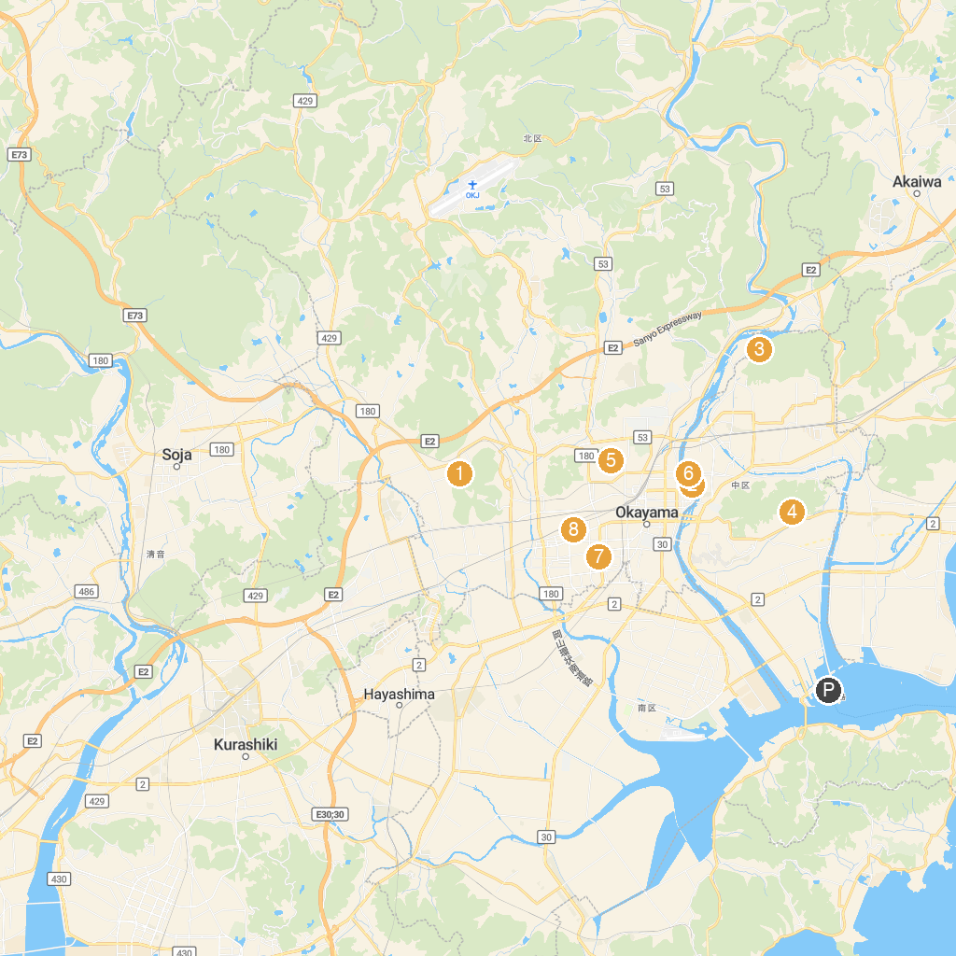
MAP KEY
1. Kibitsu Jinja (Sanbi Ichinomiya) | 5. Ikeda Zoo
2. Okayama Korakuen | 6. Yumeji Art Museum
3. Tatsunokuchi Green Shower Forest | 7. Munetada Shrine
4. Sogen Temple | 8. Okayama Dome
P. Cruise port / terminal
Map © MapTiler © OpenStreetMap contributors · cruiseports.org

