Oita City, Kyushu, Japan
Capital of Japan's 'Onsen Prefecture', Oita City blends samurai history, wild Japanese macaques, and a foodie scene that punches well above its size. Gateway to both the city's own sights and the hot-spring resort town of Beppu, just 15 minutes away by train.
⚓ Pier (Ozai Wharf or Nishi-Oita) · 🕒 Typical call: 8–10 hrs · 💴 Currency: Japanese Yen (JPY) · 🗣️ Language: Japanese · 🚌 Free/low-cost shuttle from Ozai Wharf
✍️ MY DAY IN PORT (FILL IN)
Ship / Date
In port | arrive ______ · all aboard ______
Booked excursion
Notes / meeting point
GETTING ASHORE
- Docking: Pier — large ships at Ozai Wharf (~12 km from city); smaller ships at Nishi-Oita (~2 km)
- Walk to center: Not walkable from Ozai Wharf; 15–20 min walk from Nishi-Oita to JR Oita Station
- Best For: Japanese macaques, castle history, local food, onsen day trips to Beppu
- Don't Miss: Takasakiyama Monkey Park and a bowl of toriten (tempura fried chicken)
GETTING AROUND
- 🚕 Taxi: ¥575 start + ~¥300/km (~¥2,000–3,500 to city center) — Taxis queue at Oita Port and are widely available. Expect ¥2,000–3,500 for a 5–10 km ride to Oita Station area.
- 📱 Rideshare: ✅ Uber
TOP THINGS TO DO
- Takasakiyama Monkey Park — Over 1,000 wild Japanese macaques roam this forested hillside freely.
- Umitamago Aquarium — World-class modern aquarium right next to Takasakiyama, overlooking Beppu Bay.
- Funai Castle Ruins — The moats, turrets, and stone walls of Funai Castle — begun around 1597 and completed in the early 1600s in the castle town…
- Oita Prefectural Art Museum (OPAM) — A striking building by Pritzker Prize-winning architect Shigeru Ban, with giant folding glass doors opening the ground floor to…
- Day Trip to Beppu's Hells (Jigoku Meguri) — Nine otherworldly geothermal pools — boiling cobalt blue, blood red, and steaming mud — make up Beppu's 'Hells' circuit.
BEST WALKS
- Station to Castle Ruins & OPAM: 2.5 km loop · ~40 min · flat — From JR Oita Station head northwest past the rooftop garden to Funai Castle Park — free to enter…
- Nishi-Oita Waterfront Stroll: 1.5 km · ~20 min · flat — For passengers docking at Nishi-Oita, the Oita Canteen waterfront precinct has cafes and small…
WEATHER · DAYLIGHT · MONEY
Month | High °F | Low °F | Rainy days
May | 73 | 58 | 11
Jul | 85 | 73 | 19
Sep | 80 | 69 | 16
Daylight: May 5:14AM–7:06PM · Jul 5:15AM–7:23PM · Sep 5:57AM–6:20PM
cruiseports.org/oita-city · Confirm terminal & all-aboard time with your ship

Oita City, Kyushu, Japan — Port Map
Red = walkable sights · Amber = excursions farther out · P = cruise terminal
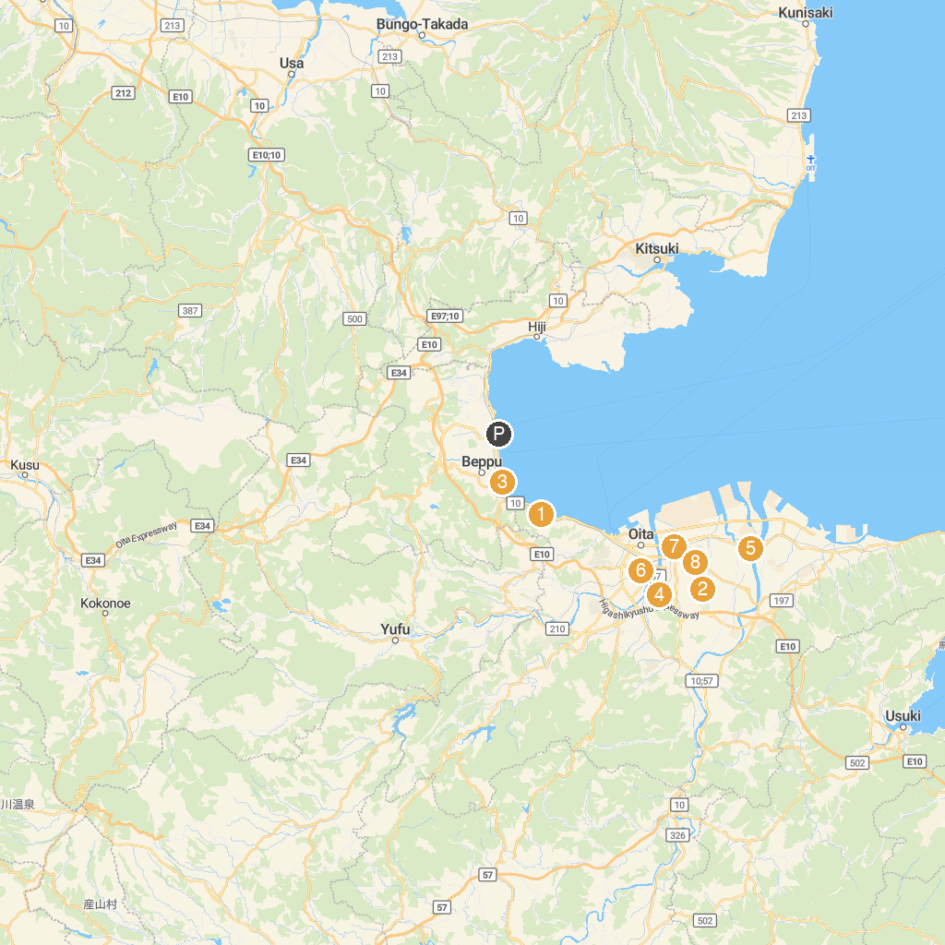
MAP KEY
1. Oita Marine Palace Aquarium "Umitamago" | 5. Hoshinji
2. Takaosan Natural Park | 6. Kongohokaiji
3. Kitahama Park | 7. 大分県立埋蔵文化財センター
4. Ikariyama Park | 8. Okuyama Park
P. Cruise port / terminal
Map © MapTiler © OpenStreetMap contributors · cruiseports.org

