Odense, Funen, Denmark
The birthplace of Hans Christian Andersen, Odense blends fairy-tale charm with Scandinavian modernity — half-timbered streets, a stunning 2021 museum, and the entire island of Funen at your doorstep.
⚓ Pier (industrial port, shuttle required) · 🕒 Typical call: 8–10 hrs · 💵 Danish Krone (DKK) — nearly cashless · 🗣️ Danish / English widely spoken · 🌷 Best: May–September
✍️ MY DAY IN PORT (FILL IN)
Ship / Date
In port | arrive ______ · all aboard ______
Booked excursion
Notes / meeting point
GETTING ASHORE
- Docking: Pier at Lindø industrial port, ~15 km north of city; cruise line shuttle to center
- Walk to center: Not walkable from port — shuttle or taxi required (20 min)
- Best For: Hans Christian Andersen museum, old-town cobblestone strolls, Egeskov Castle day trip
- Don't Miss: H.C. Andersens Hus (book ahead!), Brunsviger cake at a local bakery
GETTING AROUND
- 🚕 Taxi: ~DKK 120–130 — A short taxi ride from the harbour to the city center runs roughly 120–130 DKK, with a base fare around DKK 44–69 plus p
- 📱 Rideshare: ✅ Uber
TOP THINGS TO DO
- H.C. Andersens Hus — The 2021 museum designed by Kengo Kuma is a world-class immersive experience weaving architecture, garden, and fairy-tale…
- Old Town Quarter & Cathedral — Stroll Overgade and Nedergade — cobbled lanes of colorful half-timbered houses dating to the 1500s.
- Egeskov Castle Day Trip — Europe's best-preserved Renaissance water castle sits 30 minutes south of Odense.
- Odense River Cruise (Aafart) — Solar-powered boats cruise the Odense River from Munke Mose park toward Fruens Bøge forest.
- Den Fynske Landsby (Funen Village) — An open-air museum recreating 19th-century rural life on Funen — the world Andersen grew up in.
BEST WALKS
- Fairy-Tale City Stroll: 2 km · 90 min · Easy · Free — Walk the classic H.C.
WEATHER · DAYLIGHT · MONEY
Month | High °F | Low °F | Rainy days
May | 60 | 46 | 11
Jul | 70 | 57 | 14
Sep | 64 | 53 | 11
Daylight: May 5:08AM–9:21PM · Jul 4:57AM–9:50PM · Sep 6:51AM–7:34PM
cruiseports.org/odense · Confirm terminal & all-aboard time with your ship

Odense, Funen, Denmark — Port Map
Red = walkable sights · Amber = excursions farther out · P = cruise terminal
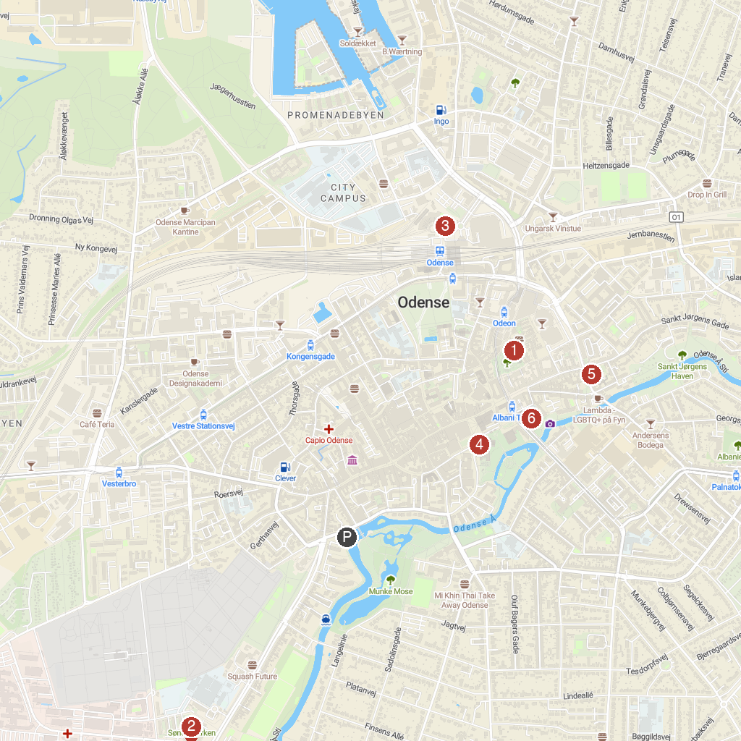
MAP KEY
1. H.C. Andersen’s House | 4. Saint Knud's Church
2. Odense Zoo | 5. Church of Our Lady
3. Danmarks Jernbanemuseum | 6. Odense Noble Virgin Convent
P. Cruise port / terminal
Map © MapTiler © OpenStreetMap contributors · cruiseports.org

