Odda, Vestland, Norway
Perched at the end of Sørfjorden beneath glaciers and orchard-covered hillsides, Odda trades its industrial past for world-class fjord adventures — and the pier drops you right in the middle of it all.
⚓ Docked (pier, smaller ships) / Tender (larger ships) · 🕒 Typical call: 7–10 hrs · 💵 Norwegian Krone (NOK) — cards accepted everywhere · 🗣️ Norwegian (English widely spoken) · 🥾 Trolltunga & Buer Glacier basecamp
✍️ MY DAY IN PORT (FILL IN)
Ship / Date
In port | arrive ______ · all aboard ______
Booked excursion
Notes / meeting point
GETTING ASHORE
- Docking: Pier in town center for smaller ships; larger ships may tender
- Walk to center: 2–5 min flat walk from pier to shops and cafes
- Best For: Glacier hikes, fjord scenery, Hardanger cider, industrial heritage
- Don't Miss: Buer Glacier hike or a RIB fjord safari if Trolltunga is too long
GETTING AROUND
- 🚕 Taxi: ~100 NOK base + 14.5 NOK/km — Odda Taxi operates daily (6 AM–midnight, pre-book for late night). Useful for reaching trailheads or nearby villages.
- 📱 Rideshare: ❌ not available
TOP THINGS TO DO
- Buer Glacier (Buerbreen) Hike — The best full-day option for most cruise passengers.
- Trolltunga Day Hike — One of Norway's most iconic viewpoints — a tongue of rock jutting over Ringedalsvatnet lake 700 m below.
- RIB Fjord Safari — Speed across the Sørfjorden on a rigid inflatable boat to see steep mountainsides, working orchards, and cascading waterfalls…
- Kraftmuseet — Norwegian Museum of Hydropower & Industry — Located 6 km north in Tyssedal, this spectacular power station carved into the fjord-side tells how glacier meltwater was turned…
- Låtefossen Waterfall & Valley Drive — Norway's famous twin waterfall thunders under a historic stone bridge on Route 13, about 16 km south of Odda.
BEST WALKS
- Town Center & Smelteverket Heritage Walk: 45–60 min · Easy · Free — From the pier, walk the flat pedestrian street (Gågata) to the town center, then loop to the…
- Sandvinvatnet Lakeside Stroll: 1.5–2 hrs return · Easy · Lake views — Head south from the pier along the fjord road to Sandvinvatnet, a clear mountain lake where locals…
WEATHER · DAYLIGHT · MONEY
Month | High °F | Low °F | Rainy days
May | 53 | 44 | 16
Jul | 67 | 57 | 22
Sep | 61 | 51 | 17
Daylight: May 4:55AM–10:06PM · Jul 4:37AM–10:40PM · Sep 7:02AM–7:54PM
cruiseports.org/odda · Confirm terminal & all-aboard time with your ship

Odda, Vestland, Norway — Port Map
Red = walkable sights · Amber = excursions farther out · P = cruise terminal
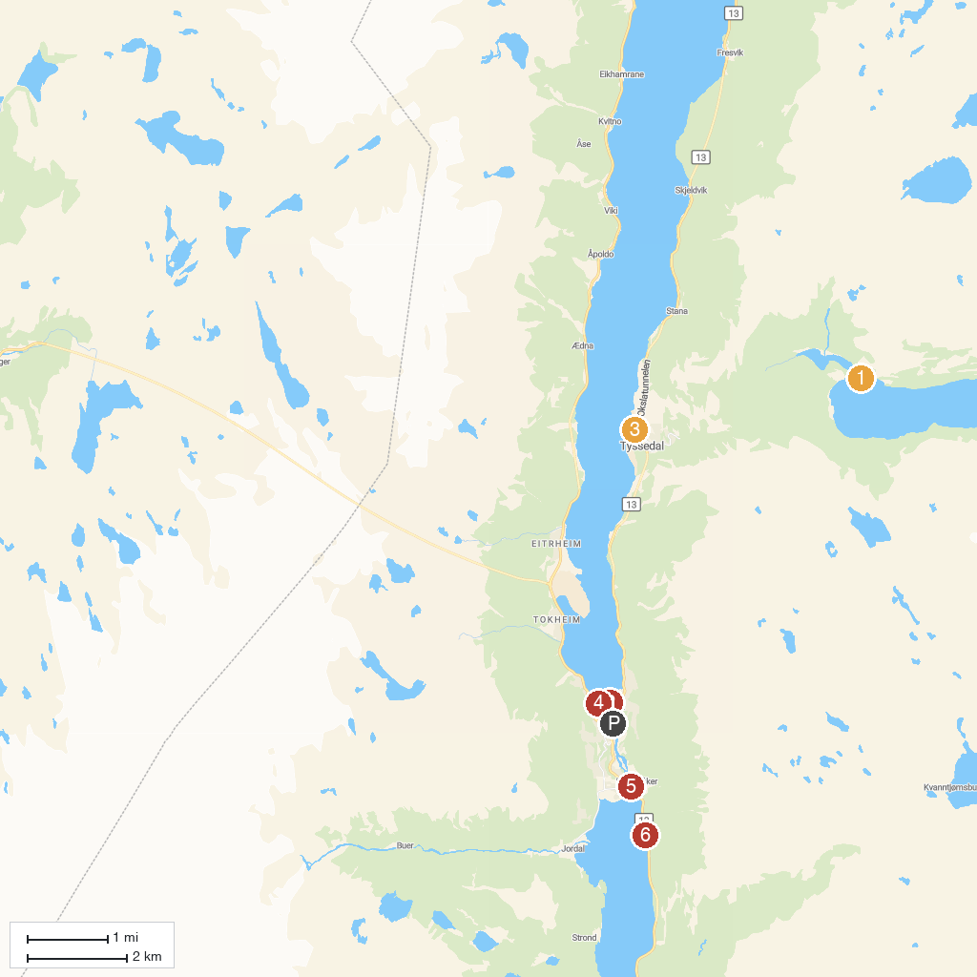
MAP KEY
1. Ringedals Dam | 5. Netflix-steinen
2. Odda Church | 6. Opo River Viewpoint
3. Trolltunga "Troll's Tongue" | 7. Utsikt til Buerbreen
4. Norwegian Museum of Hydropower and Industry
P. Cruise port / terminal
Map © MapTiler © OpenStreetMap contributors · cruiseports.org

