Ocho Rios, Saint Ann, Jamaica
Jamaica's most-visited cruise stop blends a waterfall you can literally climb with bobsleds in the rainforest, hidden turquoise swimming holes, and the real scent of jerk smoke drifting off every corner grill.
⚓ Docked (cruise pier) · 🕒 Typical call: 7-9 hrs · 💵 USD accepted / JMD official · 🗣️ English · 🌡️ Tropical year-round
✍️ MY DAY IN PORT (FILL IN)
Ship / Date
In port | arrive ______ · all aboard ______
Booked excursion
Notes / meeting point
GETTING ASHORE
- Docking: Docked — Turtle Bay Pier (primary) or Reynolds Pier when multiple ships in port; no tender required
- Walk to center: 2 min to Island Village; 10–15 min to Main Street town center
- Best For: Waterfall climbing (Dunn's River), jungle bobsledding (Mystic Mountain), Blue Hole swimming, jerk food
- Don't Miss: Climbing Dunn's River Falls — arrive early before tour buses, wear water shoes
GETTING AROUND
- 🚕 Taxi: $5–15 USD — Licensed JUTA taxis wait at both cruise docks. No meters — agree on the fare in USD before you get in. Short ride to cit
- 📱 Rideshare: ✅ Uber
TOP THINGS TO DO
- Climb Dunn's River Falls — Hold hands in a human chain and walk up 180 m of terraced limestone cascades through cool spray — Jamaica's signature shore…
- Mystic Mountain Rainforest Bobsled — Ride a SkyExplorer chairlift above the rainforest canopy, then zoom down a gravity-fed bobsled track through the jungle…
- Blue Hole (Secret Falls) — Swim in brilliant turquoise natural pools, jump from rope swings, and plunge into hidden waterfall caves at this jungle gem 30–45…
- Beach Club Day Pass — Several resorts along the coastline — including James Bond Beach and various Sandals-affiliated properties — offer day-pass…
- Bob Marley Nine Mile Birthplace Tour — Drive into the Blue Mountains to Nine Mile village, where Bob Marley was born and buried.
BEST WALKS
- Pier to Ocho Rios Bay Beach Loop: 📏 ~1.5 km · ⏱ 30–45 min · 🚶 Easy · ☀️ Best in the morning — Walk from the cruise pier through Island Village, along Main Street past craft markets, duty-free…
- Turtle River Park & Town Walk: 📏 ~2.5 km · ⏱ 45–60 min · 🌿 Park & town · 🚶 Easy flat — Extend the Main Street walk to Turtle River Park — a beautifully landscaped urban park with lush…
- Coyaba River Garden: 📏 ~4 km from pier · ⏱ 1–2 hrs on site · 🌺 Botanical · 🚕 Short taxi ride — Coyaba River Garden & Museum is a meticulously maintained botanical garden with a small waterfall…
WEATHER · DAYLIGHT · MONEY
Month | High °F | Low °F | Rainy days
May | 86 | 75 | 20
Jul | 89 | 78 | 12
Sep | 88 | 77 | 21
Daylight: May 5:34AM–6:34PM · Jul 5:40AM–6:48PM · Sep 5:56AM–6:10PM
cruiseports.org/ocho-rios · Confirm terminal & all-aboard time with your ship

Ocho Rios, Saint Ann, Jamaica — Port Map
Red = walkable sights · Amber = excursions farther out · P = cruise terminal
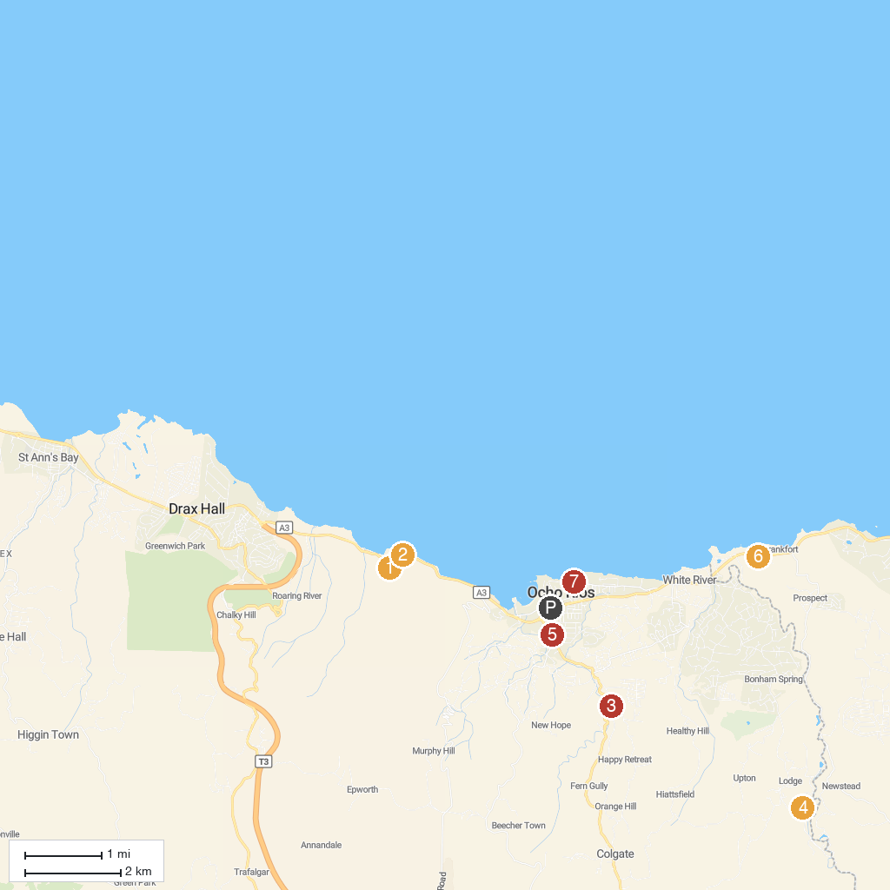
MAP KEY
1. The World Famous Dunn's River Falls & Park | 5. Seville Great House
2. Dolphin Cove Ocho Rios | 6. Ocho Rios Baptist Church
3. Fern Gully | 7. Yaaman Adventure Park
4. Island Gully Falls | 8. Our Lady Of Fatima Roman Catholic Church
P. Cruise port / terminal
Map © MapTiler © OpenStreetMap contributors · cruiseports.org

