Oberwesel, Rhineland-Palatinate, Germany
The 'Town of Towers' along the UNESCO Upper Middle Rhine Valley. Sixteen medieval watchtowers, a strikingly intact town wall you can walk, and a Gothic red church — all in a town most Rhine cruisers have to themselves.
⚓ Docked (floating pier) · 🕒 Typical call: 6–8 hrs · 💶 Euro (cash preferred) · 🗣️ German
✍️ MY DAY IN PORT (FILL IN)
Ship / Date
In port | arrive ______ · all aboard ______
Booked excursion
Notes / meeting point
GETTING ASHORE
- Docking: Floating pontoon pier on the Rhine promenade — no tender required
- Walk to center: 5–10 min (400 m, flat, cross railway pedestrian bridge)
- Best For: Medieval history, Rhine wine tasting, photography, castle views
- Don't Miss: Walking the town wall ramparts and Schönburg Castle tower museum
GETTING AROUND
- 🚕 Taxi: €5–€10 — Local taxis are available in Oberwesel. A shared on-call taxi service (Anruf-Sammel-Taxi Andi) also operates in the area
TOP THINGS TO DO
- Medieval Town Wall Walk — Oberwesel's 3.5 km town wall is the best-preserved in the Middle Rhine, with 16 of the original 22 towers still standing.
- Schönburg Castle Tower Museum — A 1,000-year-old hilltop castle now partly a hotel, with a small tower museum (≈€5–6) detailing castle history and unbeatable…
- Liebfrauenkirche (Red Church) — A striking Gothic church clad in terracotta-red stone — rare in Germany.
- Mittelrhein Wine Tasting — The valley's steep-slope Rieslings are world-class and little-known outside Germany.
- St. Martin's Church — A white Gothic fortified church set higher on the hill with quiet views over the Rhine valley.
BEST WALKS
- Town Wall & Towers Loop: 2–3 km · 1–1.5 hrs · Easy–Moderate — Start at the Rhine Promenade pier, cross the railway, and head to the Ochsenturm (Ox Tower) near…
- Castle Trail to Schönburg: ~2 km one-way · 30–45 min · Strenuous — From the Marktplatz, follow signage uphill on cobblestone paths through vineyards to Schönburg…
WEATHER · DAYLIGHT · MONEY
Month | High °F | Low °F | Rainy days
May | 66 | 50 | 12
Jul | 77 | 61 | 11
Sep | 70 | 55 | 9
Daylight: May 5:42AM–9:08PM · Jul 5:36AM–9:32PM · Sep 7:05AM–7:42PM
cruiseports.org/oberwesel · Confirm terminal & all-aboard time with your ship

Oberwesel, Rhineland-Palatinate, Germany — Port Map
Red = walkable sights · Amber = excursions farther out · P = cruise terminal
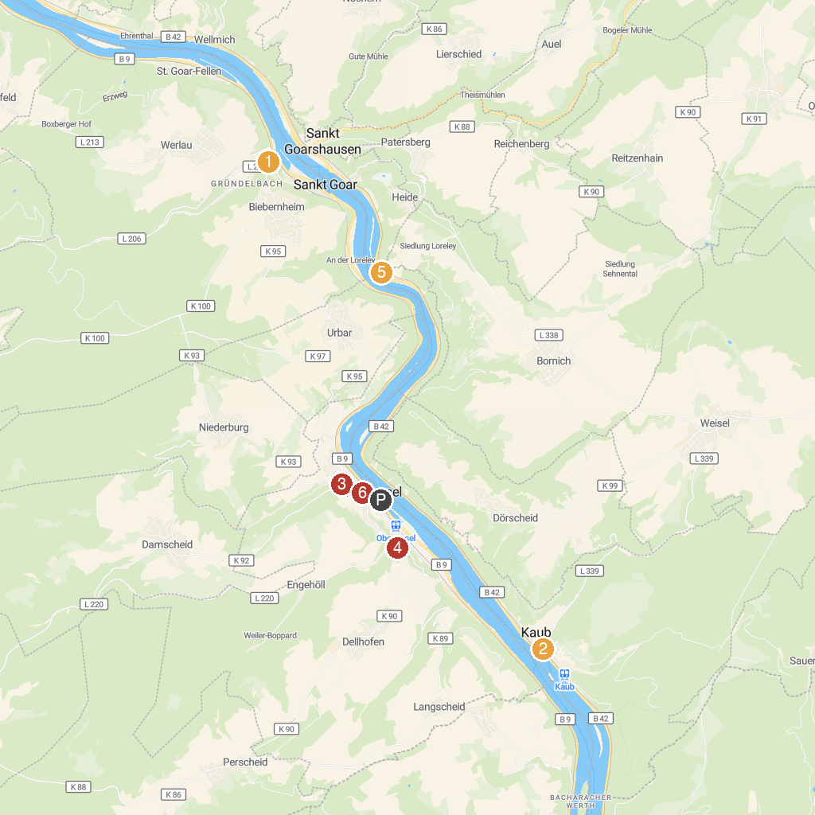
MAP KEY
1. Rheinfels Castle | 5. Loreley
2. Blüchermuseum Kaub | 6. Regionalmuseum "Leben und Arbeiten"
3. St. Martinskirche | 7. Sooneck Castle
4. Turmmuseum auf Schönburg (Tower Museum) | 8. Kulturhaus Oberwesel
P. Cruise port / terminal
Map © MapTiler © OpenStreetMap contributors · cruiseports.org

