Oban, Scotland, UK
A Victorian harbour town wrapped around a crescent bay, Oban punches above its size — world-class seafood, a centuries-old distillery, and sweeping views from a hilltop colosseum, all within easy walking distance of the tender pier.
⚓ Tender port (anchor in bay) · 🕒 Typical call: 7–9 hrs · 💷 British Pound Sterling (GBP) · 🗣️ English / Scottish Gaelic
✍️ MY DAY IN PORT (FILL IN)
Ship / Date
In port | arrive ______ · all aboard ______
Booked excursion
Notes / meeting point
GETTING ASHORE
- Docking: Tender — anchor in Oban Bay; 5–10 min ride to North Pier or Railway Pier
- Walk to center: Steps from the tender pier — town is immediately accessible
- Best For: Whisky lovers, seafood fans, Hebrides day-trippers, scenic walkers
- Don't Miss: McCaig's Tower views + The Green Shack seafood hut on the Railway Pier
GETTING AROUND
- 🚕 Taxi: £6–£8 short trips — Local taxis rank at the railway station on Station Square. Useful for uphill landmarks like McCaig's Tower or longer reg
- 📱 Rideshare: ❌ not available
TOP THINGS TO DO
- Oban Distillery Tour — One of Scotland's oldest distilleries (est.
- McCaig's Tower & Panoramic Views — This striking Victorian colosseum crowns the hill above town.
- Seal & Wildlife Boat Trip — Short boat trips depart directly from the North Pier into the Firth of Lorn to spot Atlantic grey seals, bottlenose dolphins…
- Dunollie Castle & Museum — The ancestral seat of Clan MacDougall, a 20-minute coastal walk north of the pier.
- Isle of Mull Day Trip — The CalMac ferry from the Railway Pier reaches Craignure on Mull in about 50 minutes, opening up Torosay Castle, Duart Castle…
BEST WALKS
- Waterfront Esplanade & Dunollie Walk: 3.5 km | ~50 min | Easy, flat coastal path — From the tender pier, head north along the Corran Esplanade past the war memorial and boating pond…
- Town Centre & McCaig's Tower Loop: 2 km | ~50 min | Moderate (steep ascent) — Walk up George Street through the town center, then climb the steep hill via Argyll Street to…
WEATHER · DAYLIGHT · MONEY
Month | High °F | Low °F | Rainy days
May | 55 | 45 | 16
Jul | 61 | 53 | 20
Sep | 59 | 51 | 19
Daylight: May 5:08AM–9:28PM · Jul 4:53AM–10:03PM · Sep 6:51AM–7:43PM
cruiseports.org/oban-uk · Confirm terminal & all-aboard time with your ship

Oban, Scotland, UK — Port Map
Red = walkable sights · Amber = excursions farther out · P = cruise terminal
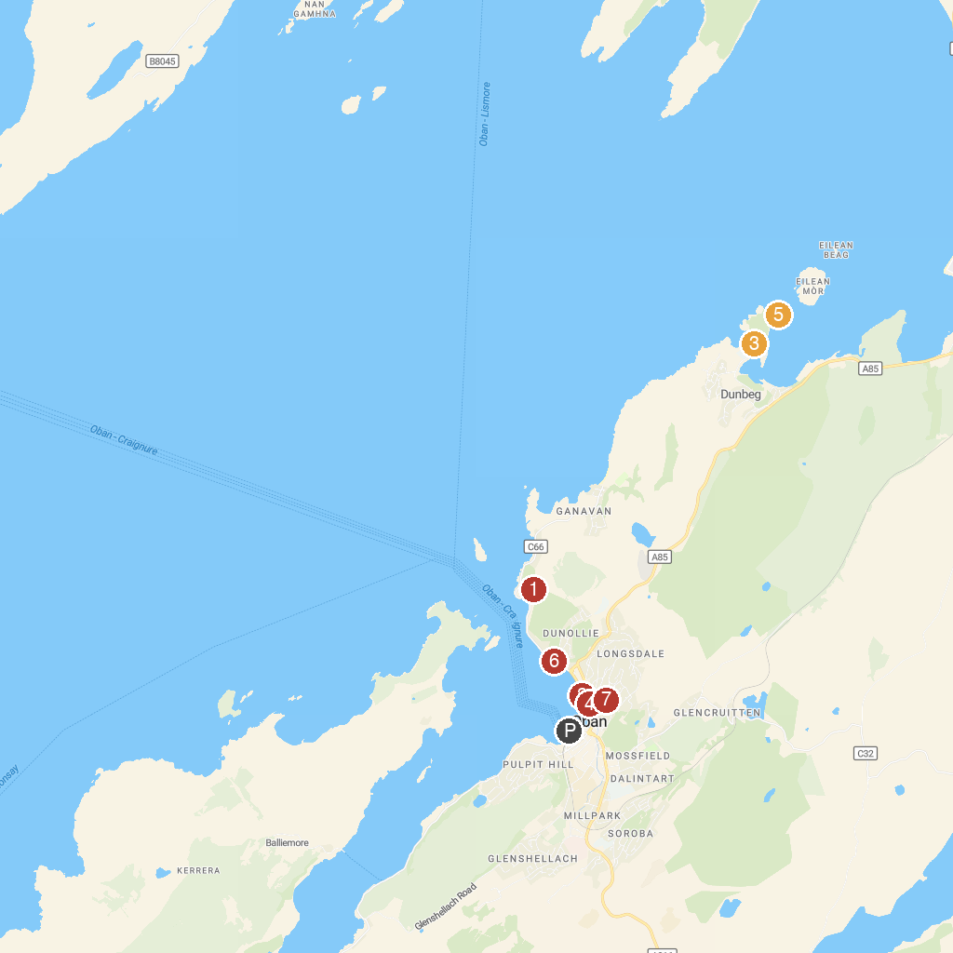
MAP KEY
1. Dunollie Museum, Castle and Grounds | 5. Oban Distillery
2. Oban War & Peace Museum | 6. Dunstaffnage Castle and Chapel
3. Ocean Explorer Centre | 7. St. Columba’s Cathedral
4. Duart Castle | 8. McCaig’s Tower & Battery Hill
P. Cruise port / terminal
Map © MapTiler © OpenStreetMap contributors · cruiseports.org

