Oban, Stewart Island, New Zealand
New Zealand's third island sits just 30 km below the South Island, home to more kiwis than people. Oban is tiny, unhurried, and completely unlike any other cruise port — bring your rain jacket and your patience for wildlife.
⚓ Tender port (no pier) · 🕒 Typical call: 6-8 hrs · 💵 NZD (cards widely accepted) · 🗣️ English / Te Reo Māori · 🐦 Bird & nature paradise
✍️ MY DAY IN PORT (FILL IN)
Ship / Date
In port | arrive ______ · all aboard ______
Booked excursion
Notes / meeting point
GETTING ASHORE
- Docking: Tender — anchor in Halfmoon Bay, tender to Oban main wharf
- Walk to centre: Tenders land at the Oban wharf, in the heart of the village
- Best For: Birdwatching, Rakiura National Park, Ulva Island sanctuary
- Don't Miss: Water taxi to Ulva Island — predator-free forest with rare native birds
GETTING AROUND
- 🚕 Taxi: NZ$20–$40 per trip (up to 4 pax) — Aurora Cab Company offers private car hire on the island. Fixed rates apply to popular destinations such as Lee Bay (~NZ
- 📱 Rideshare: ❌ not available
TOP THINGS TO DO
- Ulva Island Open Sanctuary — A predator-free island just a 10-minute water taxi from Golden Bay.
- Rakiura National Park Short Walks — The park covers 85% of the island.
- Guided Kiwi Spotting — Stewart Island has an estimated 20,000 Brown Kiwi — one of the few places where they're sometimes active during daylight.
- Rakiura Museum — A well-crafted small museum on Ayr Street covering the island's whaling, sealing, and tin-mining past plus rich Māori heritage.
- Electric Bike Island Exploration — Stewart Island has only about 28 km of roads — perfect for an e-bike.
BEST WALKS
- Observation Rock Lookout: 3 km return · 45-60 min · easy-moderate — A short but rewarding walk up to Observation Rock for panoramic views over Paterson Inlet and…
- Fuchsia Walk & Braggs Bay Track: 2-3 km · 30-45 min · easy — A flat loop from the centre of Oban through native fuchsia forest and along the bay shore.
- Golden Bay to Lee Bay & Anchor Stone: 10 km return · 2.5-3 hrs · easy (flat road) — Walk (or e-bike) the road from Golden Bay to Lee Bay, the official entrance to Rakiura National Park.
WEATHER · DAYLIGHT · MONEY
Month | High °F | Low °F | Rainy days
May | 56 | 43 | 16
Jul | 52 | 39 | 15
Sep | 55 | 41 | 14
Daylight: May 8:30AM–5:35PM · Jul 8:44AM–5:18PM · Sep 7:23AM–6:28PM
cruiseports.org/oban-nz · Confirm terminal & all-aboard time with your ship

Oban, Stewart Island, New Zealand — Port Map
Red = walkable sights · Amber = excursions farther out · P = cruise terminal
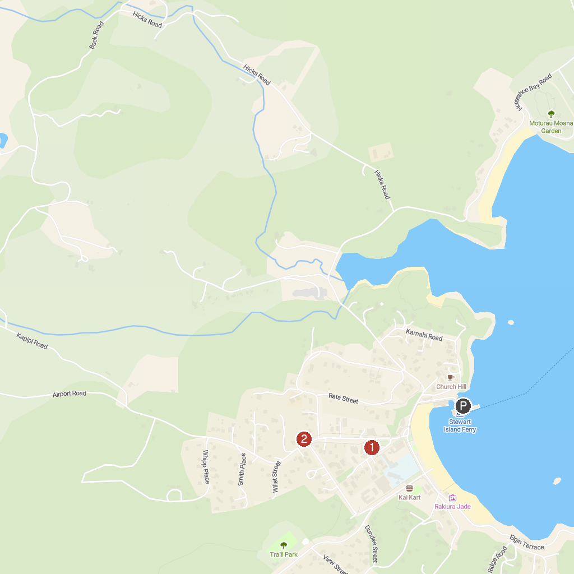
MAP KEY
1. Rakiura Museum | 2. Tequila Fishing and Bird Watching Charters
P. Cruise port / terminal
Map © MapTiler © OpenStreetMap contributors · cruiseports.org

