Nuuk, Greenland, Denmark
The world's northernmost capital tucks a surprisingly vibrant city between icy fjords and Arctic peaks. Expedition and mid-size ships dock at the working cargo quay; larger vessels anchor and tender into the photogenic Colonial Harbor.
⚓ Pier (small–mid ships) / Tender (large ships) · 🕒 Typical call: 6–8 hrs · 💵 Danish Krone (DKK) — cards widely accepted · 🗣️ Greenlandic & Danish; English spoken in tourism · 🌡️ Summer 5–10 °C — windproof layers essential
✍️ MY DAY IN PORT (FILL IN)
Ship / Date
In port | arrive ______ · all aboard ______
Booked excursion
Notes / meeting point
GETTING ASHORE
- Docking: Small/expedition ships dock at Ny Atlantkaj; large ships tender to Colonial Harbor
- Walk to Center: 5 min from tender pier; 20–30 min (or shuttle) from cargo quay
- Best For: Inuit history, fjord boat tours, Arctic wildlife, unique local cuisine
- Don't Miss: Qilakitsoq Mummies at the Greenland National Museum
GETTING AROUND
- 🚕 Taxi: ~70 DKK (~$10 USD) — Metered taxis wait directly outside the cruise terminal. City center is ~2 km away; operators include Nuuk Taxa (+299 32
- 📱 Rideshare: ❌ not available
TOP THINGS TO DO
- Nuuk Fjord Boat Tour — Head into the vast Nuuk Fjord — one of the world's largest fjord systems — watching for humpback whales, seals, and icebergs with…
- Greenland National Museum — See the remarkably preserved Qilakitsoq Mummies — four 15th-century Inuit figures including a baby, discovered in a cliff tomb in…
- Colonial Harbor Walk & Katuaq — Stroll the 1728 Colonial Harbor with its brightly painted houses, Hans Egede statue lookout, and red wooden cathedral.
- Sermitsiaq Hiking — The triple-peaked Sermitsiaq mountain is the symbol of Nuuk and visible from everywhere in the city.
- Greenlandic Cuisine Tasting — Sample muskox burgers, fresh Arctic halibut, and reindeer at local spots like Cafetuaq (inside Katuaq) or the legendary Charoen…
BEST WALKS
- Colonial Harbor to Hans Egede Lookout: ~0.5 miles | 30–45 min | Easy–moderate (uphill finish) — From the tender pier, wander among the colorful 18th-century wooden houses of the Colonial Harbor…
- Colonial Harbor to Katuaq Cultural Centre: ~0.8 miles | 15–20 min | Easy (mostly flat) — Walk uphill from the historic harbor through the main shopping street (Imaneq) into modern Nuuk…
WEATHER · DAYLIGHT · MONEY
Month | High °F | Low °F | Rainy days
May | 37 | 28 | 9
Jul | 54 | 43 | 9
Sep | 44 | 35 | 12
Daylight: May 5:11AM–11:37PM · Sep 7:51AM–8:51PM
cruiseports.org/nuuk · Confirm terminal & all-aboard time with your ship

Nuuk, Greenland, Denmark — Port Map
Red = walkable sights · Amber = excursions farther out · P = cruise terminal
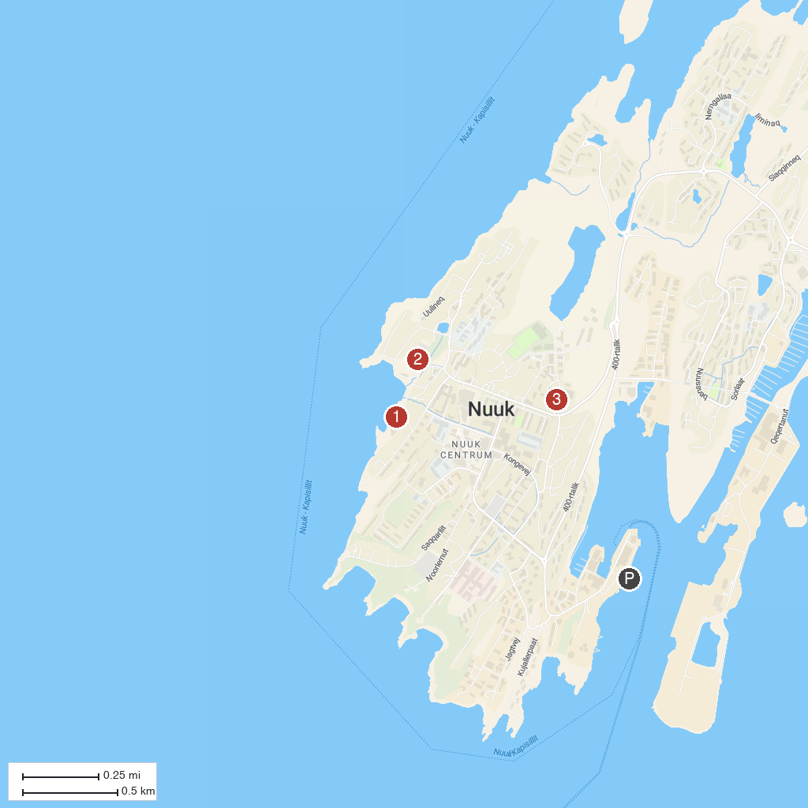
MAP KEY
1. Greenland National Museum and Archives | 3. Nuuk Art Museum
2. Church of our Saviour
P. Cruise port / terminal
Map © MapTiler © OpenStreetMap contributors · cruiseports.org

