Nuremberg, Bavaria, Germany
Bavaria's second city carries a dual identity — a fairy-tale medieval Altstadt rebuilt stone by stone after WWII, and the sobering courtroom where Nazi leaders faced justice. Few river cruise stops pack this much history into a single day.
⚓ Docked (pier) · 🕒 Typical call: 8-10 hrs · 💶 Currency: Euro (€) · 🗣️ Language: German
✍️ MY DAY IN PORT (FILL IN)
Ship / Date
In port | arrive ______ · all aboard ______
Booked excursion
Notes / meeting point
GETTING ASHORE
- Docking: Docked on the Main-Danube Canal, ~5.5 km south of the Old Town
- Getting to Center: Cruise line shuttle (most lines; free or low-cost) or taxi ~15 min / €15–20
- Best For: Medieval architecture, WWII history, Bavarian food, Christmas market (December)
- Don't Miss: Drei im Weckla (3 sausages in a roll) from a street kiosk at Hauptmarkt
GETTING AROUND
- 🚕 Taxi: €20–€24 to city center — Regulated taxis available at the port; base fare €4.70 plus metered rate. Quick and convenient for groups of up to 4.
- 📱 Rideshare: ✅ Uber, Bolt
- 🚌 Hop-on hop-off: ✅ City-Tour Nürnberg
TOP THINGS TO DO
- Memorium Nuremberg Trials (Courtroom 600) — The actual courtroom where the International Military Tribunal tried Nazi leaders in 1945–1946.
- Imperial Castle (Kaiserburg) — The skyline-defining fortress that served as the seat of Holy Roman Emperors for centuries.
- Old Town Walk: Hauptmarkt to Weissgerbergasse — Start at the Gothic Schöner Brunnen fountain (spin the brass ring!), walk a couple of minutes to St.
- Nazi Party Rally Grounds & Documentation Center — The unfinished Congress Hall, designed to hold 50,000, now houses a sobering museum documenting the Third Reich's rise and fall.
- Albrecht Dürer's House — One of Germany's finest Renaissance artists lived here from 1509 until his death.
BEST WALKS
- Hauptmarkt to Kaiserburg Loop: ~2 km · 45-60 min · Easy with one steep climb — Start at the Hauptmarkt, admire the Schöner Brunnen fountain and spin the brass ring for luck.
- Way of Human Rights to Germanic National Museum: ~1 km · 20 min · Flat — A short, meaningful stroll along the outdoor installation of 30 white pillars, each inscribed with…
WEATHER · DAYLIGHT · MONEY
Month | High °F | Low °F | Rainy days
May | 65 | 47 | 14
Jul | 77 | 58 | 12
Sep | 68 | 51 | 9
Daylight: May 5:31AM–8:53PM · Jul 5:26AM–9:16PM · Sep 6:52AM–7:28PM
cruiseports.org/nuremberg · Confirm terminal & all-aboard time with your ship

Nuremberg, Bavaria, Germany — Port Map
Red = walkable sights · Amber = excursions farther out · P = cruise terminal
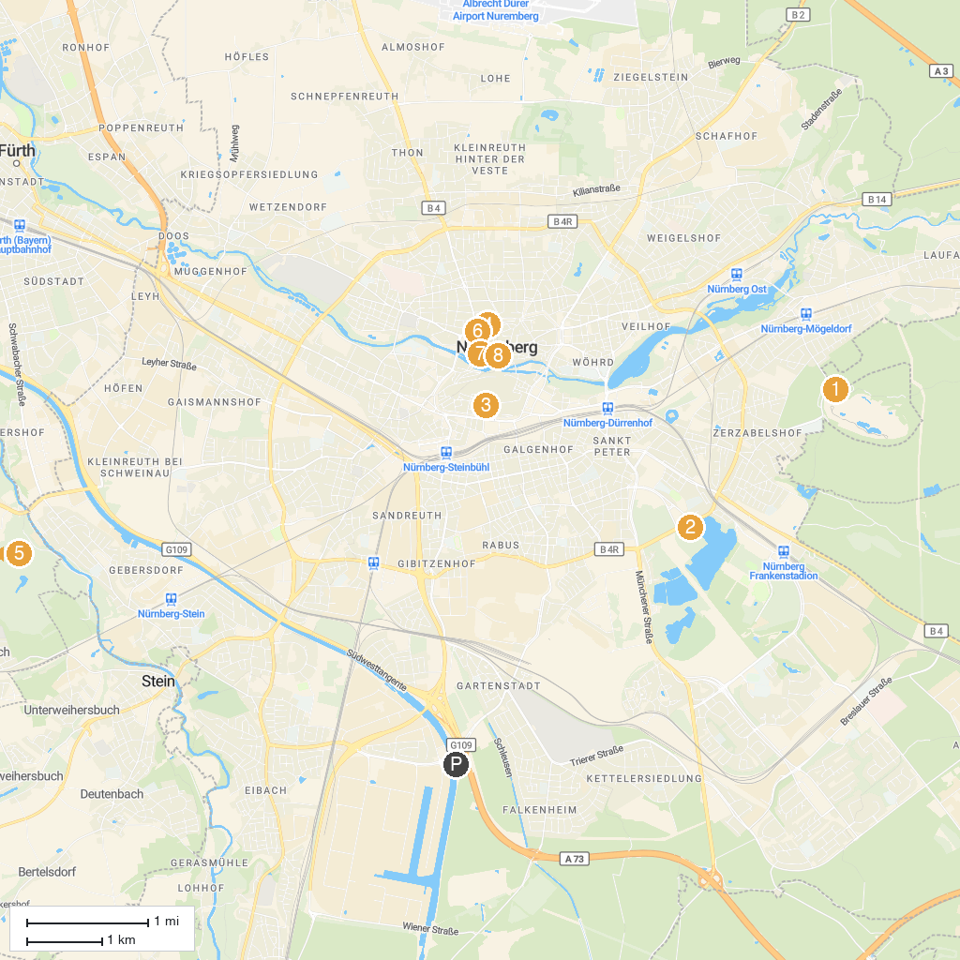
MAP KEY
1. Nürnberg Zoo | 5. PLAYMOBIL -Fun Park
2. Documentation Center Nazi Party Rally Grounds | 6. Museums Nuremberg - Albrecht Dürer House
3. Germanisches Nationalmuseum | 7. Toy Museum
4. Imperial Castle of Nuremberg | 8. Tourist Information am Hauptmarkt
P. Cruise port / terminal
Map © MapTiler © OpenStreetMap contributors · cruiseports.org

