Novi Sad, Vojvodina, Serbia
Serbia's second city earns its nickname 'Athens of the Danube' — Austro-Hungarian boulevards, a hilltop fortress the Ottomans never took, and a riverside beach locals call the finest sandy strand on the river.
⚓ Docked (pier) · 🕒 Typical call: 6–8 hrs · 💵 Serbian Dinar (RSD) · 🗣️ Serbian (English widely spoken)
✍️ MY DAY IN PORT (FILL IN)
Ship / Date
In port | arrive ______ · all aboard ______
Booked excursion
Notes / meeting point
GETTING ASHORE
- Docking: Docked at the city-center quay (Kej žrtava racije) — no tender
- Walk to center: ~10–15 min to Liberty Square (800 m flat)
- Best For: History, architecture, Danube views, local food & wine
- Don't Miss: Petrovaradin Fortress clock tower and underground galleries
GETTING AROUND
- 🚕 Taxi: €5–€12 — Metered taxis are plentiful and affordable. Use registered companies (Red Taxi, Naš Taxi, Grand Taxi) and insist on the
- 📱 Rideshare: ✅ CarGo, Yandex Go
TOP THINGS TO DO
- Petrovaradin Fortress & Underground Galleries — The 18th-century 'Gibraltar of the Danube' was never conquered.
- Novi Sad Old Town Walk — Liberty Square with its neo-Gothic Name of Mary Church and neo-Renaissance City Hall, plus Zmaj Jovina pedestrian street lined…
- Vojvodina Food & Bermet Wine Tasting — Sample ćevapi with kajmak, spicy riblja čorba (river fish soup), and Bermet — the sweet Fruška Gora wine reportedly served on the…
- Fruška Gora National Park & Monasteries — Rolling wine country 20 km from the dock, dotted with Orthodox monasteries, vineyards, and forested trails.
- Štrand River Beach — One of Europe's finest sandy river beaches stretches 700 m along the Danube — lounge chairs, beach bars, volleyball, and clear…
BEST WALKS
- Danube Park to Liberty Square: 1 km · 15 min · Flat — Stroll from the dock through Danube Park past the swan pond, then up Dunavska Street to Liberty…
- Liberty Square to Petrovaradin Fortress: 1.5 km · 25 min · Moderate climb — From Liberty Square walk to Varadin Bridge, cross the Danube, and climb the cobblestone ramp to the…
WEATHER · DAYLIGHT · MONEY
Month | High °F | Low °F | Rainy days
May | 71 | 54 | 13
Jul | 83 | 66 | 8
Sep | 74 | 58 | 8
Daylight: May 5:11AM–8:03PM · Jul 5:07AM–8:25PM · Sep 6:19AM–6:51PM
cruiseports.org/novi-sad · Confirm terminal & all-aboard time with your ship

Novi Sad, Vojvodina, Serbia — Port Map
Red = walkable sights · Amber = excursions farther out · P = cruise terminal
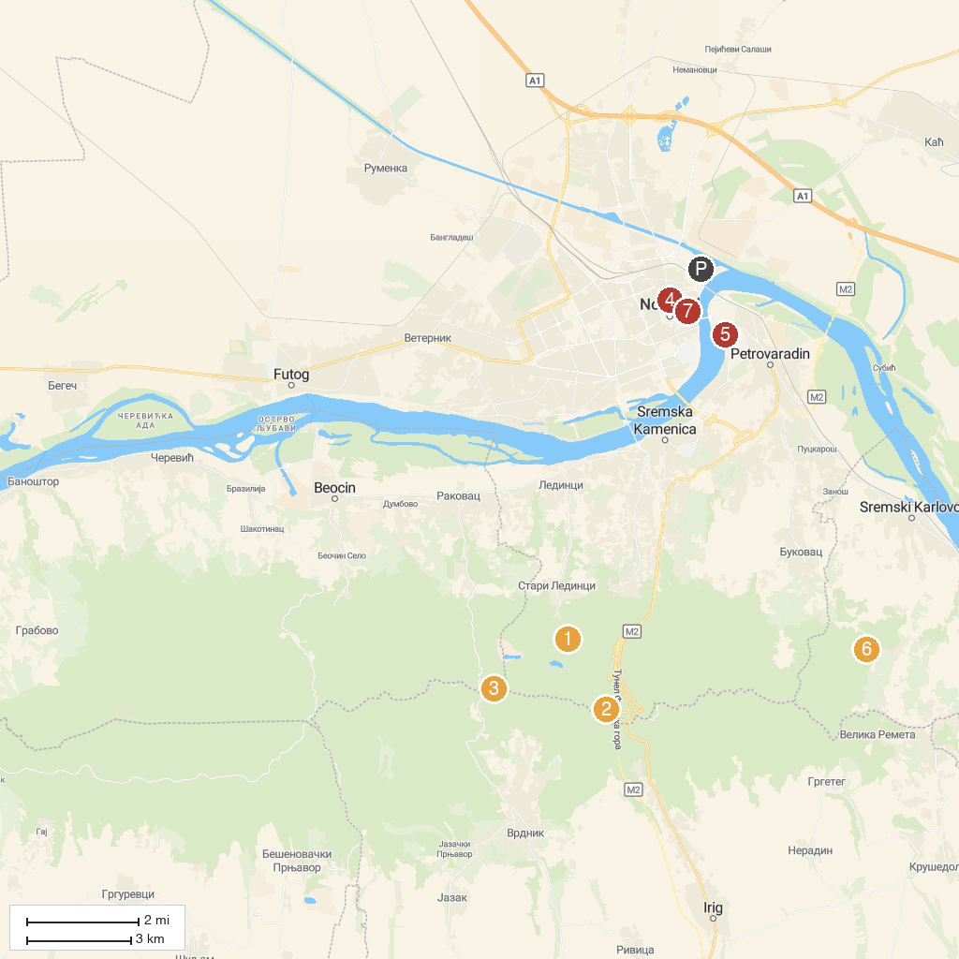
MAP KEY
1. Извор Звечан | 5. Astronomical Society Novi Sad
2. Краљева столица | 6. Stražilovo
3. Змајевац | 7. Frushka Gora National Park
4. Matica Srpska | 8. Muzej Vojvodine
P. Cruise port / terminal
Map © MapTiler © OpenStreetMap contributors · cruiseports.org

