Nosy Be Island, Diana, Madagascar
Madagascar's Perfume Island — where black lemurs leap through primary rainforest, turquoise lagoons ring coral reefs, and the air itself smells of ylang-ylang. A tender port with big wildlife rewards for those who venture beyond the dock.
⚓ Tender port (no pier) · 🕒 Typical call: 7-9 hrs · 💵 Euros & Malagasy Ariary (MGA) · 🗣️ French & Malagasy · 🦎 Endemic wildlife
✍️ MY DAY IN PORT (FILL IN)
Ship / Date
In port | arrive ______ · all aboard ______
Booked excursion
Notes / meeting point
GETTING ASHORE
- Docking: Tender — ships anchor in the bay; 15-20 min tender to Hell-Ville pier
- Walk to centre: 5 min from tender pier to port gate; 15 min uphill to town (tuk-tuk recommended)
- Best For: Wildlife (lemurs, chameleons), snorkeling, island hopping, ylang-ylang culture
- Don't Miss: Lokobe Nature Reserve or Nosy Komba for close-up black lemur encounters
GETTING AROUND
- 🚕 Taxi: $5–$15 per trip — Taxis wait near the pier for trips further around the island. Always agree on a price upfront; half-day private hire typ
- 📱 Rideshare: ❌ not available
TOP THINGS TO DO
- Lokobe Nature Reserve — Nosy Be's last primary rainforest, reachable by taxi then traditional pirogue.
- Nosy Komba — Lemur Island — A short boat ride from Hell-Ville, this volcanic island has semi-habituated black lemurs that climb onto your shoulders.
- Nosy Tanikely Marine Reserve — A marine sanctuary island with vibrant coral gardens, reef fish, and sea turtles visible from the surface.
- Lemuria Land & SPPM Distillery — A short tuk-tuk ride from the port, this eco-park lets you walk among lemurs, giant Aldabra tortoises, and chameleons, then tour…
- Andilana Beach Day — The island's finest beach — a mile of white powder sand at the northern tip, framed by calm turquoise water.
BEST WALKS
- Hell-Ville Waterfront & Bazar Be: 1-2 km · 30-45 min · Easy · Flat — From the tender pier, stroll along the waterfront, then cut uphill to Bazar Be — the bustling…
- Sacred Banyan Tree of Mahatsinjo: Tuk-tuk ~15 min each way · ~1 hr total · Easy — A 200-year-old sacred banyan tree spreading over 5,000 square metres in the village of Ampombolava.
WEATHER · DAYLIGHT · MONEY
Month | High °F | Low °F | Rainy days
May | 83 | 75 | 17
Jul | 80 | 71 | 10
Sep | 82 | 72 | 16
Daylight: May 5:58AM–5:27PM · Jul 6:10AM–5:35PM · Sep 5:41AM–5:42PM
cruiseports.org/nosy-be-island · Confirm terminal & all-aboard time with your ship

Nosy Be Island, Diana, Madagascar — Port Map
Red = walkable sights · Amber = excursions farther out · P = cruise terminal
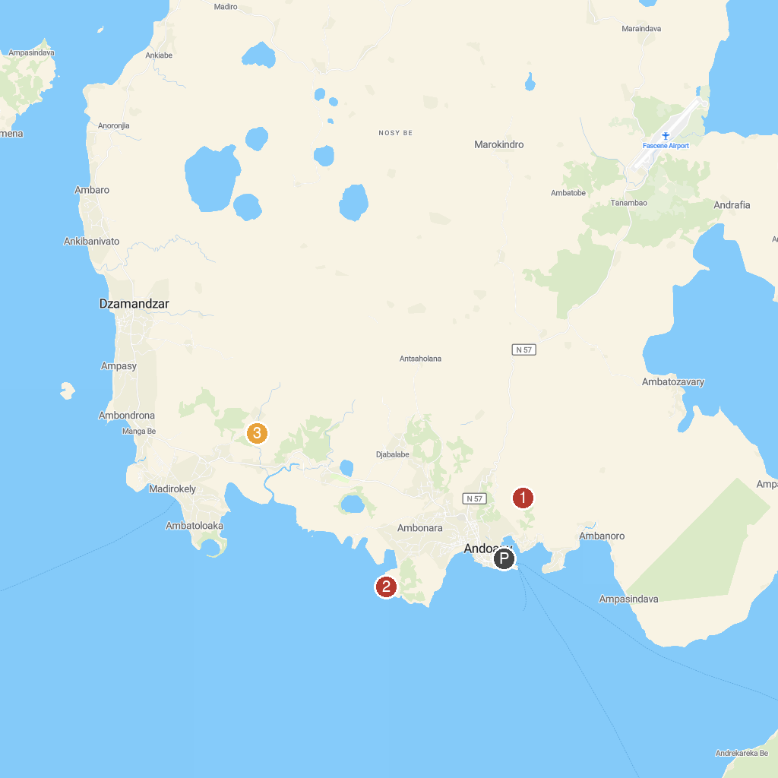
MAP KEY
1. Lemuria Land | 3. Cascade de Nosy Be
2. Mahatsingo Sacred Tree
P. Cruise port / terminal
Map © MapTiler © OpenStreetMap contributors · cruiseports.org

