Noshiro, Akita, Japan
A rare, unhurried stop on Japan's Sea of Japan coast — Noshiro trades tourist crowds for vast pine forests, a UNESCO beech wilderness just an hour away, and deeply local Akita culture that most cruise passengers never encounter.
⚓ Pier (Nakajima Wharf) · 🕒 Typical call: 8-10 hrs · 💴 Japanese Yen (JPY) · 🗣️ Japanese (minimal English) · 🌲 UNESCO Shirakami-Sanchi nearby
✍️ MY DAY IN PORT (FILL IN)
Ship / Date
In port | arrive ______ · all aboard ______
Booked excursion
Notes / meeting point
GETTING ASHORE
- Docking: Pier — Nakajima Wharf, 13m deep, 260m berth. No tendering.
- Walk to center: ~4.5 km (3 miles) to Noshiro Station; free shuttle usually provided by cruise line.
- Best For: Nature lovers, authentic Japan seekers, photography, UNESCO day trips
- Don't Miss: Kaze no Matsubara pine forest walk; Aoike Blue Pond at Shirakami-Sanchi (day trip)
GETTING AROUND
- 🚕 Taxi: ¥1,500–¥3,000 — Taxis are available at the port and take about 15 minutes to Noshiro city center. Japanese meter fares start around ¥450
TOP THINGS TO DO
- Shirakami-Sanchi & Aoike Blue Pond — Japan's first UNESCO World Natural Heritage Site protects vast virgin beech forests.
- Kaze no Matsubara Pine Forest Walk — One of Japan's five great pine forests — 14 km of planted Edo-era black pines along the coast, protecting the city from sea winds…
- Noshiro City & Basketball Heritage — Noshiro is famous across Japan for its high-school basketball dynasty — Noshiro Technical High School, whose powerhouse program…
- Oga Peninsula & Namahage Culture — About two hours south, the Oga Peninsula is home to the Namahage — fearsome ogre-like deities who visit homes at New Year.
- Resort Shirakami Scenic Train — One of Japan's most celebrated train journeys hugs the rocky Sea of Japan coastline between Noshiro/Higashi-Noshiro and Akita.
BEST WALKS
- Pine Forest & City Stroll: 3-4 km · Easy · 1-1.5 hrs — From Noshiro Station, walk west toward the coast to enter Kaze no Matsubara pine forest.
WEATHER · DAYLIGHT · MONEY
Month | High °F | Low °F | Rainy days
May | 64 | 51 | 14
Jul | 78 | 68 | 15
Sep | 74 | 63 | 14
Daylight: May 4:24AM–6:48PM · Jul 4:23AM–7:08PM · Sep 5:20AM–5:48PM
cruiseports.org/noshiro · Confirm terminal & all-aboard time with your ship

Noshiro, Akita, Japan — Port Map
Red = walkable sights · Amber = excursions farther out · P = cruise terminal
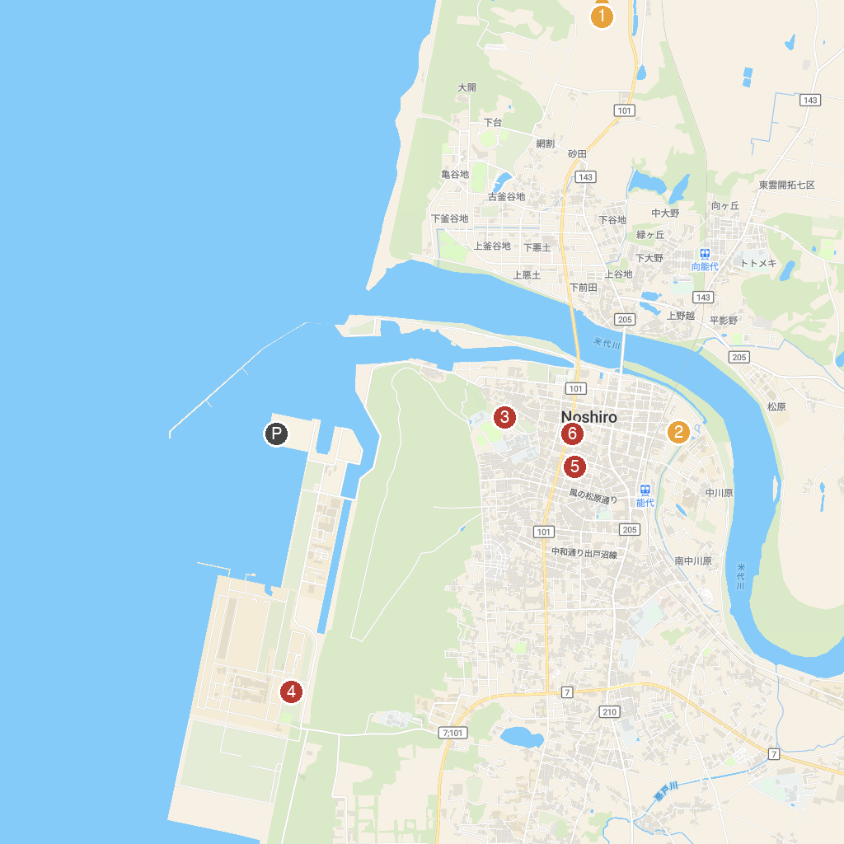
MAP KEY
1. Roadside Station Minehama | 4. Noshiro Energium Park
2. Hiyoshi Shrine | 5. Kaneyu
3. Noshiro Park | 6. Keyaki Park
P. Cruise port / terminal
Map © MapTiler © OpenStreetMap contributors · cruiseports.org

