Norfolk, Virginia, USA
America's largest naval base meets a surprisingly walkable downtown — the Battleship Wisconsin sits two minutes from the gangway, and world-class art is free.
⚓ Docked — Half Moone Cruise Center · 🕒 Typical call: 6-10 hrs · 💵 USD · 🗣️ English
✍️ MY DAY IN PORT (FILL IN)
Ship / Date
In port | arrive ______ · all aboard ______
Booked excursion
Notes / meeting point
GETTING ASHORE
- Docking: Pier-side at Half Moone Cruise & Celebration Center, 1 Waterside Dr, downtown Norfolk
- Walk to center: 2 min to Nauticus/Battleship Wisconsin; 10 min to MacArthur Memorial & Chrysler Museum
- Best For: Naval history, walkable art district, harbor cruise, family day
- Don't Miss: Walking the deck of Battleship Wisconsin (Iowa-class BB-64)
GETTING AROUND
- 🚕 Taxi: $8–$15 — Taxis are available at the terminal with a ~$3 base fare plus ~$1.65/km. Short downtown hops typically run $8–$15.
- 📱 Rideshare: ✅ Uber, Lyft
TOP THINGS TO DO
- Battleship Wisconsin Self-Guided Tour — Board the Iowa-class BB-64 docked at Nauticus — one of the largest battleships ever built.
- Chrysler Museum of Art — Free admission to one of America's finest regional art museums — 5,000 years of art plus an internationally acclaimed glass…
- Victory Rover Naval Base Harbor Cruise — A 2-hour narrated boat cruise departs from Waterside Drive and sails past active aircraft carriers, destroyers, and submarines at…
- MacArthur Memorial — The tomb and museum of General Douglas MacArthur, housed in Norfolk's 1850 City Hall.
- Norfolk Botanical Garden — Virginia's largest botanical garden — 175 acres with more than 60 themed gardens on the shores of Lake Whitehurst.
BEST WALKS
- Waterfront & Naval History Loop: 1.5 miles · 45-60 min · Easy — Start at the Half Moone terminal, walk to Nauticus for a quick Battleship Wisconsin deck visit…
- Art & History Mile: 1 mile · 30-40 min · Easy — Walk 10 minutes up Granby Street to the Chrysler Museum of Art (free), then cut two blocks east to…
WEATHER · DAYLIGHT · MONEY
Month | High °F | Low °F | Rainy days
May | 75 | 60 | 12
Jul | 87 | 73 | 15
Sep | 80 | 68 | 11
Daylight: May 5:57AM–8:06PM · Jul 5:58AM–8:23PM · Sep 6:47AM–7:11PM
cruiseports.org/norfolk-va · Confirm terminal & all-aboard time with your ship

Norfolk, Virginia, USA — Port Map
Red = walkable sights · Amber = excursions farther out · P = cruise terminal
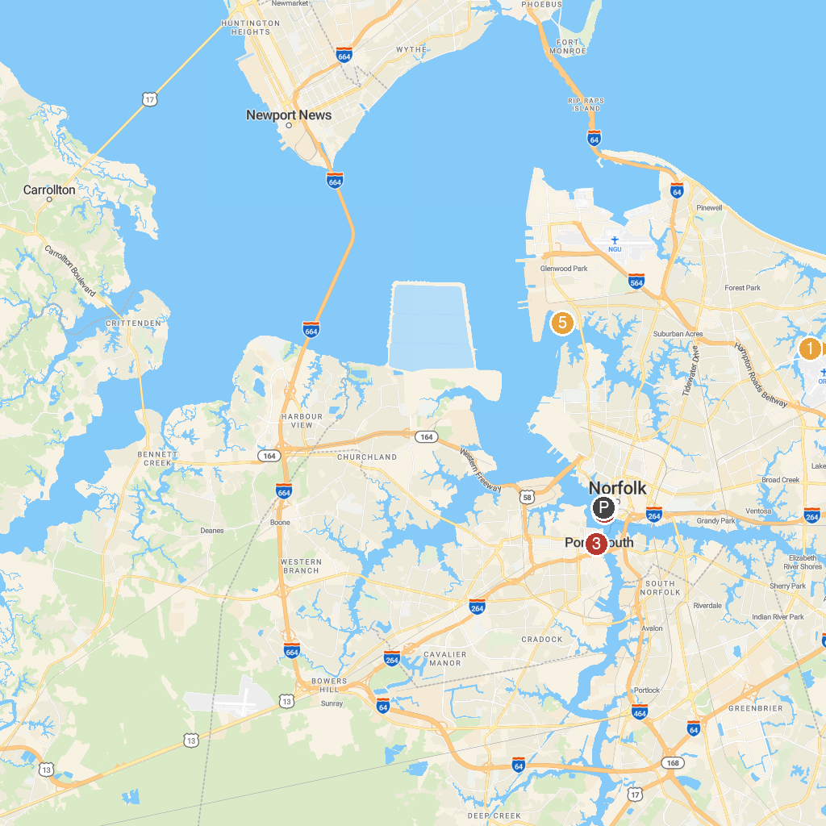
MAP KEY
1. Norfolk Botanical Garden | 4. Nauticus
2. Victory Rover Naval Base Cruises | 5. Mount Trashmore Park
3. Children's Museum of Virginia | 6. Hermitage Museum & Gardens
P. Cruise port / terminal
Map © MapTiler © OpenStreetMap contributors · cruiseports.org

