Norfolk Island, Australia
A remote South Pacific island steeped in convict history and Bounty mutineer legend, where Norfolk pines tower over emerald bays and UNESCO ruins line the shore.
⚓ Tender port (no pier docking) · 🕒 Typical call: 6–8 hrs · 💵 Australian Dollar (AUD) · 🗣️ English & Norfolk language
✍️ MY DAY IN PORT (FILL IN)
Ship / Date
In port | arrive ______ · all aboard ______
Booked excursion
Notes / meeting point
GETTING ASHORE
- Docking: Tender only — ships anchor offshore; boats land at Cascade or Kingston Pier depending on conditions
- Walk to centre: Shuttle bus required (10–15 min) from either pier to Burnt Pine village
- Best For: History, snorkelling, hiking, and unique Pitcairn-descendant culture
- Don't Miss: Kingston & Arthur's Vale Historic Area (KAVHA) — UNESCO World Heritage convict settlement
GETTING AROUND
- 🚕 Taxi: ~AUD 7–15 per trip — Very few licensed taxis on the island — pre-booking is essential as street hailing is not possible. Fares are set by ind
- 📱 Rideshare: ❌ not available
- 🚌 Hop-on hop-off: ✅
TOP THINGS TO DO
- Kingston UNESCO Heritage Walk — Explore Kingston and Arthur's Vale Historic Area (KAVHA), part of the UNESCO-listed Australian Convict Sites World Heritage…
- Emily Bay Snorkelling & Glass-Bottom Boat — Emily Bay Lagoon is the island's most sheltered spot — calm turquoise water ideal for snorkelling over coral gardens.
- Mount Pitt & Mount Bates Summit Hike — Trek through dense Norfolk pine forest in the National Park to reach Mount Bates (319 m), the island's highest point, or…
- Bounty Folk Museum & Fletcher's Cyclorama — Dive into the HMS Bounty mutineer story at the privately-run Bounty Folk Museum, then see the dramatic Fletcher's Mutiny…
- Norfolk Island National Park Birdwatching — The island is one of the few habitats of the critically endangered Norfolk Island Green Parrot.
BEST WALKS
- Kingston Foreshore & KAVHA Loop: ~2 km | Easy | 45–60 min — From Kingston Pier, walk the foreshore past the Quality Row Georgian buildings, the old gaol…
- Burnt Pine Village Wander: ~1 km | Easy | 30 min — The island's commercial hub is compact.
WEATHER · DAYLIGHT · MONEY
Month | High °F | Low °F | Rainy days
May | 86 | 73 | 17
Jul | 89 | 74 | 16
Sep | 87 | 74 | 21
Daylight: May 5:34AM–6:32PM · Jul 5:40AM–6:46PM · Sep 5:55AM–6:08PM
cruiseports.org/norfolk-island · Confirm terminal & all-aboard time with your ship

Norfolk Island, Australia — Port Map
Red = walkable sights · Amber = excursions farther out · P = cruise terminal
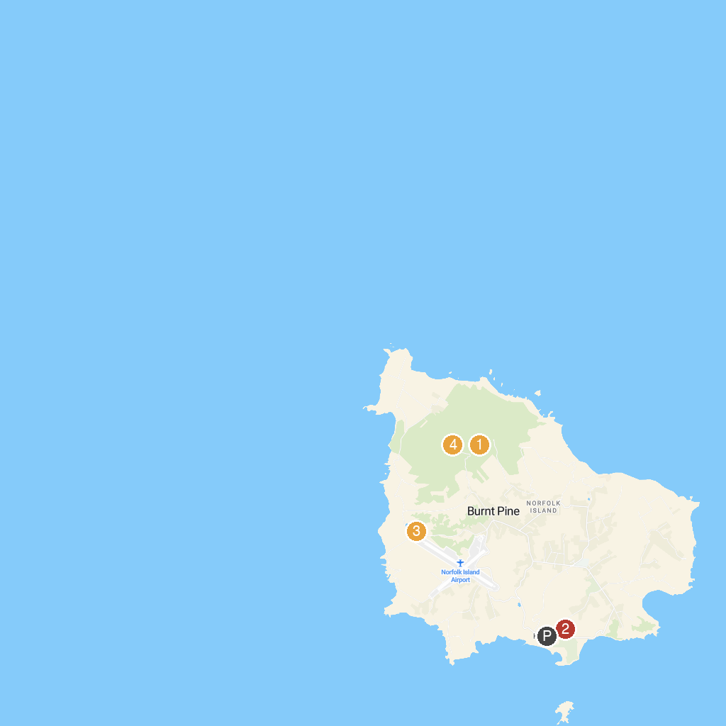
MAP KEY
1. Norfolk Island National Park | 3. St Barnabas Chapel
2. Queen Elizabeth Lookout | 4. Mount Pitt Lookout
P. Cruise port / terminal
Map © MapTiler © OpenStreetMap contributors · cruiseports.org

