Nordfjordeid, Vestland, Norway
A quiet fjord town with outsized Viking roots — home to the largest Viking ship ever found in Norway and the ancestral heartland of the iconic Fjord Horse. Easily walkable from the SeaWalk pier.
⚓ SeaWalk (floating pier — no tender) · 🕒 Typical call: 7-9 hrs · 💵 Norwegian Krone (NOK) — cashless country · 🗣️ Norwegian / English widely spoken
✍️ MY DAY IN PORT (FILL IN)
Ship / Date
In port | arrive ______ · all aboard ______
Booked excursion
Notes / meeting point
GETTING ASHORE
- Docking: SeaWalk floating pier (220 m); ships moor bow-to-shore and the pier extends to the hull, passengers walk ashore — no tender boats
- Walk to center: 5 min flat to Eidsgata historic street
- Best For: Viking history, Fjord Horse encounters, peaceful Norwegian town atmosphere
- Don't Miss: Stepping aboard the reconstructed Myklebust Ship at Sagastad Viking Center
GETTING AROUND
- 🚕 Taxi: NOK 1,000–1,300 to Loen (~56 km) — Taxis wait at the dock for longer excursions to attractions like Loen Skylift or Briksdal Glacier. Short in-town rides a
- 📱 Rideshare: ❌ not available
TOP THINGS TO DO
- Sagastad Viking Center — The centrepiece of Nordfjordeid — a modern museum built around the 30-metre reconstructed Myklebust Ship, the largest Viking…
- Norwegian Fjord Horse Centre — Norway's national centre for the beloved Fjord Horse breed.
- Loen Skylift & Mount Hoven — A 20-minute cable car ride ascends 1,011 metres above Loenfjorden for jaw-dropping 360° views.
- Briksdal Glacier — Visit Briksdalsbreen, an arm of the Jostedalsbreen ice cap.
- Hike to Trollenykjen Viewpoint — A well-marked trail leads up to Trollenykjen (881 m) with panoramic 360° views over Eidsfjorden, the town, and your cruise ship…
BEST WALKS
- Viking & Fjord Horse Loop: 3.5 km · 1.5 hrs · Easy, flat — From the SeaWalk pier, walk into town along the fjord promenade, explore Eidsgata, continue to…
- Town & Church Stroll: 1.5 km · 30 min · Easy — Quick loop for those with limited time — pier to Eidsgata shops and Minibakeriet bakery, then up to…
WEATHER · DAYLIGHT · MONEY
Month | High °F | Low °F | Rainy days
May | 56 | 43 | 17
Jul | 67 | 54 | 20
Sep | 60 | 48 | 19
Daylight: May 4:43AM–10:23PM · Jul 4:20AM–11:01PM · Sep 7:02AM–7:58PM
cruiseports.org/nordfjordeid · Confirm terminal & all-aboard time with your ship

Nordfjordeid, Vestland, Norway — Port Map
Red = walkable sights · Amber = excursions farther out · P = cruise terminal
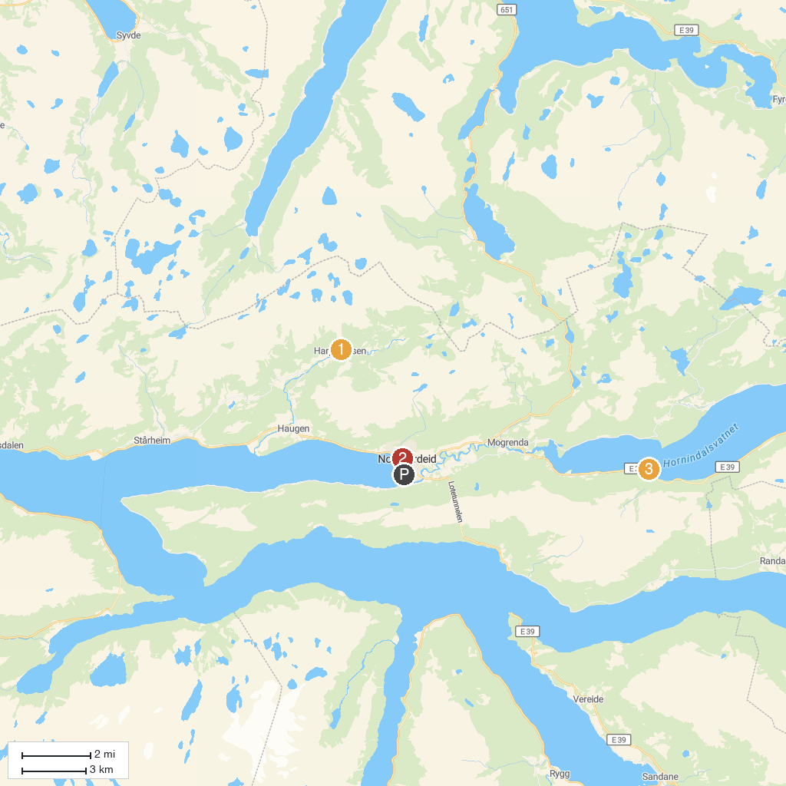
MAP KEY
1. Harpefossen Skisenter AS | 3. Fotostop Hornindalsvatnet
2. Eid kyrkje
P. Cruise port / terminal
Map © MapTiler © OpenStreetMap contributors · cruiseports.org

