Nisyros Island, Dodecanese, Greece
One of the few places on Earth where you can walk down into a living volcanic crater — Nisyros is raw, dramatic, and utterly untouched by mass tourism.
⚓ Tender port (most ships) · 🕒 Typical call: 6–8 hrs · 💶 Euro (€) · 🗣️ Greek
✍️ MY DAY IN PORT (FILL IN)
Ship / Date
In port | arrive ______ · all aboard ______
Booked excursion
Notes / meeting point
GETTING ASHORE
- Docking: Tender to Mandraki pier (large ships); small ships may dock
- Walk to center: 5 min from tender landing to Mandraki village
- Best For: Volcano crater, authentic Greek villages, volcanic beaches
- Don't Miss: Walking into Stefanos Crater & sipping soumada in Mandraki square
GETTING AROUND
- 🚕 Taxi: Negotiated; ~€15–25 per trip — Only about 2 taxis operate on the island. They can be found near the harbor or booked by phone through your hotel. Price
TOP THINGS TO DO
- Stefanos Crater Walk — Descend into one of the world's most accessible active hydrothermal craters.
- Nikia Village & Caldera Rim — Perched on the crater rim, Nikia features an iconic elliptical pebble mosaic square and sweeping views into the caldera.
- Paleokastro Ancient Fortress — One of the best-preserved ancient fortresses in the Aegean, built from massive black volcanic basalt blocks in the 4th century BC.
- Hohlaki Black-Stone Beach — Just behind the Panagia Spiliani monastery, this beach of smooth jet-black volcanic stones is visually stunning.
- Mandraki Village & Monastery of Panagia Spiliani — Wander the chochlakia-paved lanes of Mandraki's whitewashed labyrinth, then climb 130 steps to the 14th-century cave monastery…
BEST WALKS
- Mandraki Port to Panagia Spiliani Monastery: 30–45 min • Easy–Moderate • Free — From the tender pier, stroll through Mandraki's pebble-mosaic lanes to Ilikiomeni Square, then…
- Mandraki to Hohlaki Beach: 15 min • Easy • Free — A flat coastal walk from the pier behind the monastery to the dramatic black-stone beach.
WEATHER · DAYLIGHT · MONEY
Month | High °F | Low °F | Rainy days
May | 68 | 66 | 4
Jul | 79 | 76 | 0
Sep | 77 | 75 | 1
Daylight: May 6:04AM–8:11PM · Jul 6:04AM–8:29PM · Sep 6:54AM–7:18PM
cruiseports.org/nisyros-island · Confirm terminal & all-aboard time with your ship

Nisyros Island, Dodecanese, Greece — Port Map
Red = walkable sights · Amber = excursions farther out · P = cruise terminal
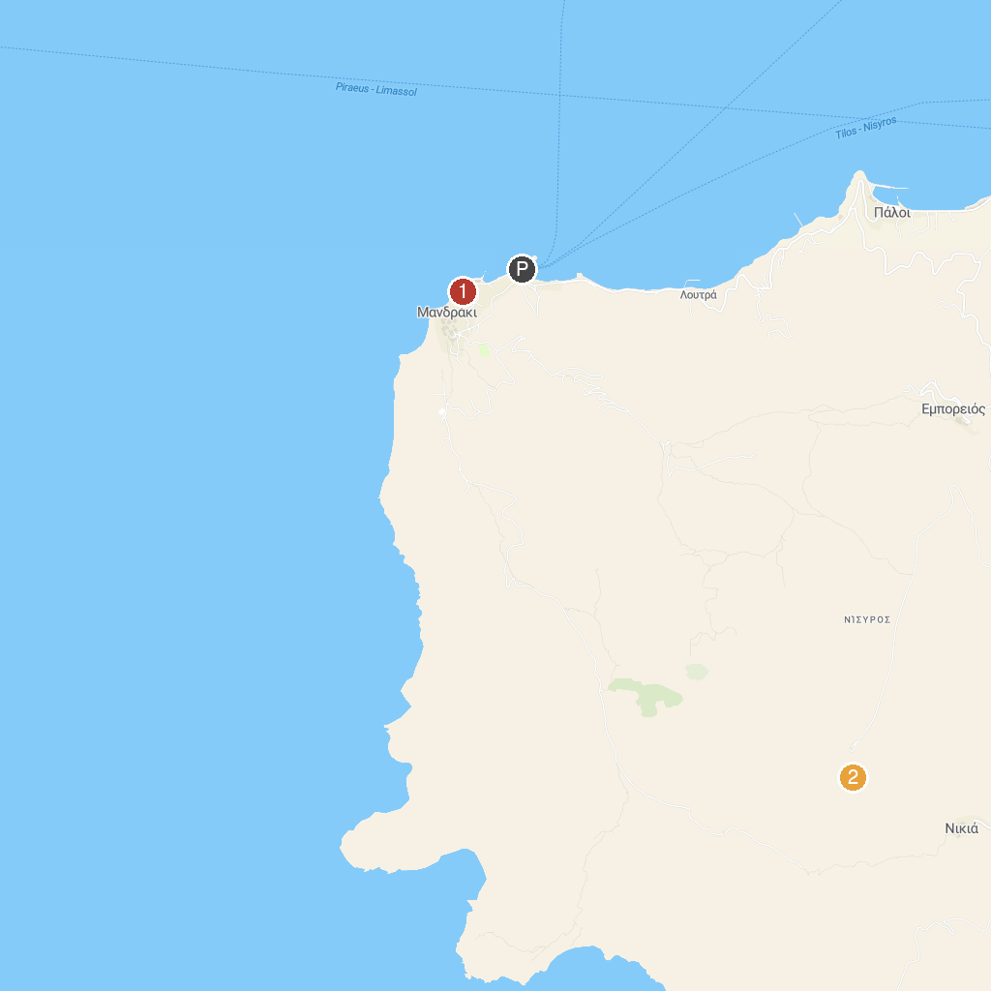
MAP KEY
1. Archaeological Museum of Nisyros | 2. Stefanos Crater
P. Cruise port / terminal
Map © MapTiler © OpenStreetMap contributors · cruiseports.org

