Niigata City, Niigata Prefecture, Japan
Japan's rice and sake capital sits on the Sea of Japan with two docking options, historic geisha quarters, and no crowds. One of Asia's most underrated cruise calls.
⚓ Docked (pier) · 🕒 Typical call: 8-10 hrs · 💴 Currency: Japanese Yen (JPY) · 🗣️ Language: Japanese
✍️ MY DAY IN PORT (FILL IN)
Ship / Date
In port | arrive ______ · all aboard ______
Booked excursion
Notes / meeting point
GETTING ASHORE
- Docking: Yamanoshita Wharf (West Port) for most ships; East Port for mega-ships (~20 km from center)
- Walk to center: Not walkable — shuttle or taxi required; city center ~10-15 min by taxi
- Best For: Sake tasting, Kiwami sushi, traditional Japanese culture, historic villas
- Don't Miss: Ponshukan sake vending machines at Niigata Station; Former Saito Villa garden
GETTING AROUND
- 🚕 Taxi: ¥1,200–¥2,800 — From Niigata West Port (closer to downtown), a taxi to Niigata Station takes about 15 minutes. Taxis accept IC cards and
- 📱 Rideshare: ✅ Uber
- 🚌 Hop-on hop-off: ✅
TOP THINGS TO DO
- Ponshukan Sake Tasting — For ¥500 you get five tokens and a ceramic cup — insert tokens into any of 100+ vending machines dispensing premium Niigata sakes.
- Former Saito Villa & Garden — A magnificent 1918 merchant family villa with a serene traditional Japanese garden designed to be viewed from tatami-mat rooms.
- Kiwami Sushi Lunch — Niigata's Kiwami initiative means nearly every sushi shop offers 10 pieces of premium seasonal sushi — sea urchin, fatty tuna…
- Imayotsukasa Sake Brewery — A historic brewery a short walk from Niigata Station with English-language tours and a beautiful tasting room.
- Bandai Bridge & Shinano River Walk — Stroll across the elegant six-arched granite Bandai Bridge — a national cultural property — and follow the Shinano Riverbank.
BEST WALKS
- Station to Furumachi Geisha District: 2.5 km · ~30 min · Flat — Walk from Niigata Station east exit across the iconic Bandai Bridge, through the historic Furumachi…
- Riverside Culture Loop: 2 km · ~25 min · Flat — From Bandai Bridge, follow the river path north to Minatopia (Niigata City History Museum) with its…
WEATHER · DAYLIGHT · MONEY
Month | High °F | Low °F | Rainy days
May | 69 | 54 | 12
Jul | 82 | 72 | 14
Sep | 78 | 68 | 15
Daylight: May 4:34AM–6:46PM · Jul 4:33AM–7:05PM · Sep 5:25AM–5:51PM
cruiseports.org/niigata-city · Confirm terminal & all-aboard time with your ship

Niigata City, Niigata Prefecture, Japan — Port Map
Red = walkable sights · Amber = excursions farther out · P = cruise terminal
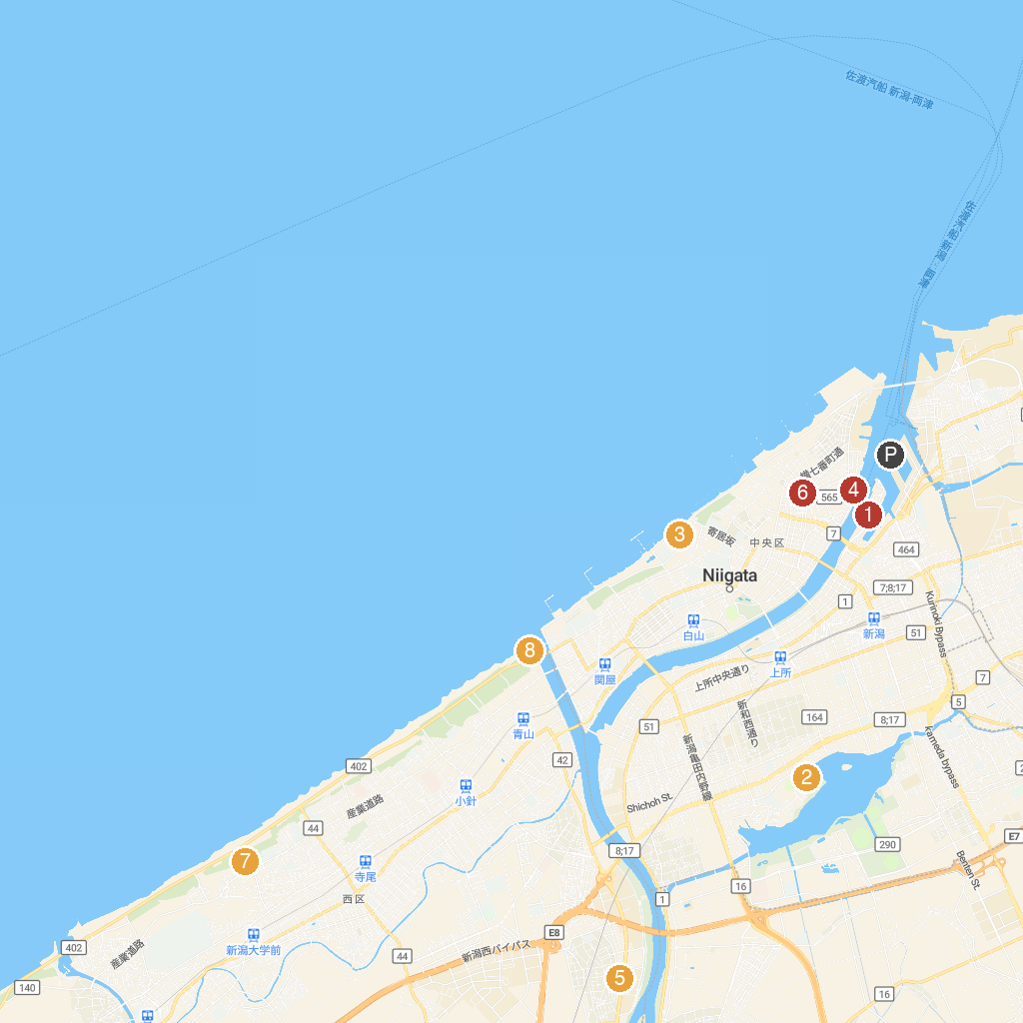
MAP KEY
1. Toki Messe | 5. Setsuryosha Museum
2. Niigata Science Museum | 6. Former Ozawa Family Residence
3. Niigata City Aquarium Marinepia Nihonkai (Sea of Japan) | 7. 新潟市西総合スポーツセンター
4. Minatopia: Niigata City History Museum | 8. 関屋分水資料館
P. Cruise port / terminal
Map © MapTiler © OpenStreetMap contributors · cruiseports.org

