Nierstein, Rhineland-Palatinate, Germany
Germany's oldest wine village packs remarkable history into a compact Rhine-bank town. The iron-red Roter Hang slope has produced prized Riesling since 742 AD — and it's all a short walk from the floating pontoon.
⚓ Pier (floating pontoon) · 🕒 Typical call: 5–7 hrs · 💶 Euro (cash preferred) · 🗣️ German · 🍷 Wine destination
✍️ MY DAY IN PORT (FILL IN)
Ship / Date
In port | arrive ______ · all aboard ______
Booked excursion
Notes / meeting point
GETTING ASHORE
- Docking: Floating pontoon on Rhine Promenade — no tender
- Walk to centre: ~5–8 min (400–600 m flat) to Marktplatz
- Best for: Wine tasting, vineyard walks, historic village strolling
- Don't miss: A glass of Roter Hang Riesling straight from a local Weingut
GETTING AROUND
- 🚕 Taxi: €5–€10 (town); €20–€30 to Mainz — Local taxis serve the area — try White Eagle Taxi (+49 6133 2555) or Rhein Taxi Nierstein (+49 6133 3882879). The town c
- 📱 Rideshare: ✅ Uber
TOP THINGS TO DO
- Roter Hang Winery Tasting — Visit one of Nierstein's celebrated estates — Louis Guntrum, Raddeck, or Gehring — for a guided tasting of Riesling and…
- Covered Wagon Vineyard Ride (Funzelfahrt) — Ride a tractor-pulled covered wagon through the Roter Hang vineyards while a local vintner pours wine and explains the terroir.
- St. Kilian's Church & Rhine Views — Climb to the red-and-white St.
- Paleontological Museum — The town hall houses a small museum displaying 250-million-year-old amphibian and reptile footprints found in the red sandstone…
- Roter Hang Vineyard Walk — Follow paved vineyard paths up the Roter Hang ridge to the Wartturm watchtower — the highest vantage point in the vineyards — and…
BEST WALKS
- Rhine Promenade to Marktplatz: 30 min · Easy · 1 km round-trip — A simple flat stroll from the docking pontoon along the Rhine bank into the village centre.
- Village to St. Kilian's Church & Roter Hang Viewpoint: 1.5–2 hrs · Moderate · ~3 km loop — Head uphill from the Marktplatz through vineyard lanes to St.
WEATHER · DAYLIGHT · MONEY
Month | High °F | Low °F | Rainy days
May | 67 | 49 | 11
Jul | 79 | 61 | 10
Sep | 70 | 54 | 8
Daylight: May 5:41AM–9:05PM · Jul 5:35AM–9:29PM · Sep 7:03AM–7:39PM
cruiseports.org/nierstein · Confirm terminal & all-aboard time with your ship

Nierstein, Rhineland-Palatinate, Germany — Port Map
Red = walkable sights · Amber = excursions farther out · P = cruise terminal
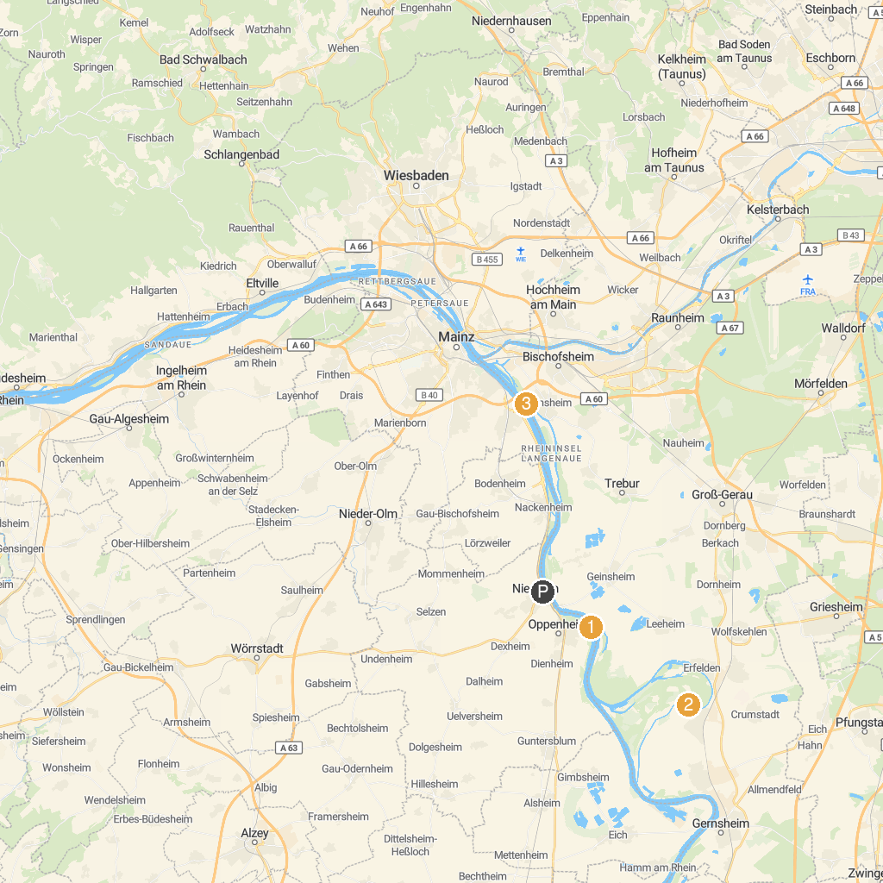
MAP KEY
1. St. Stephan's Church | 5. Schiffsmühle Ginsheim am Rhein
2. Stadt Park | 6. Das Büchnerhaus - BüchnerFindetStatt e.V.
3. Strandbad Oppenheim | 7. Schleuse / Staustufe Kostheim
4. Umweltbildungszentrum Schatzinsel Kühkopf
P. Cruise port / terminal
Map © MapTiler © OpenStreetMap contributors · cruiseports.org

