Nice, Côte d'Azur, France
The capital of the French Riviera balances grand Belle Époque boulevards with a labyrinthine old town — and puts Monaco, Èze, and Cannes within easy reach of your ship.
⚓ Tendered (Villefranche) or Docked (Port Lympia) · 🕒 Typical call: 8–10 hrs · 💶 Euro (EUR) · 🗣️ French
✍️ MY DAY IN PORT (FILL IN)
Ship / Date
In port | arrive ______ · all aboard ______
Booked excursion
Notes / meeting point
GETTING ASHORE
- Docking: Large ships anchor in Villefranche-sur-Mer bay (tender); smaller ships dock at Port Lympia in Nice
- Walk to centre: Port Lympia: 10-min walk to Vieux-Nice. Villefranche tender: 30-min bus or taxi to Nice centre
- Best For: Promenade strolls, Vieux-Nice market, Monaco day trip
- Don't Miss: Cours Saleya flower market (mornings), Colline du Château views, a socca pancake in the old town
GETTING AROUND
- 🚕 Taxi: €10–€20 — Taxis from Port Lympia to Vieux Nice or Promenade des Anglais are short and affordable (5–10 min). Official rates are me
- 📱 Rideshare: ✅ Uber, Bolt
- 🚌 Hop-on hop-off: ✅ Nice Le Grand Tour
TOP THINGS TO DO
- Promenade des Anglais & Vieux-Nice — Walk the famous seafront promenade, then dive into the Baroque alleyways of the old town.
- Monaco & Monte-Carlo — The Principality is 20 km east — explore the Rock (Prince's Palace, Oceanographic Museum), stroll casino square, and walk the…
- Èze Village & Trophée des Alpes — Perched 430 m above the sea, medieval Èze offers panoramic Riviera views and an exotic garden.
- Cannes & the Lérins Islands — Head west to Cannes' famous Croisette, browse the covered Forville market, or take a short ferry to peaceful Île…
- Niçoise Cuisine & Market Tour — Sample socca (chickpea crêpe), pan bagnat, and pissaladière at Cours Saleya.
BEST WALKS
- Promenade to Colline du Château: 4 km · 1.5–2 hrs · Easy-moderate — Start at Place Masséna, walk the Promenade des Anglais west to east, then climb (lift available) to…
- Vieux-Nice Market Walk: 2 km · 1 hr · Easy — From Cours Saleya morning market, wind through Rue du Jésus and Rue Droite past Baroque churches…
WEATHER · DAYLIGHT · MONEY
Month | High °F | Low °F | Rainy days
May | 70 | 57 | 9
Jul | 83 | 70 | 4
Sep | 77 | 65 | 6
Daylight: May 6:05AM–8:49PM · Jul 6:03AM–9:09PM · Sep 7:10AM–7:40PM
cruiseports.org/nice · Confirm terminal & all-aboard time with your ship

Nice, Côte d'Azur, France — Port Map
Red = walkable sights · Amber = excursions farther out · P = cruise terminal
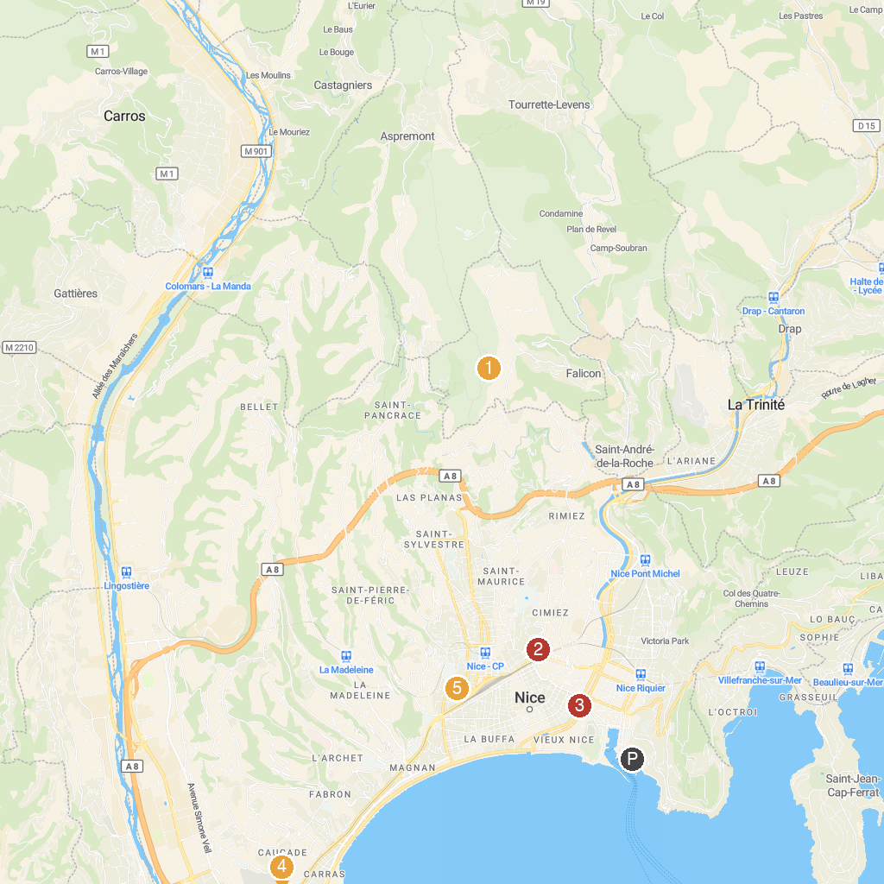
MAP KEY
1. Pyramid of Falicon | 5. Modern and Contemporary Art Museum (MAMAC)
2. Marc Chagall National Museum | 6. Musée océanographique de Monaco
3. Casino de Monte-Carlo | 7. Parc Phœnix
4. Prince's Palace of Monaco | 8. Cathédrale Saint-Nicolas de Nice
P. Cruise port / terminal
Map © MapTiler © OpenStreetMap contributors · cruiseports.org

